AMITY UNIVERSITY MAHARASHTRA

AMITY INSTITUTE OF INFORMATION TECHNOLOGY

ANDROID PROGRAMMING

LAB FILE

BCA/BSC -IT

2018-2022



Prathmesh Patil

BCA SEM5

A71004819033

**INDEX**

|  |  |  |
| --- | --- | --- |
| Index No | Experiments | Date |
| 1 | Experiment 1 |  |
| 2 | Experiment 2 |  |
| 3 | Experiment 3 |  |
| 4 | Experiment 4 |  |
| 5 | Experiment 5 |  |
| 6 | Experiment 6 |  |
| 7 | Experiment 7 |  |
| 8 | Experiment 8 |  |
| 9 | Experiment 9 |  |
| 10 | Experiment 10 |  |
| 11 | Experiment 11 |  |
| 12 | Experiment 12 |  |

**EXPERIMENT 1**

Introduction & Installation  
JavaI SE Runtime Environment (build 16.0.1) Android Studio

Sol:-

Introduction:-

Android Studio is the official integrated development environment (IDE) for Google’s Android operating system, built on JetBrains’ IntelliJ IDEA software and designed specifically for Android development. It is available for download on Windows, macOS and Linux based operating systems or as a subscription-based service in 2020. It is a replacement for the Eclipse Android Development Tools (E-ADT) as the primary IDE for native Android application development.

Android Studio was announced on May 16, 2013 at the Google I/O conference. It was in early access preview stage starting from version 0.1 in May 2013, then entered beta stage starting from version 0.8 which was released in June 2014. The first stable build was released in December 2014, starting from version 1.0.

On May 7, 2019, Kotlin replaced Java as Google’s preferred language for Android app development. Java is still supported, as is C++.

A specific feature of the Android Studio is an absence of the possibility to switch autosave feature off.

The following features are provided in the current stable version:

Gradle-based build support

Android-specific refactoring and quick fixes

Lint tools to catch performance, usability, version compatibility and other problems

Pro Guard integration and app-signing capabilities

Template-based wizards to create common Android designs and components

A rich layout editor that allows users to drag-and-drop UI components, option to preview layouts on multiple screen configurations.

Support for building Android Wear apps

Built-in support for Google Cloud Platform, enabling integration with Firebase Cloud Messaging (Earlier ‘Google Cloud Messaging’) and Google App Engine.

Android Virtual Device (Emulator) to run and debug apps in the Android studio. Android Studio supports all the same programming languages of IntelliJ (and Clion) e.g. Java, C++, and more with extensions, such as Go and Android Studio 3.0 or later supports Kotlin and “all Java 7 language features and a subset of Java 8 language features that vary by platform version.” External projects backport some Java 9 features. While IntelliJ states that Android Studio supports all released Java versions, and Java 12, it’s not clear to what level Android Studio supports Java versions up to Java 12 (the documentation mentions partial Java 8 support). At least some new language features up to Java 12 are usable in Android.

Once an app has been compiled with Android Studio, it can be published on the Google Play Store. The application has to be in line with the Google Play Store developer content policy.

Installation:-

1. Java :-

Step 1:- Open the command prompt and check whether the java is install or not :-

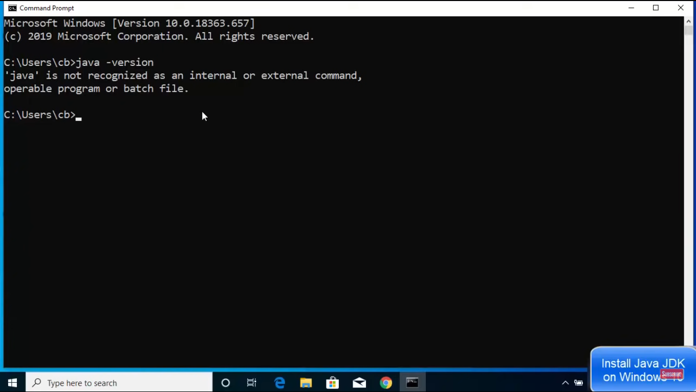

Step 2:- Download the JAVA JDK

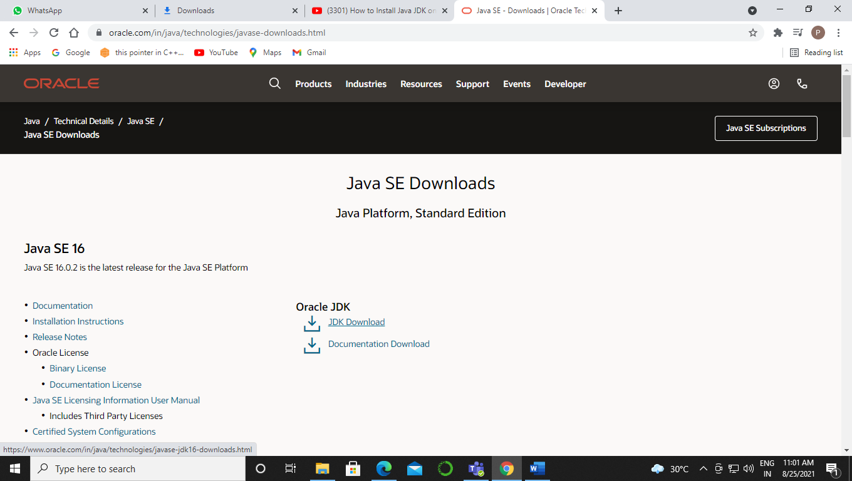

Step 3:- Start downloading JDK, after downloading open the setup.

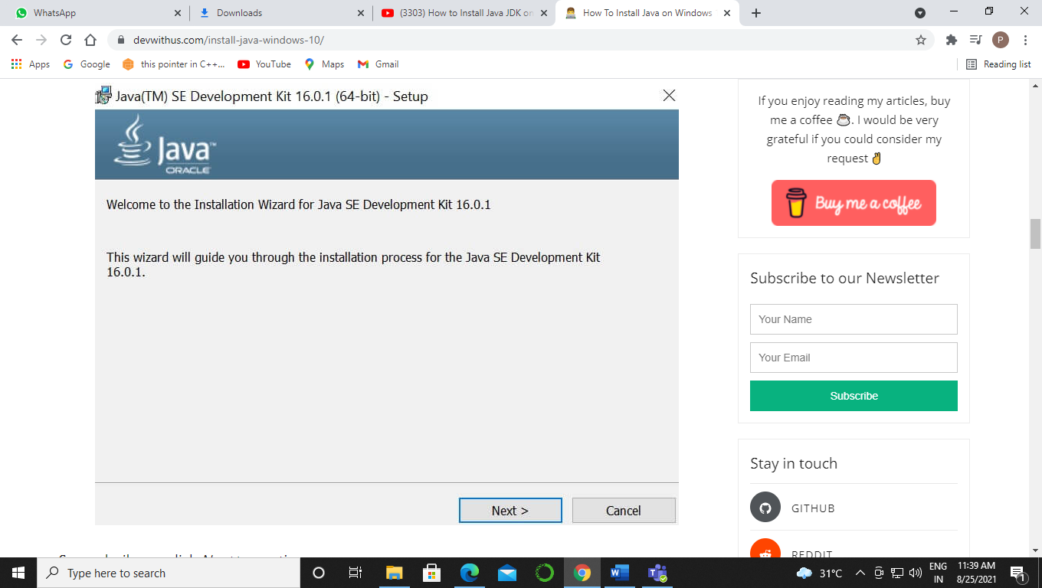

Step 4:-Click on next and installation will start.

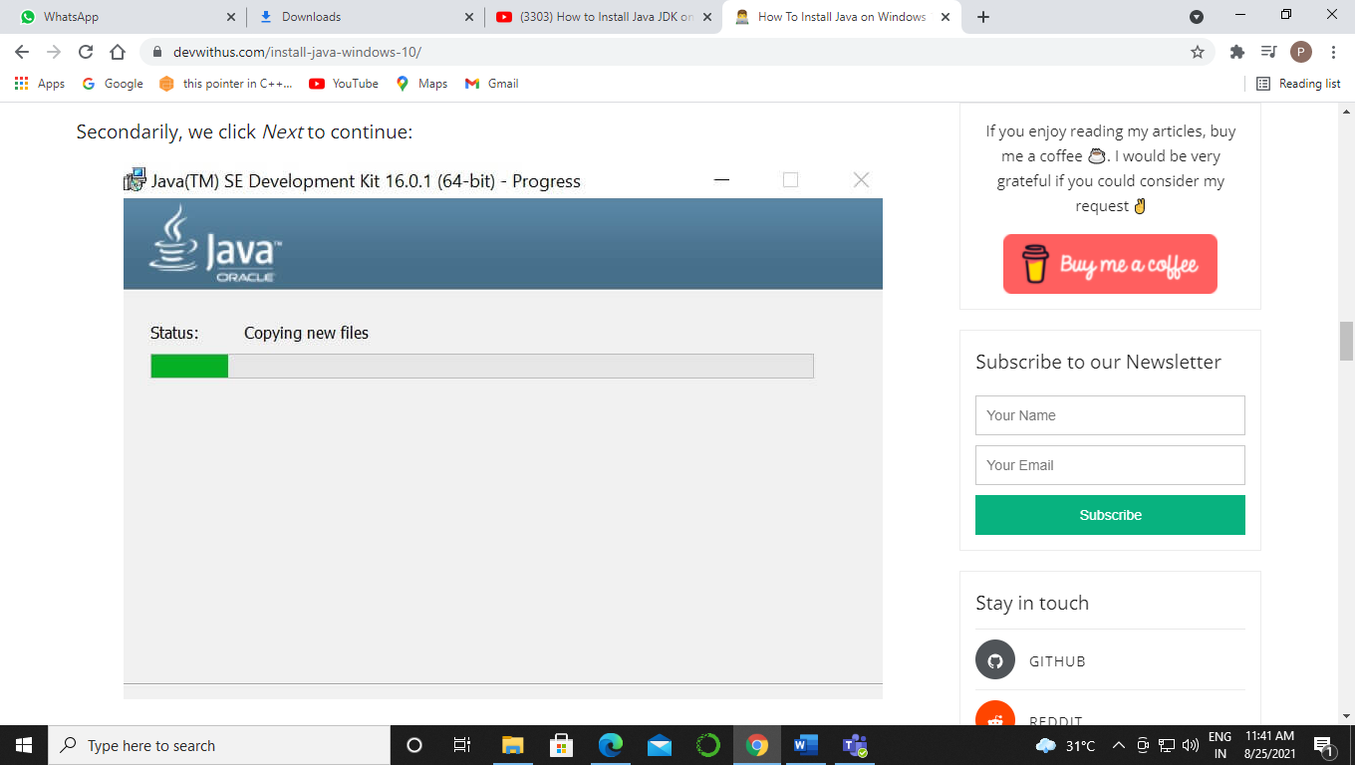

Step 5:- After installing you have to set path of the JDK in environment variables, so open your system settings and go to Environment variables….

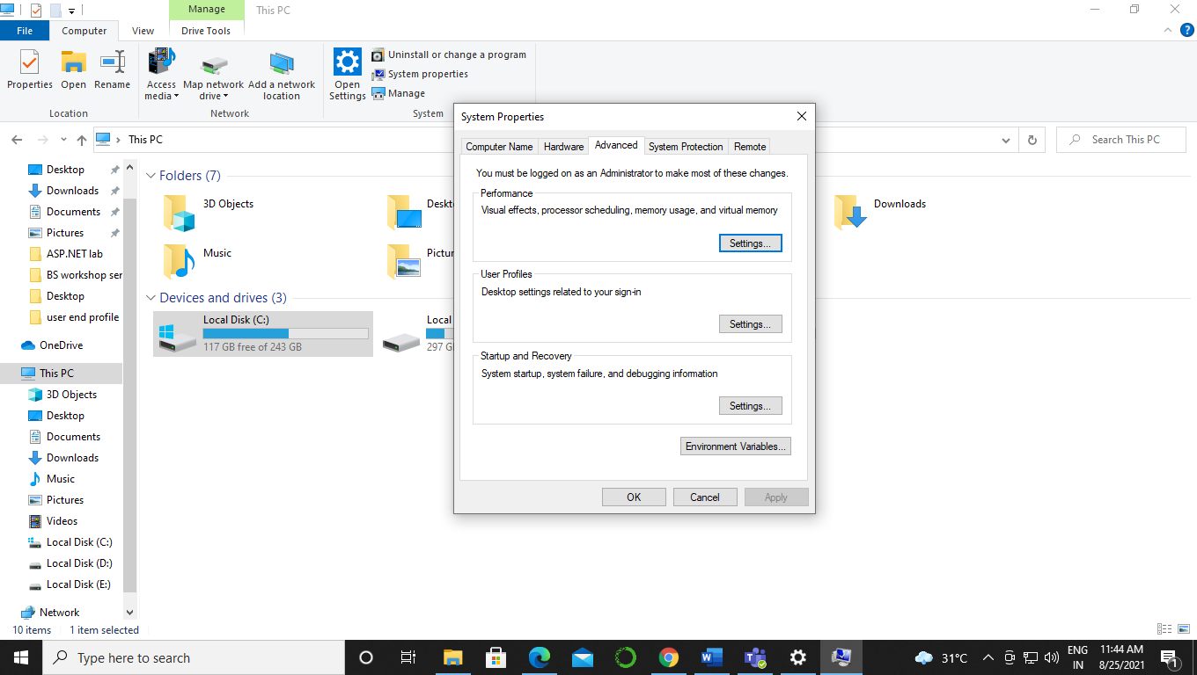

Step 6:- In Environment variables you have to go to in path where you have to set path of java bin.

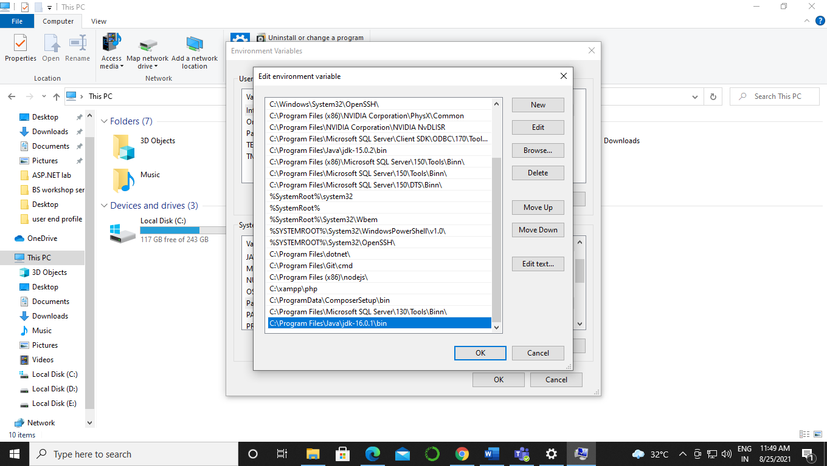

Step 7:- After setting the path now you have to set path for JAVA_HOME for that you have copy source path.

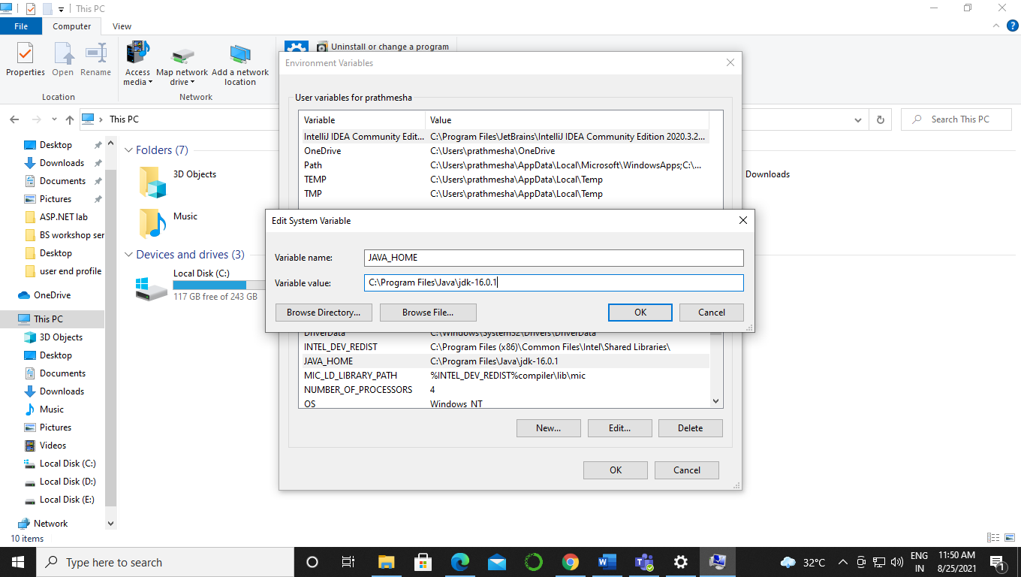

Step 8:- After setting path just press ok and open command prompt to check whether java installation is done or not.

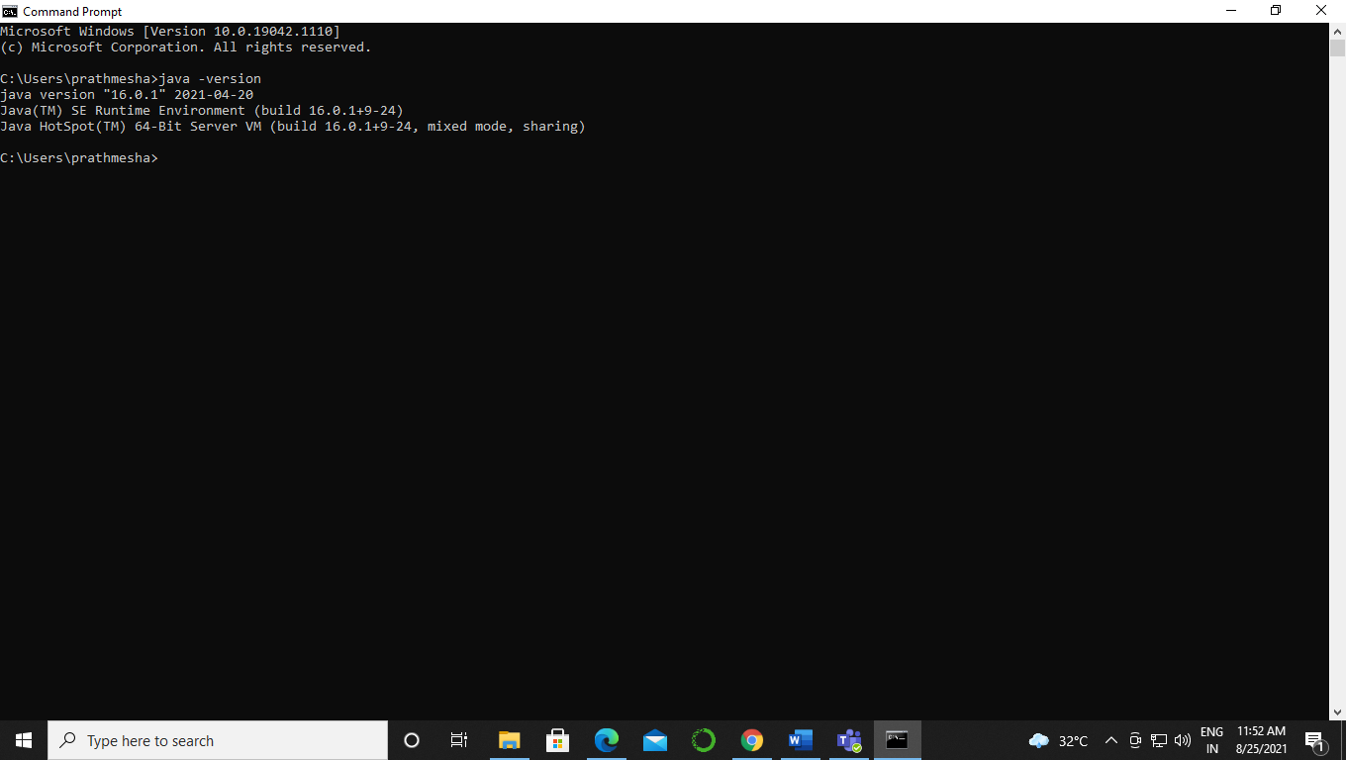

1. Android Studio:-

Step1: Open you downloaded android studio file and wait for few seconds, it will take some time to load on your screen.

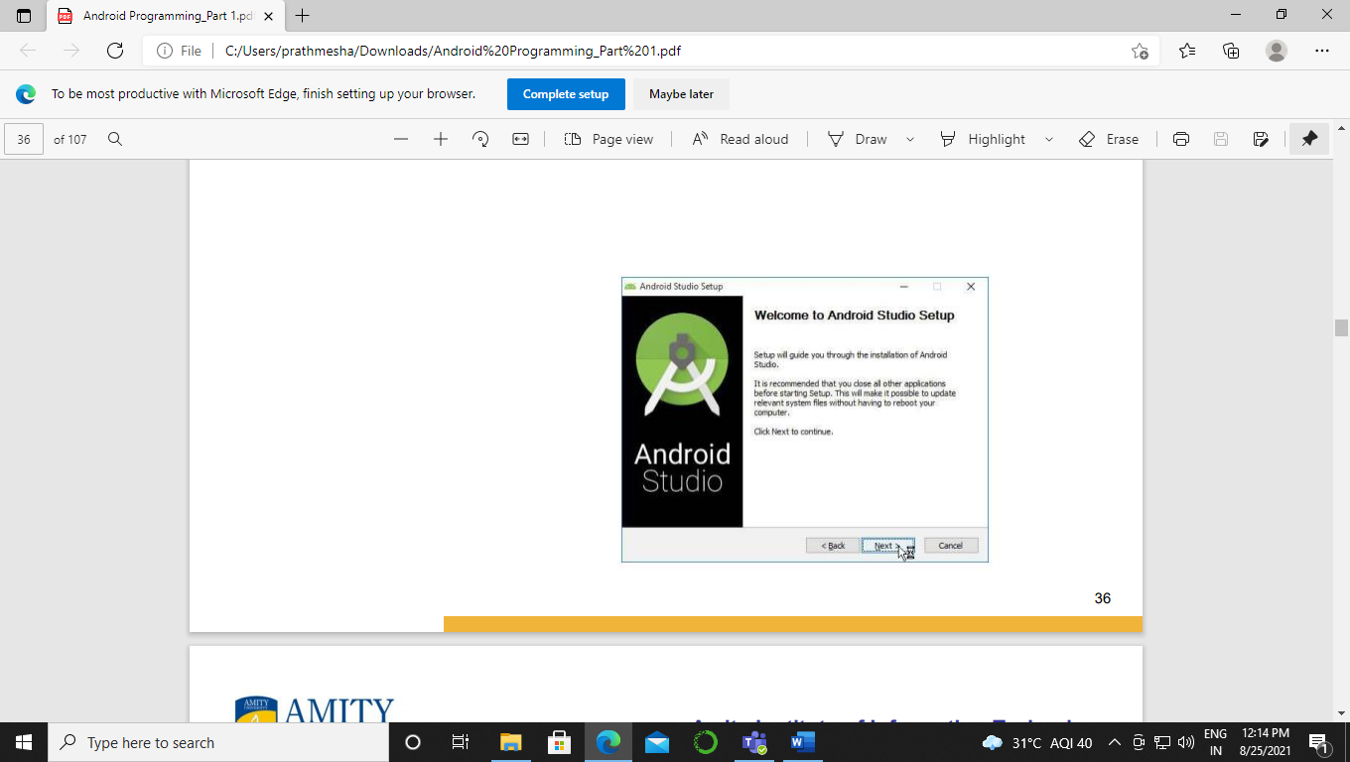

Step2: After that the window will appear on your screen, where it will show you welcome to android studio. Go for “Next”

Step3: Now choose what you want to install, all are most important component in android programming. Go for “Next.

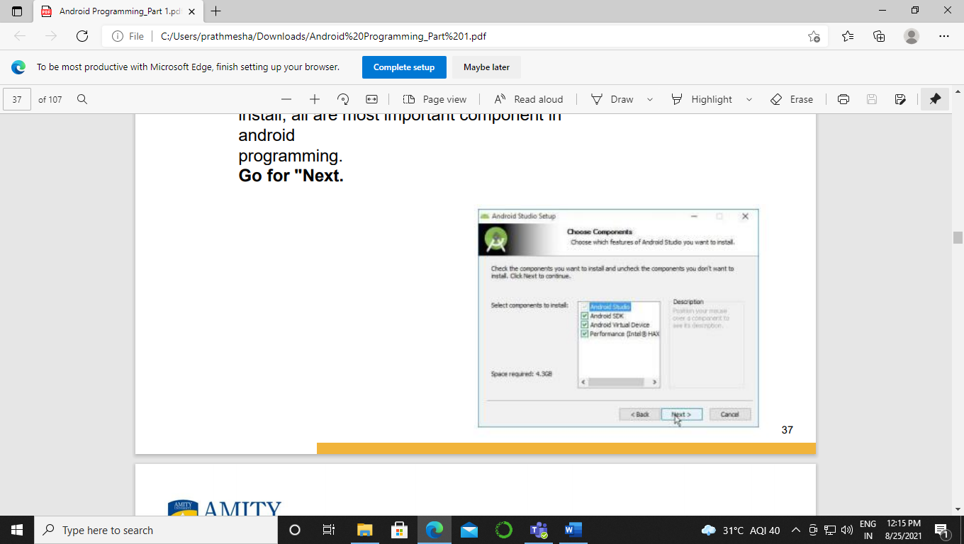

Step4: Go for “I Agree”, It’s for integrating SDK, it will confirm SDK installation.

Step5: Go for “I Agree”, It’s for Haxm installation.

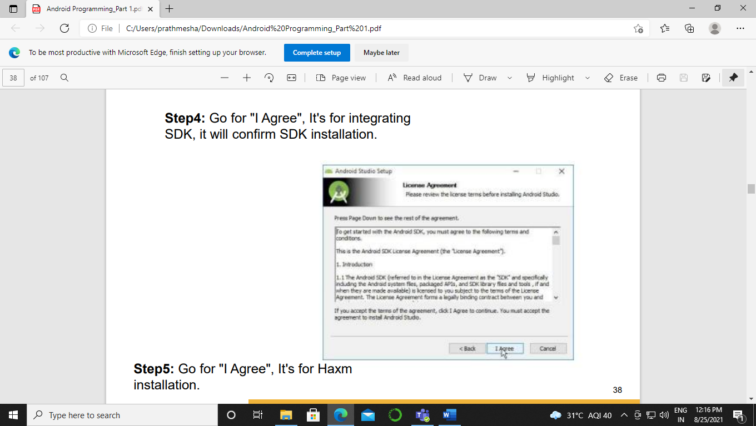

Step6: Now choose the location for Android Studio and SDK. Go for “Next

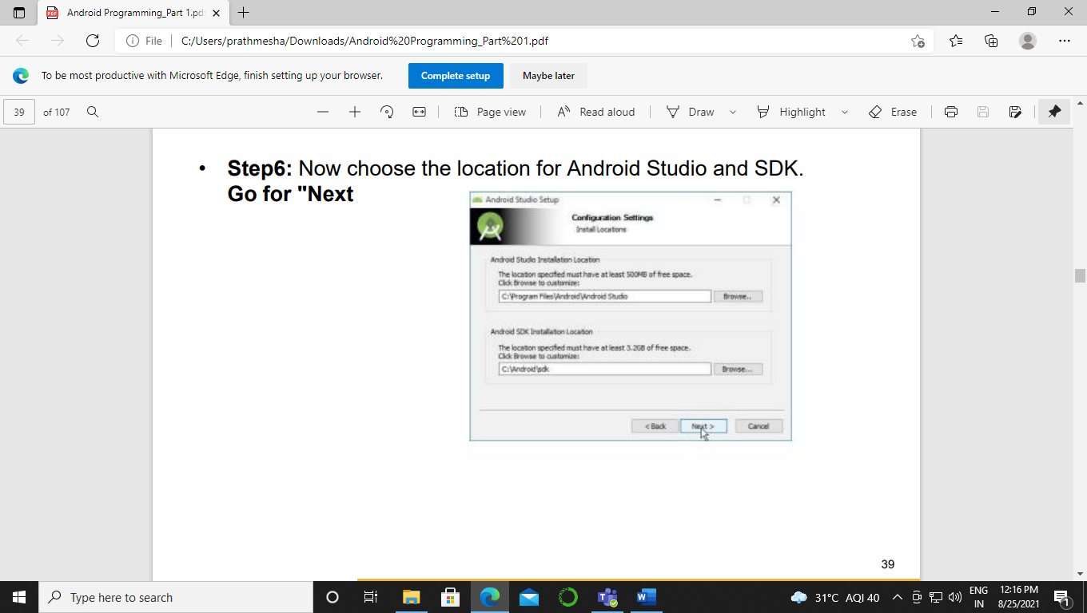

Step7: Here you need to define the size of android emulator processor. You can define up to 2GB and more than that, depends on your RAM capacity. The size will be determined through Haxm. This will help your android studio to run faster.

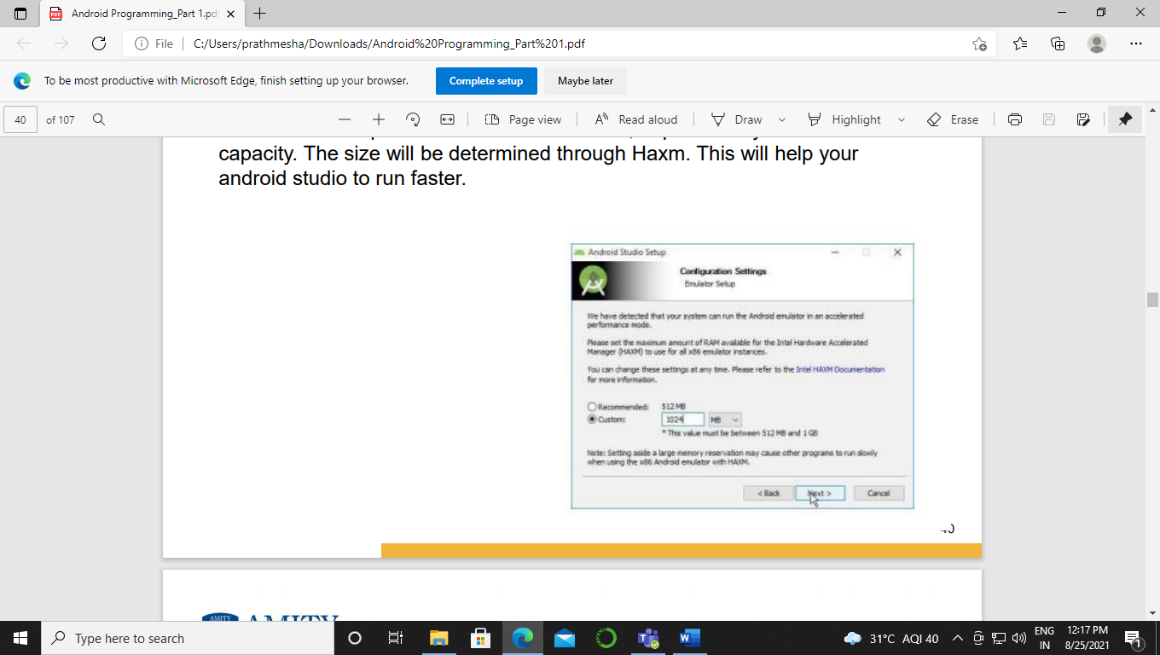

Step8: Now choose setting for shortcut of android studio on your computer.

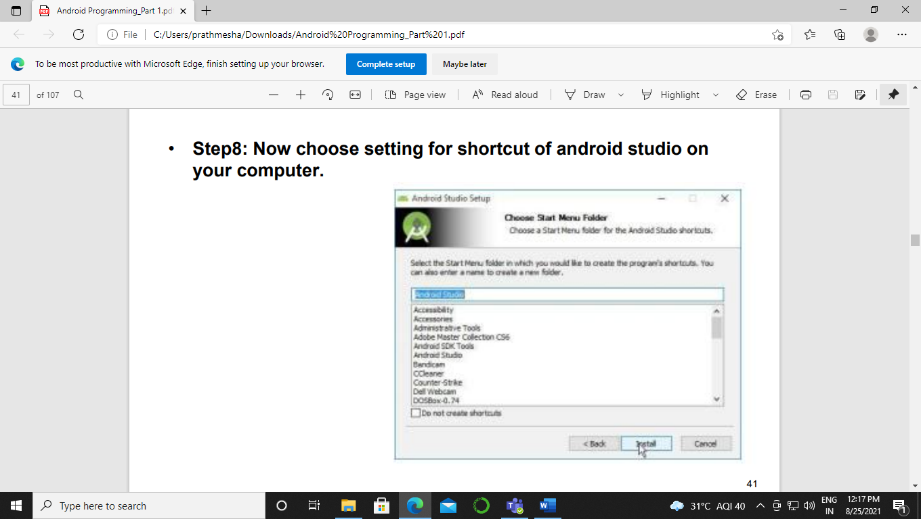

Step9: After that it will take lots of time to copy all the files to the storage location you have selected before.

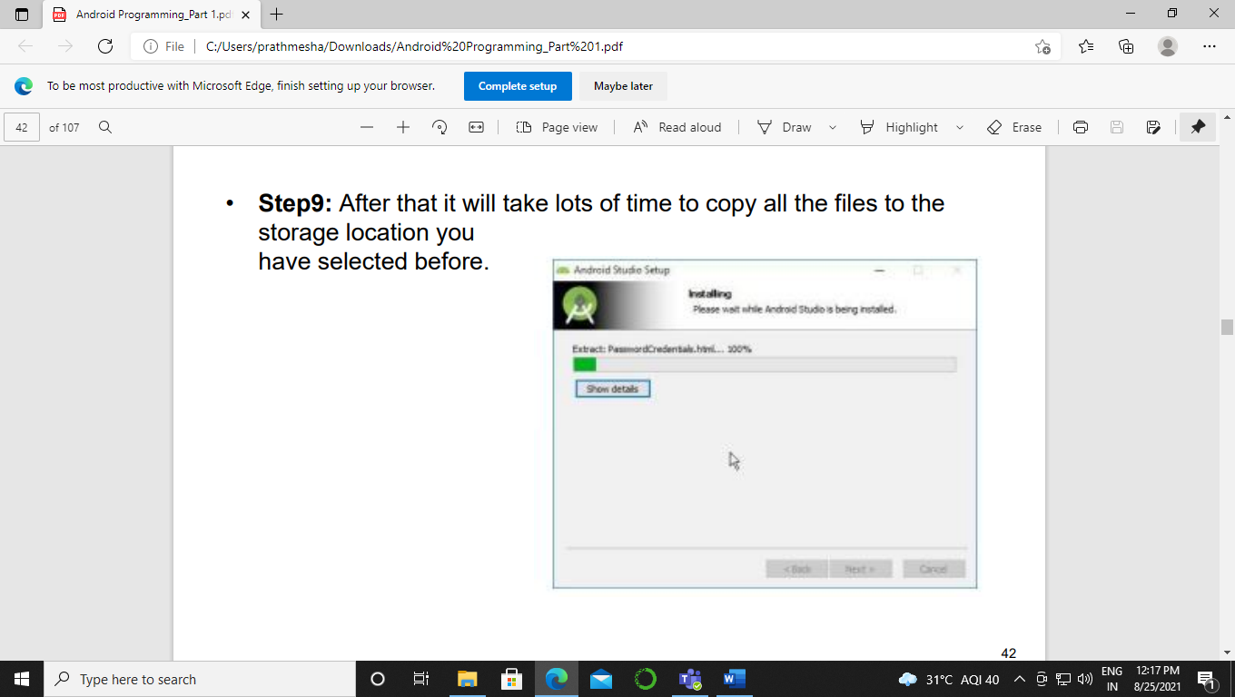

**EXPERIMENT 2:-**

General Form Design/ Development of Interactive application

1. Development of an android application for a basic calculator.

Sol:-

Activity_main.xml:-

<?xml version=”1.0” encoding=”utf-8”?>  
<oolean.constraintlayout.widget.ConstraintLayout xmlns:android=”http://schemas.android.com/apk/res/android”  
 xmlns:app=”http://schemas.android.com/apk/res-auto”  
 xmlns:tools=”http://schemas.android.com/tools”  
 android:layout_width=”match_parent”  
 android:layout_height=”match_parent”  
 tools:context=”.MainActivity”>  
  
 <EditText  
 android:id=”@+id/et1”  
 android:layout_width=”190dp”  
 android:layout_height=”58dp”  
 android:layout_marginStart=”93dp”  
 android:layout_marginLeft=”93dp”  
 android:layout_marginTop=”36dp”  
 android:layout_marginBottom=”637dp”  
 android:hint=”Enter a number”  
 app:layout_constraintBottom_toBottomOf=”parent”  
 app:layout_constraintStart_toStartOf=”parent”  
 app:layout_constraintTop_toTopOf=”parent” />  
  
 <EditText  
 android:id=”@+id/et2”  
 android:layout_width=”190dp”  
 android:layout_height=”58dp”  
 android:layout_marginStart=”93dp”  
 android:layout_marginLeft=”93dp”  
 android:layout_marginTop=”155dp”  
 android:layout_marginBottom=”518dp”  
 android:hint=”Enter a number”  
 app:layout_constraintBottom_toBottomOf=”parent”  
 app:layout_constraintStart_toStartOf=”parent”  
 app:layout_constraintTop_toTopOf=”parent” />  
  
 <Button  
 android:id=”@+id/btn1”  
 android:layout_width=”160dp”  
 android:layout_height=”48dp”  
 android:layout_marginStart=”38dp”  
 android:layout_marginLeft=”38dp”  
 android:layout_marginTop=”230dp”  
 android:layout_marginEnd=”279dp”  
 android:layout_marginRight=”279dp”  
 android:layout_marginBottom=”453dp”  
 android:text=”Addition”  
 app:backgroundTint=”#FF5722”  
 app:layout_constraintBottom_toBottomOf=”parent”  
 app:layout_constraintEnd_toEndOf=”parent”  
 app:layout_constraintStart_toStartOf=”parent”  
 app:layout_constraintTop_toTopOf=”parent” />  
  
 <Button  
 android:id=”@+id/btn2”  
 android:layout_width=”wrap_content”  
 android:layout_height=”wrap_content”  
 android:layout_marginStart=”201dp”  
 android:layout_marginLeft=”201dp”  
 android:layout_marginTop=”230dp”  
 android:layout_marginEnd=”116dp”  
 android:layout_marginRight=”116dp”  
 android:layout_marginBottom=”453dp”  
 android:text=”Subtraction”  
 app:backgroundTint=”#FF5722”  
 app:layout_constraintBottom_toBottomOf=”parent”  
 app:layout_constraintEnd_toEndOf=”parent”  
 app:layout_constraintHorizontal_bias=”0.0”  
 app:layout_constraintStart_toStartOf=”parent”  
 app:layout_constraintTop_toTopOf=”parent”  
 app:layout_constraintVertical_bias=”0.0” />  
  
 <Button  
 android:id=”@+id/btn3”  
 android:layout_width=”wrap_content”  
 android:layout_height=”wrap_content”  
 android:layout_marginStart=”38dp”  
 android:layout_marginLeft=”38dp”  
 android:layout_marginTop=”291dp”  
 android:layout_marginEnd=”279dp”  
 android:layout_marginRight=”279dp”  
 android:layout_marginBottom=”392dp”  
 android:text=”Multiplication”  
 app:backgroundTint=”#FF5722”  
 app:layout_constraintBottom_toBottomOf=”parent”  
 app:layout_constraintEnd_toEndOf=”parent”  
 app:layout_constraintStart_toStartOf=”parent”  
 app:layout_constraintTop_toTopOf=”parent” />  
  
 <Button  
 android:id=”@+id/btn4”  
 android:layout_width=”141dp”  
 android:layout_height=”42dp”  
 android:layout_marginStart=”201dp”  
 android:layout_marginLeft=”201dp”  
 android:layout_marginTop=”288dp”  
 android:layout_marginEnd=”116dp”  
 android:layout_marginRight=”116dp”  
 android:layout_marginBottom=”395dp”  
 android:text=”Division”  
 app:backgroundTint=”#FF5722”  
 app:layout_constraintBottom_toBottomOf=”parent”  
 app:layout_constraintEnd_toEndOf=”parent”  
 app:layout_constraintHorizontal_bias=”0.0”  
 app:layout_constraintStart_toStartOf=”parent”  
 app:layout_constraintTop_toTopOf=”parent” />  
  
 <TextView  
 android:id=”@+id/txt1”  
 android:layout_width=”99dp”  
 android:layout_height=”38dp”  
 android:layout_marginStart=”118dp”  
 android:layout_marginLeft=”118dp”  
 android:layout_marginTop=”361dp”  
 android:layout_marginEnd=”194dp”  
 android:layout_marginRight=”194dp”  
 android:layout_marginBottom=”333dp”  
 android:text=”Result”  
 android:textSize=”20dp”  
 app:layout_constraintBottom_toBottomOf=”parent”  
 app:layout_constraintEnd_toEndOf=”parent”  
 app:layout_constraintHorizontal_bias=”0.0”  
 app:layout_constraintStart_toStartOf=”parent”  
 app:layout_constraintTop_toTopOf=”parent”  
 app:layout_constraintVertical_bias=”0.0” />  
  
</oolean.constraintlayout.widget.ConstraintLayout>

MainActivity.java:-

package com.example.knowyournumber;  
  
import oolean.appcompat.app.AppCompatActivity;  
  
import android.os.Bundle;  
import android.view.View;  
import android.widget.Button;  
import android.widget.EditText;  
import android.widget.TextView;  
  
public class MainActivity extends AppCompatActivity {  
  
 @Override  
 protected void onCreate(Bundle savedInstanceState) {  
 super.onCreate(savedInstanceState);  
 setContentView(R.layout.*activity_main*);  
 Button bb1 = (Button)findViewById(R.id.*btn1*);  
 Button bb2 = (Button)findViewById(R.id.*btn2*);  
 Button bb3 = (Button)findViewById(R.id.*btn3*);  
 Button bb4 = (Button)findViewById(R.id.*btn4*);  
 bb1.setOnClickListener(new View.OnClickListener() {  
 @Override  
 public void onClick(View view) {  
 EditText etxt1 = (EditText)findViewById(R.id.*et1*);  
 EditText etxt2 = (EditText)findViewById(R.id.*et2*);  
 TextView Res = (TextView)findViewById(R.id.*txt1*);  
 int a = Integer.*parseInt*(etxt1.getText().toString());  
 int b = Integer.*parseInt*(etxt2.getText().toString());  
 int add = a + b;  
 Res.setText(add+”” );  
 }  
 });  
  
 bb2.setOnClickListener(new View.OnClickListener() {  
 @Override  
 public void onClick(View view) {  
 EditText etxt1 = (EditText)findViewById(R.id.*et1*);  
 EditText etxt2 = (EditText)findViewById(R.id.*et2*);  
 TextView Res = (TextView)findViewById(R.id.*txt1*);  
 int a = Integer.*parseInt*(etxt1.getText().toString());  
 int b = Integer.*parseInt*(etxt2.getText().toString());  
 int sub = a – b;  
 Res.setText(sub+”” );  
 }  
 });  
  
 bb3.setOnClickListener(new View.OnClickListener() {  
 @Override  
 public void onClick(View view) {  
 EditText etxt1 = (EditText)findViewById(R.id.*et1*);  
 EditText etxt2 = (EditText)findViewById(R.id.*et2*);  
 TextView Res = (TextView)findViewById(R.id.*txt1*);  
 int a = Integer.*parseInt*(etxt1.getText().toString());  
 int b = Integer.*parseInt*(etxt2.getText().toString());  
 int mult = a * b;  
 Res.setText(mult+”” );  
 }  
 });  
  
 bb4.setOnClickListener(new View.OnClickListener() {  
 @Override  
 public void onClick(View view) {  
 EditText etxt1 = (EditText)findViewById(R.id.*et1*);  
 EditText etxt2 = (EditText)findViewById(R.id.*et2*);  
 TextView Res = (TextView)findViewById(R.id.*txt1*);  
 int a = Integer.*parseInt*(etxt1.getText().toString());  
 int b = Integer.*parseInt*(etxt2.getText().toString());  
 int div = a / b;  
 Res.setText(div+”” );  
 }  
 });  
 }  
}

Output:-

1. Addition:-

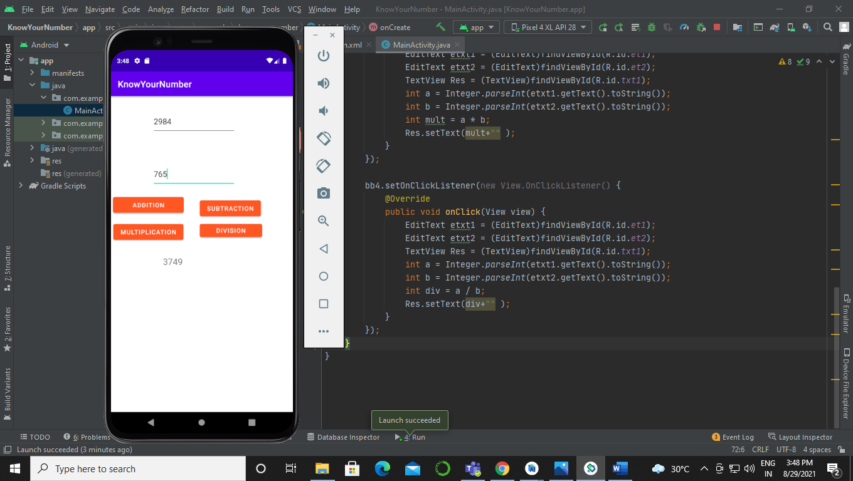

1. Subtraction:-

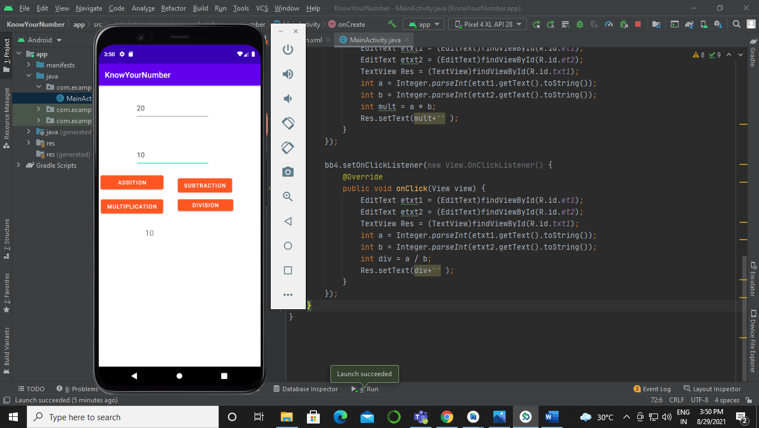

1. Multiplication:-

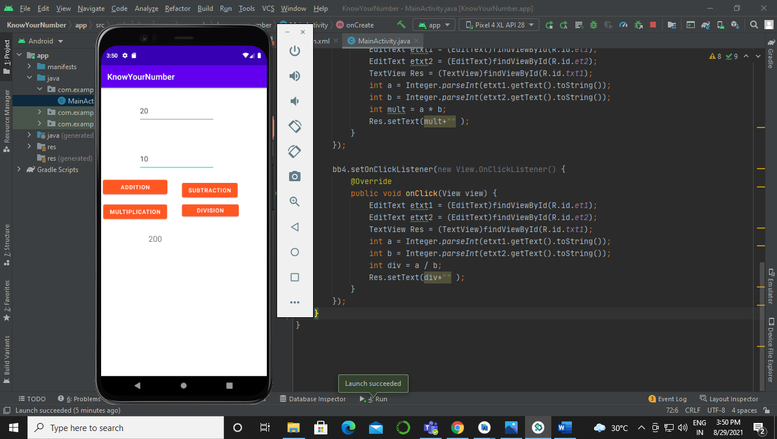

1. Division:-

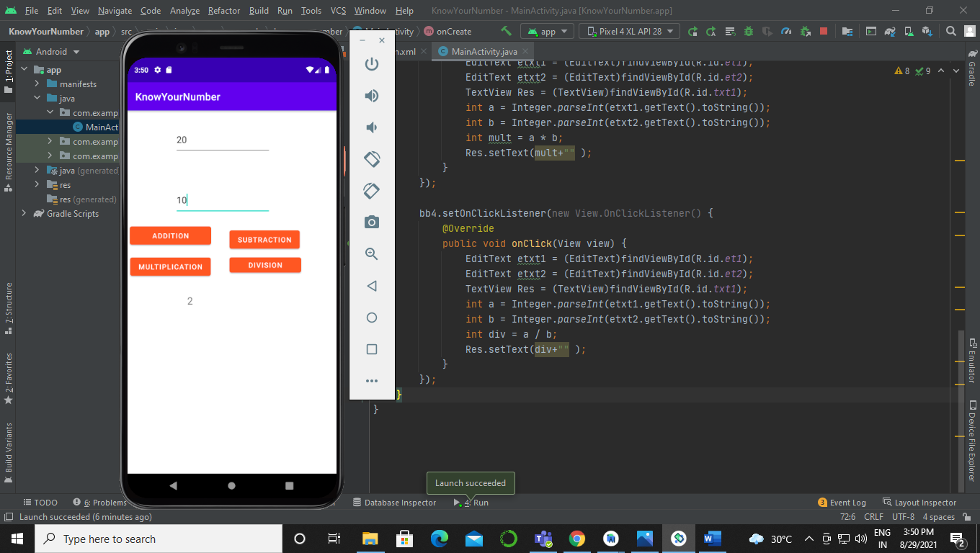

1. Development of an android application “Know your number” which provides an opening screen that introduces the problem and allows the user to provide the number as an input. It should also allow the user to choose among the various options that are (i) Factorial of  the number (ii) Is the number Even/Odd. Depending on the user’s choice the answer is to be displayed. The application should display pleasing styles.

Sol:-

Activity_main.xml:-

<?xml version=”1.0” encoding=”utf-8”?>  
<oolean.constraintlayout.widget.ConstraintLayout xmlns:android=”http://schemas.android.com/apk/res/android”  
 xmlns:app=”http://schemas.android.com/apk/res-auto”  
 xmlns:tools=”http://schemas.android.com/tools”  
 android:layout_width=”match_parent”  
 android:layout_height=”match_parent”  
 tools:context=”.MainActivity”>  
  
 <TextView  
 android:id=”@+id/txt1”  
 android:layout_width=”wrap_content”  
 android:layout_height=”wrap_content”  
 android:text=”Factoiral and Even Odd”  
 app:layout_constraintBottom_toBottomOf=”parent”  
 app:layout_constraintHorizontal_bias=”0.473”  
 app:layout_constraintLeft_toLeftOf=”parent”  
 app:layout_constraintRight_toRightOf=”parent”  
 app:layout_constraintTop_toTopOf=”parent”  
 app:layout_constraintVertical_bias=”0.103” />  
  
 <EditText  
 android:id=”@+id/et1”  
 android:layout_width=”wrap_content”  
 android:layout_height=”wrap_content”  
 android:layout_marginStart=”127dp”  
 android:layout_marginLeft=”127dp”  
 android:layout_marginTop=”130dp”  
 android:layout_marginBottom=”556dp”  
 android:hint=”Enter a Number”  
 app:layout_constraintBottom_toBottomOf=”parent”  
 app:layout_constraintStart_toStartOf=”parent”  
 app:layout_constraintTop_toTopOf=”parent” />  
  
 <Button  
 android:id=”@+id/btn1”  
 android:layout_width=”138dp”  
 android:layout_height=”44dp”  
 android:layout_marginStart=”52dp”  
 android:layout_marginLeft=”52dp”  
 android:layout_marginTop=”209dp”  
 android:layout_marginBottom=”474dp”  
 android:text=”Factorial”  
 app:backgroundTint=”#FF9800”  
 app:layout_constraintBottom_toBottomOf=”parent”  
 app:layout_constraintStart_toStartOf=”parent”  
 app:layout_constraintTop_toTopOf=”parent”  
 app:layout_constraintVertical_bias=”0.25” />  
  
 <Button  
 android:id=”@+id/btn2”  
 android:layout_width=”wrap_content”  
 android:layout_height=”wrap_content”  
 android:layout_marginStart=”213dp”  
 android:layout_marginLeft=”213dp”  
 android:layout_marginTop=”209dp”  
 android:layout_marginBottom=”474dp”  
 android:text=”Even or Odd”  
 app:backgroundTint=”#FF9800”  
 app:layout_constraintBottom_toBottomOf=”parent”  
 app:layout_constraintStart_toStartOf=”parent”  
 app:layout_constraintTop_toTopOf=”parent” />  
  
 <TextView  
 android:id=”@+id/txt2”  
 android:layout_width=”183dp”  
 android:layout_height=”56dp”  
 android:layout_marginStart=”112dp”  
 android:layout_marginLeft=”112dp”  
 android:layout_marginTop=”274dp”  
 android:layout_marginBottom=”406dp”  
 android:hint=”Result:-“  
 app:layout_constraintBottom_toBottomOf=”parent”  
 app:layout_constraintStart_toStartOf=”parent”  
 app:layout_constraintTop_toTopOf=”parent”  
 app:layout_constraintVertical_bias=”0.0” />  
  
</oolean.constraintlayout.widget.ConstraintLayout>

MainActivity.java:-

package com.example.know_your_number;  
  
import oolean.appcompat.app.AppCompatActivity;  
  
import android.os.Bundle;  
import android.view.View;  
import android.widget.Button;  
import android.widget.EditText;  
import android.widget.TextView;  
  
public class MainActivity extends AppCompatActivity {  
  
 @Override  
 protected void onCreate(Bundle savedInstanceState) {  
 super.onCreate(savedInstanceState);  
 setContentView(R.layout.*activity_main*);  
 Button bb1 = (Button)findViewById(R.id.*btn1*);  
 Button bb2 = (Button)findViewById(R.id.*btn2*);  
  
 bb1.setOnClickListener(new View.OnClickListener() {  
 @Override  
 public void onClick(View view) {  
 EditText etxt1 = (EditText)findViewById(R.id.*et1*);  
 TextView res = (TextView)findViewById(R.id.*txt2*);  
 int num = Integer.*parseInt*(etxt1.getText().toString());  
 int i, fact = 1;  
 for(i=1;i<=num;i++){  
 fact = fact * i;  
 }  
 res.setText(“The factorial of “+num+ “ is “ +fact);  
 }  
 });  
  
 bb2.setOnClickListener(new View.OnClickListener() {  
 @Override  
 public void onClick(View view) {  
 EditText etxt1 = (EditText)findViewById(R.id.*et1*);  
 TextView res = (TextView)findViewById(R.id.*txt2*);  
 int num = Integer.*parseInt*(etxt1.getText().toString());  
 if(num%2==0){  
 res.setText(num +” is a even number”);  
 }  
 else{  
 res.setText(num + “ is a odd number”);  
 }  
  
 }  
 });  
 }  
  
  
}

Output:-

Factorial of a number :-

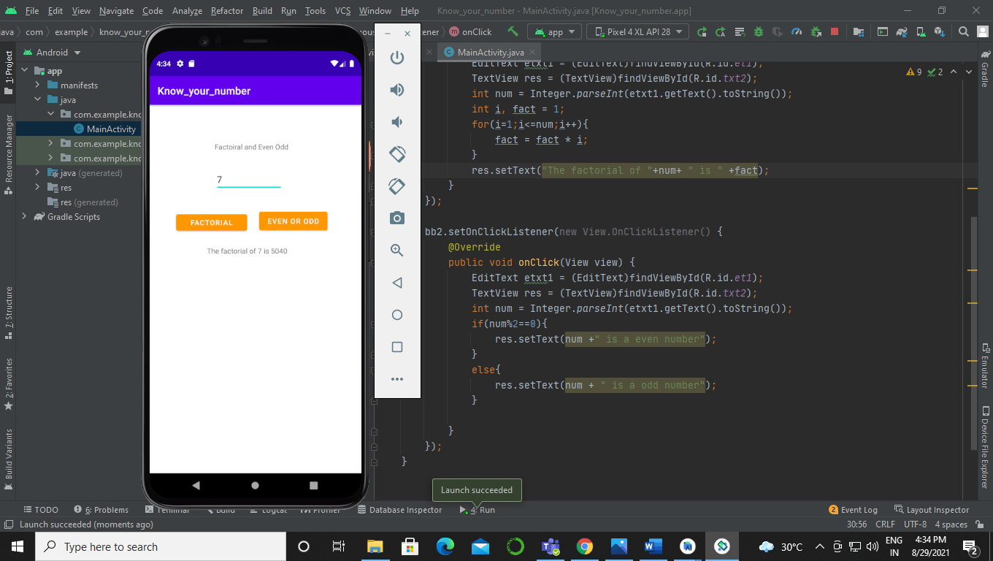

Even odd number:-

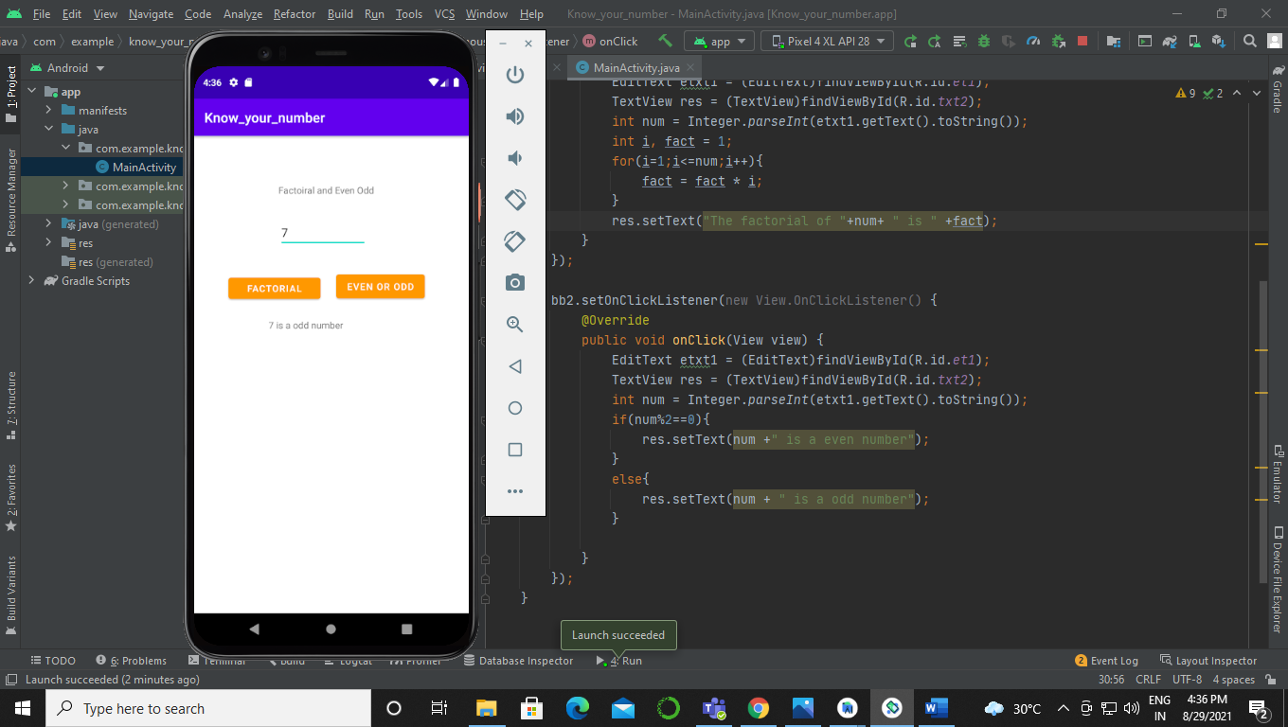

**Experiment 3**

Working with Layouts

1. Develop an android application “Know your string” which provides an opening screen that introduces the problem and allows the user to provide the string as an input. It should also allow the user to

choose among the various string methods for example (i) Length of

the String (ii) Trimming a string (iii) Converting lowercase string to upper case (iv) Converting uppercase string to lower case.

Depending on the user’s choice the answer is to be displayed. The application should follow the following layout style

1. Linear Layout

(ii) Relative Layout

Sol:-

1. Linear Layout:-

Activity_main.xml:-

<?xml version=”1.0” encoding=”utf-8”?>  
<oolean.constraintlayout.widget.ConstraintLayout xmlns:android=”http://schemas.android.com/apk/res/android”  
 xmlns:app=”http://schemas.android.com/apk/res-auto”  
 xmlns:tools=”http://schemas.android.com/tools”  
 android:layout_width=”match_parent”  
 android:layout_height=”match_parent”  
 tools:context=”.MainActivity”>  
  
 <TextView  
 android:id=”@+id/tv1”  
 android:layout_width=”351dp”  
 android:layout_height=”42dp”  
 android:text=”Know your strings”  
 app:layout_constraintBottom_toBottomOf=”parent”  
 app:layout_constraintHorizontal_bias=”0.083”  
 app:layout_constraintLeft_toLeftOf=”parent”  
 app:layout_constraintRight_toRightOf=”parent”  
 app:layout_constraintTop_toTopOf=”parent”  
 app:layout_constraintVertical_bias=”0.053” />  
  
 <LinearLayout  
 android:id=”@+id/ll”  
 android:layout_width=”407dp”  
 android:layout_height=”645dp”  
 android:layout_marginStart=”5dp”  
 android:layout_marginLeft=”5dp”  
 android:layout_marginTop=”79dp”  
 android:layout_marginEnd=”1dp”  
 android:layout_marginRight=”1dp”  
 android:layout_marginBottom=”1dp”  
 android:orientation=”vertical”  
 app:layout_constraintBottom_toBottomOf=”parent”  
 app:layout_constraintEnd_toEndOf=”parent”  
 app:layout_constraintHorizontal_bias=”0.0”  
 app:layout_constraintStart_toStartOf=”parent”  
 app:layout_constraintTop_toTopOf=”parent”  
 app:layout_constraintVertical_bias=”0.0”>  
  
  
 <TextView  
 android:id=”@+id/tv2”  
 android:layout_width=”236dp”  
 android:layout_height=”wrap_content”  
 android:text=”String :-“ />  
  
 <EditText  
 android:id=”@+id/et1”  
 android:layout_width=”match_parent”  
 android:layout_height=”wrap_content”  
 android:hint=”Enter the string” />  
  
 <TextView  
 android:id=”@+id/tv3”  
 android:layout_width=”match_parent”  
 android:layout_height=”wrap_content”  
 android:text=”choose any one option:-“ />  
  
 <Button  
 android:id=”@+id/btn1”  
 android:layout_width=”321dp”  
 android:layout_height=”wrap_content”  
 android:text=”Length of the string”  
 app:backgroundTint=”#F60303” />  
  
 <Button  
 android:id=”@+id/btn2”  
 android:layout_width=”318dp”  
 android:layout_height=”wrap_content”  
 android:text=”Trimming a string”  
 app:backgroundTint=”#FFC107” />  
  
 <Button  
 android:id=”@+id/btn3”  
 android:layout_width=”wrap_content”  
 android:layout_height=”wrap_content”  
 android:text=”Converting string from upper to lower case”  
 app:backgroundTint=”#2196F3” />  
  
 <Button  
 android:id=”@+id/btn4”  
 android:layout_width=”wrap_content”  
 android:layout_height=”wrap_content”  
 android:text=”Converting string from lower to upper case”  
 app:backgroundTint=”#4CAF50” />  
  
 <TextView  
 android:id=”@+id/tv4”  
 android:layout_width=”match_parent”  
 android:layout_height=”38dp” />  
  
  
 </LinearLayout>  
  
  
</oolean.constraintlayout.widget.ConstraintLayout>

MainActivity.java:-

package com.example.androidprograminglab4;  
  
import oolean.appcompat.app.AppCompatActivity;  
  
import android.os.Bundle;  
import android.view.View;  
import android.widget.Button;  
import android.widget.EditText;  
import android.widget.TextView;  
  
import org.w3c.dom.Text;  
  
public class MainActivity extends AppCompatActivity {  
  
 @Override  
 protected void onCreate(Bundle savedInstanceState) {  
 super.onCreate(savedInstanceState);  
 setContentView(R.layout.*activity_main*);  
  
 Button button1 = (Button)findViewById(R.id.*btn1*);  
 Button button2 = (Button)findViewById(R.id.*btn2*);  
 Button button3 = (Button)findViewById(R.id.*btn3*);  
 Button button4 = (Button)findViewById(R.id.*btn4*);  
  
 //For button 1  
 button1.setOnClickListener(new View.OnClickListener() {  
 @Override  
 public void onClick(View view) {  
 EditText ett1 = (EditText)findViewById(R.id.*et1*);  
 TextView tt = (TextView)findViewById(R.id.*tv4*);  
 String s1 = (ett1.getText().toString());  
 tt.setText(“The length of string is :-“ +s1.length());  
  
  
 }  
 });  
 //For button2  
 button2.setOnClickListener(new View.OnClickListener() {  
 @Override  
 public void onClick(View v) {  
 EditText ett1 = (EditText)findViewById(R.id.*et1*);  
 TextView tt = (TextView)findViewById(R.id.*tv4*);  
 String s1 = (ett1.getText().toString());  
 tt.setText(“Trimming of a string is :-“ +s1.trim());  
 }  
 });  
 //for button3  
 button3.setOnClickListener(new View.OnClickListener() {  
 @Override  
 public void onClick(View v) {  
 EditText ett1 = (EditText)findViewById(R.id.*et1*);  
 TextView tt = (TextView)findViewById(R.id.*tv4*);  
 String s1 = (ett1.getText().toString());  
 tt.setText(“Lower case of a string is :-“ +s1.toLowerCase());  
 }  
 });  
 //for button4  
 button4.setOnClickListener(new View.OnClickListener() {  
 @Override  
 public void onClick(View v) {  
 EditText ett1 = (EditText)findViewById(R.id.*et1*);  
 TextView tt = (TextView)findViewById(R.id.*tv4*);  
 String s1 = (ett1.getText().toString());  
 tt.setText(“Upper case of a string is :-“ +s1.toUpperCase());  
 }  
 });  
 }  
}

Output:-

1. Length of the String:-

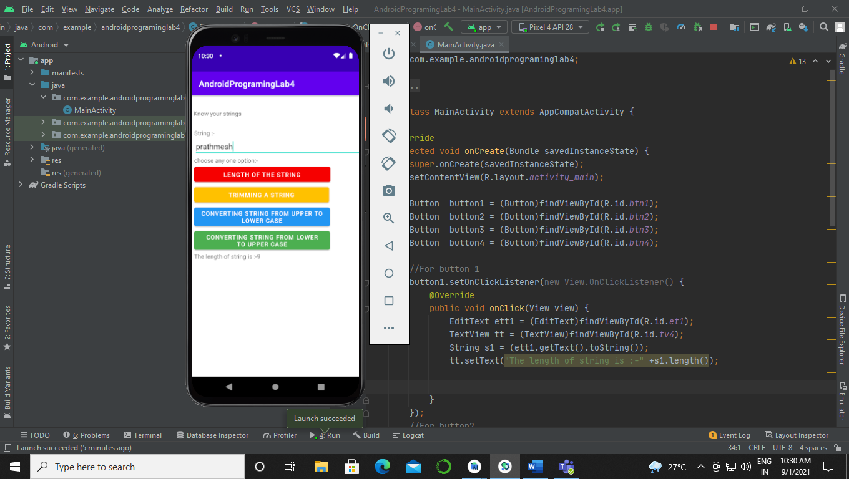

1. Trimming a string:-

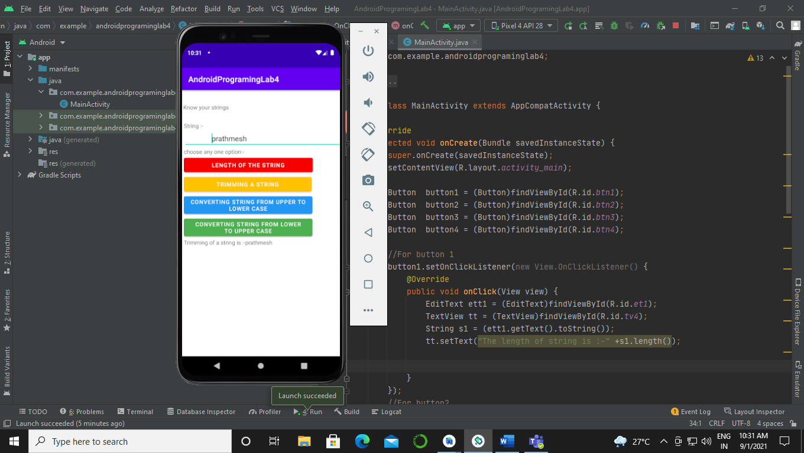

1. Converting lowercase string to upper case:-

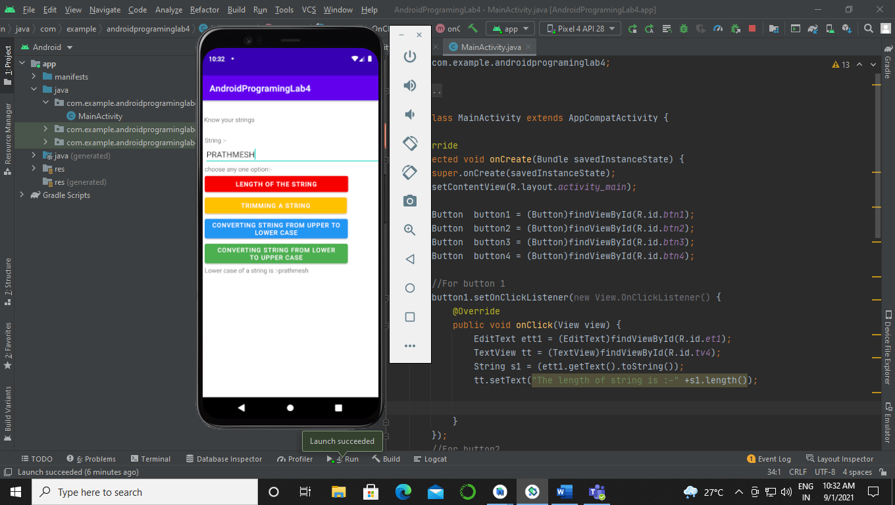

1. Converting uppercase string to lower case:-

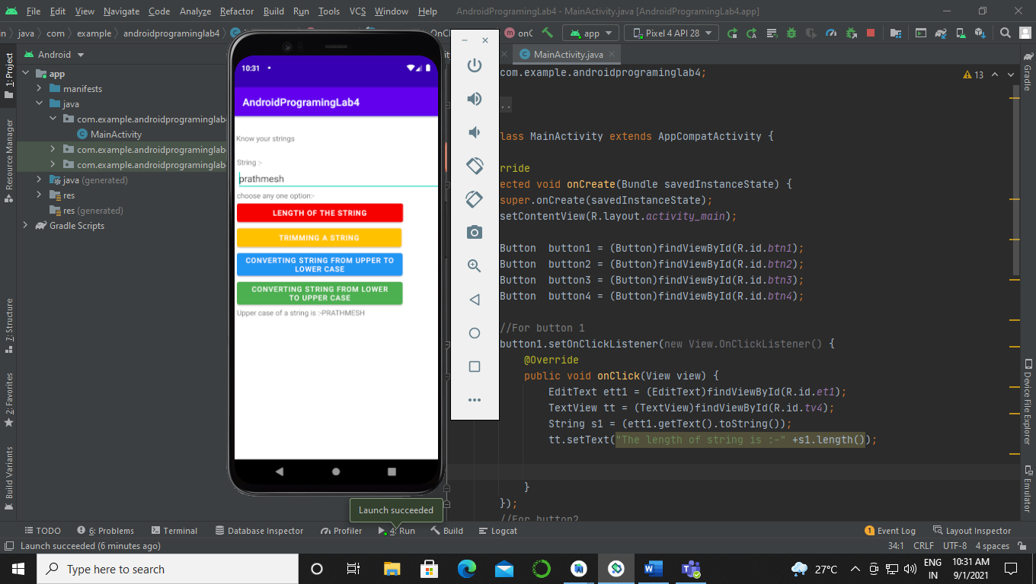

1. Relative Layout:-

Activity_main.xml:-

<?xml version=”1.0” encoding=”utf-8”?>  
<RelativeLayout  
 xmlns:android=”http://schemas.android.com/apk/res/android”  
 xmlns:app=”http://schemas.android.com/apk/res-auto”  
 xmlns:tools=”http://schemas.android.com/tools”  
 android:layout_width=”match_parent”  
 android:layout_height=”match_parent”  
 tools:context=”.MainActivity”>  
  
 <TextView  
 android:id=”@+id/tv2”  
 android:layout_width=”236dp”  
 android:layout_height=”wrap_content”  
 android:text=”Know Your String “  
 android:layout_marginTop=”50dp”  
 android:layout_centerHorizontal=”true”  
 />  
  
 <EditText  
 android:id=”@+id/et1”  
 android:layout_width=”wrap_content”  
 android:layout_height=”wrap_content”  
 android:layout_marginTop=”40dp”  
  
 android:hint=”Enter the string”  
 android:layout_centerHorizontal=”true”  
 android:layout_below=”@id/tv2”  
 />  
  
 <TextView  
 android:id=”@+id/tv3”  
 android:layout_width=”wrap_content”  
 android:layout_height=”wrap_content”  
 android:text=”choose any one option:-“  
 android:layout_marginTop=”50dp”  
 android:layout_centerHorizontal=”true”  
 android:layout_below=”@id/et1”  
 />  
 <RadioGroup  
 android:id=”@+id/rg”  
 android:layout_width=”wrap_content”  
 android:layout_height=”wrap_content”  
 android:layout_marginTop=”50dp”  
 android:layout_centerHorizontal=”true”  
 android:layout_below=”@id/tv3”  
 >  
 <RadioButton  
 android:id=”@+id/rb1”  
 android:layout_width=”wrap_content”  
 android:layout_height=”wrap_content”  
 android:text=”Length of string”  
 />  
 <RadioButton  
 android:id=”@+id/rb2”  
 android:layout_width=”wrap_content”  
 android:layout_height=”wrap_content”  
 android:text=”Trimming of string”  
 />  
 <RadioButton  
 android:id=”@+id/rb3”  
 android:layout_width=”wrap_content”  
 android:layout_height=”wrap_content”  
 android:text=”Upper case of string”  
 />  
 <RadioButton  
 android:id=”@+id/rb4”  
 android:layout_width=”wrap_content”  
 android:layout_height=”wrap_content”  
 android:text=”Lower case of string”  
 />  
 </RadioGroup>  
 <Button  
 android:id=”@+id/btn1”  
 android:layout_width=”wrap_content”  
 android:layout_height=”wrap_content”  
 android:layout_marginTop=”30dp”  
 android:layout_centerHorizontal=”true”  
 android:text=”Submit”  
 android:layout_below=”@id/rg”  
 />  
 <TextView  
 android:id=”@+id/tv4”  
 android:layout_width=”wrap_content”  
 android:layout_height=”wrap_content”  
 android:hint=”Result”  
 android:layout_marginTop=”50dp”  
 android:layout_centerHorizontal=”true”  
 android:layout_below=”@id/btn1”  
 />  
</RelativeLayout>

MainActivity.java:-

package com.example.relativelayout;  
  
import oolean.appcompat.app.AppCompatActivity;  
  
import android.os.Bundle;  
import android.view.View;  
import android.widget.Button;  
import android.widget.EditText;  
import android.widget.RadioButton;  
import android.widget.RadioGroup;  
import android.widget.TextView;  
  
public class MainActivity extends AppCompatActivity {  
  
 @Override  
 protected void onCreate(Bundle savedInstanceState) {  
 super.onCreate(savedInstanceState);  
 setContentView(R.layout.*activity_main*);  
 Button bbt =(Button)findViewById(R.id.*btn1*);  
 bbt.setOnClickListener(new View.OnClickListener() {  
 @Override  
 public void onClick(View v) {  
 EditText e1 = (EditText)findViewById(R.id.*et1*);  
 RadioGroup g1 = (RadioGroup)findViewById(R.id.*rg*);  
 RadioButton r1 = (RadioButton)findViewById(R.id.*rb1*);  
 RadioButton r2 = (RadioButton)findViewById(R.id.*rb2*);  
 RadioButton r3 = (RadioButton)findViewById(R.id.*rb3*);  
 RadioButton r4 = (RadioButton)findViewById(R.id.*rb4*);  
 TextView txt = (TextView)findViewById(R.id.*tv4*);  
 if(r1.isChecked()){  
 String s1 = e1.getText().toString();  
 txt.setText(“The length of the string is :- “+s1.length());  
  
 }  
 else if(r2.isChecked()){  
 String s1 = e1.getText().toString();  
 txt.setText(“The trimming of the string is :- “+s1.trim());  
  
 }  
 else if(r3.isChecked()){  
 String s1 = e1.getText().toString();  
 txt.setText(“The upper case of the string is :- “+s1.toUpperCase());  
  
 }  
 else if(r4.isChecked()){  
 String s1 = e1.getText().toString();  
 txt.setText(“The lower case of the string is :- “+s1.toLowerCase());  
  
 }  
 else{  
 txt.setText(“Nothing is selected”);  
 }  
 }  
 });  
 }  
}

Output:-

1. Length of the String:-

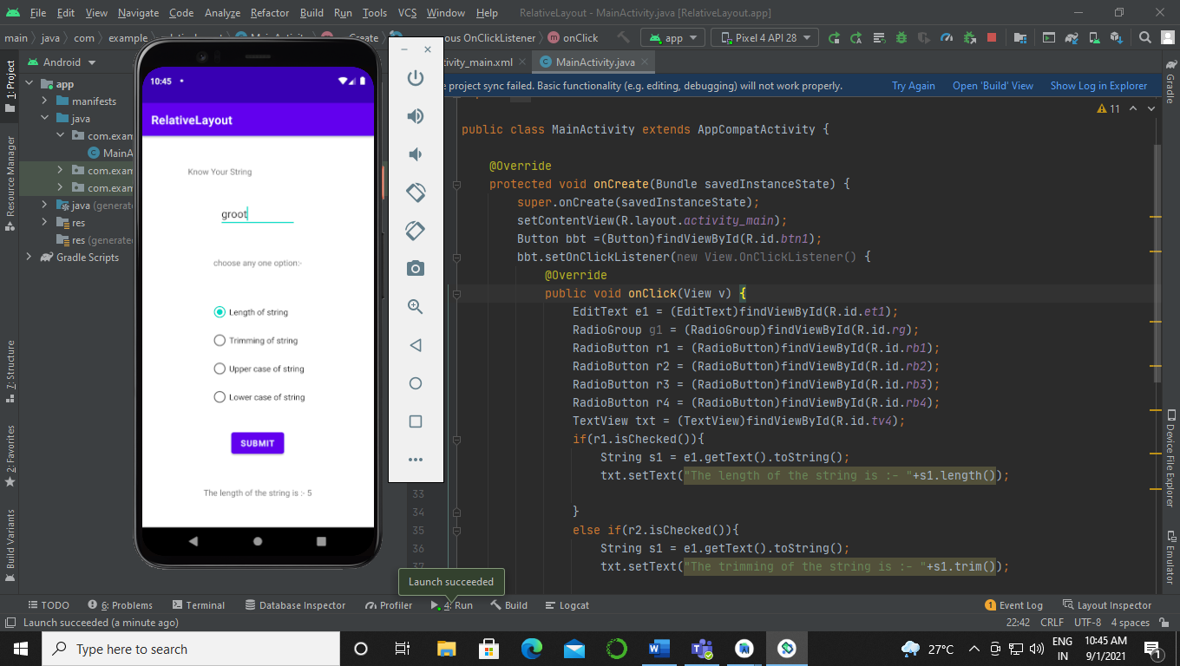

1. Trimming a string:-

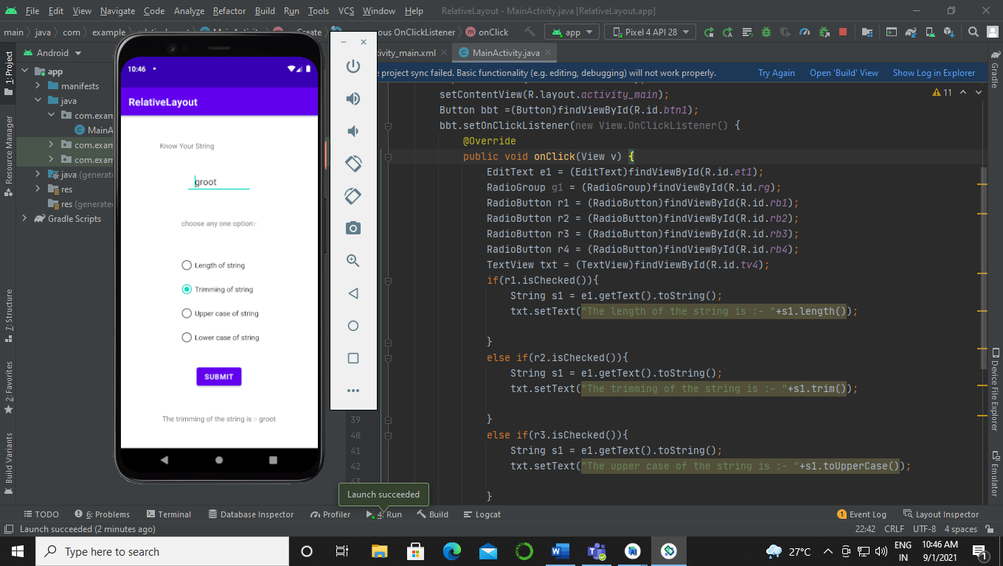

1. Converting lowercase string to upper case:-

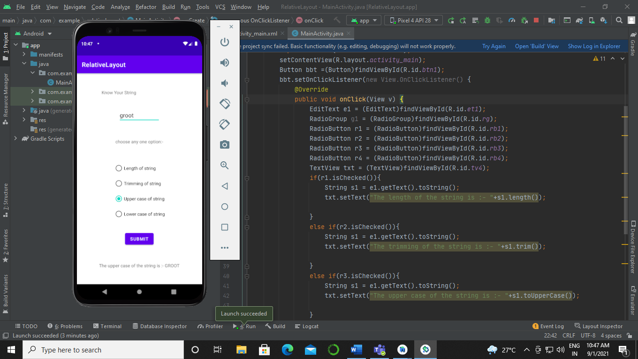

1. Converting uppercase string to lower case:-

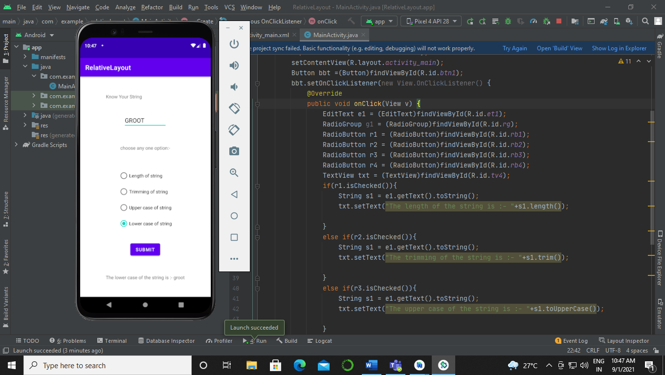

**Experiment 4:-**

Applications using controls –

1. Develop an android application for facilitating communication between activities using Intent. Exhibit the role of Explicit Intent for the same.

Sol:-

Activity_main.xml:-

<?xml version=”1.0” encoding=”utf-8”?>  
<RelativeLayout  
 xmlns:android=”http://schemas.android.com/apk/res/android”  
 xmlns:tools=”http://schemas.android.com/tools”  
 xmlns:app=”http://schemas.android.com/apk/res-auto”  
 android:layout_width=”match_parent”  
 android:layout_height=”match_parent”  
 tools:context=”.MainActivity”>  
  
 <TextView  
 android:id=”@+id/tv1”  
 android:layout_width=”wrap_content”  
 android:layout_height=”wrap_content”  
 android:layout_marginTop=”50dp”  
 android:text=”Explicit Intent”  
 android:layout_centerHorizontal=”true”  
 android:textSize=”20dp”  
 />  
  
 <TextView  
 android:id=”@+id/tv2”  
 android:layout_width=”wrap_content”  
 android:layout_height=”wrap_content”  
 android:layout_marginTop=”50dp”  
 android:text=”Activity 1”  
 android:layout_centerHorizontal=”true”  
 android:textSize=”20dp”  
 android:layout_below=”@+id/tv1”  
 />  
 <EditText  
 android:id=”@+id/et1”  
 android:layout_width=”wrap_content”  
 android:layout_height=”wrap_content”  
 android:layout_marginTop=”50dp”  
 android:hint=”Enter a number”  
 android:layout_below=”@id/tv2”  
 android:layout_centerHorizontal=”true”  
 android:textSize=”20dp”  
 />  
  
 <Button  
 android:id=”@+id/button”  
 android:layout_width=”wrap_content”  
 android:layout_height=”wrap_content”  
 android:layout_below=”@id/et1”  
 android:layout_centerHorizontal=”true”  
 android:layout_marginTop=”35dp”  
 android:text=”Button”  
 app:backgroundTint=”#03A9F4” />  
  
</RelativeLayout>

Activity_2.xml:-

<?xml version=”1.0” encoding=”utf-8”?>  
<RelativeLayout  
 xmlns:android=”http://schemas.android.com/apk/res/android”  
 xmlns:app=”http://schemas.android.com/apk/res-auto”  
 xmlns:tools=”http://schemas.android.com/tools”  
 android:layout_width=”match_parent”  
 android:layout_height=”match_parent”  
 tools:context=”.Activity2”>  
  
 <TextView  
 android:id=”@+id/tv1”  
 android:layout_width=”wrap_content”  
 android:layout_height=”wrap_content”  
 android:layout_marginTop=”50dp”  
 android:text=”Explicit Intent”  
 android:layout_centerHorizontal=”true”  
 android:textSize=”20dp”  
 />  
  
 <TextView  
 android:id=”@+id/tv2”  
 android:layout_width=”wrap_content”  
 android:layout_height=”wrap_content”  
 android:layout_marginTop=”50dp”  
 android:text=”Activity 2”  
 android:layout_centerHorizontal=”true”  
 android:textSize=”20dp”  
 android:layout_below=”@+id/tv1”  
 />  
  
 <TextView  
 android:id=”@+id/tv3”  
 android:layout_width=”wrap_content”  
 android:layout_height=”wrap_content”  
 android:layout_marginTop=”50dp”  
 android:text=”Result”  
 android:layout_centerHorizontal=”true”  
 android:textSize=”20dp”  
 android:layout_below=”@+id/tv2”  
 />  
  
 <Button  
 android:id=”@+id/button”  
 android:layout_width=”wrap_content”  
 android:layout_height=”wrap_content”  
 android:layout_below=”@id/tv3”  
 android:layout_centerHorizontal=”true”  
 android:layout_marginTop=”35dp”  
 android:text=”Activity 3”  
 app:backgroundTint=”#03A9F4” />  
  
  
</RelativeLayout>

Activity_3.xml:-

<?xml version=”1.0” encoding=”utf-8”?>  
<RelativeLayout  
 xmlns:android=”http://schemas.android.com/apk/res/android”  
 xmlns:app=”http://schemas.android.com/apk/res-auto”  
 xmlns:tools=”http://schemas.android.com/tools”  
 android:layout_width=”match_parent”  
 android:layout_height=”match_parent”  
 tools:context=”.Activity3”>  
  
 <TextView  
 android:id=”@+id/tv2”  
 android:layout_width=”236dp”  
 android:layout_height=”wrap_content”  
 android:text=”String :-“  
 android:layout_marginTop=”50dp”  
 android:layout_centerHorizontal=”true”  
 />  
  
 <EditText  
 android:id=”@+id/et1”  
 android:layout_width=”wrap_content”  
 android:layout_height=”wrap_content”  
 android:layout_marginTop=”40dp”  
  
 android:hint=”Enter the string”  
 android:layout_centerHorizontal=”true”  
 android:layout_below=”@id/tv2”  
 />  
  
 <TextView  
 android:id=”@+id/tv3”  
 android:layout_width=”wrap_content”  
 android:layout_height=”wrap_content”  
 android:text=”choose any one option:-“  
 android:layout_marginTop=”50dp”  
 android:layout_centerHorizontal=”true”  
 android:layout_below=”@id/et1”  
 />  
 <RadioGroup  
 android:id=”@+id/rg”  
 android:layout_width=”wrap_content”  
 android:layout_height=”wrap_content”  
 android:layout_marginTop=”50dp”  
 android:layout_centerHorizontal=”true”  
 android:layout_below=”@id/tv3”  
 >  
 <RadioButton  
 android:id=”@+id/rb1”  
 android:layout_width=”wrap_content”  
 android:layout_height=”wrap_content”  
 android:text=”Length of string”  
 />  
 <RadioButton  
 android:id=”@+id/rb2”  
 android:layout_width=”wrap_content”  
 android:layout_height=”wrap_content”  
 android:text=”Trimming of string”  
 />  
 <RadioButton  
 android:id=”@+id/rb3”  
 android:layout_width=”wrap_content”  
 android:layout_height=”wrap_content”  
 android:text=”Upper case of string”  
 />  
 <RadioButton  
 android:id=”@+id/rb4”  
 android:layout_width=”wrap_content”  
 android:layout_height=”wrap_content”  
 android:text=”Lower case of string”  
 />  
 </RadioGroup>  
 <Button  
 android:id=”@+id/btn1”  
 android:layout_width=”wrap_content”  
 android:layout_height=”wrap_content”  
 android:layout_marginTop=”30dp”  
 android:layout_centerHorizontal=”true”  
 android:text=”Submit”  
 android:layout_below=”@id/rg”  
 />  
 <TextView  
 android:id=”@+id/tv4”  
 android:layout_width=”wrap_content”  
 android:layout_height=”wrap_content”  
 android:hint=”Result”  
 android:layout_marginTop=”50dp”  
 android:layout_centerHorizontal=”true”  
 android:layout_below=”@id/btn1”  
 />  
</RelativeLayout>

MainActivity.java:-

package com.example.androidprogramminglab5;  
  
import oolean.appcompat.app.AppCompatActivity;  
  
import android.content.Intent;  
import android.os.Bundle;  
import android.view.View;  
import android.widget.Button;  
import android.widget.EditText;  
  
public class MainActivity extends AppCompatActivity {  
 public static final String *ei*=”intent”;  
  
 @Override  
 protected void onCreate(Bundle savedInstanceState) {  
 super.onCreate(savedInstanceState);  
 setContentView(R.layout.*activity_main*);  
 Button btn1 = (Button)findViewById(R.id.*button*);  
 btn1.setOnClickListener(new View.OnClickListener() {  
 @Override  
 public void onClick(View v) {  
 Intent i = new Intent(MainActivity.this,Activity2.class);  
 EditText txt = (EditText)findViewById(R.id.*et1*);  
 int n = Integer.*parseInt*(txt.getText().toString());  
 i.putExtra(*ei*,n);  
 startActivity(i);  
  
 }  
 });  
 }  
}

activity2.java:-

package com.example.androidprogramminglab5;  
  
import oolean.appcompat.app.AppCompatActivity;  
  
import android.content.Intent;  
import android.os.Bundle;  
import android.view.View;  
import android.widget.Button;  
import android.widget.TextView;  
  
public class Activity2 extends AppCompatActivity {  
 public static final String *em* =”next intent”;  
  
 @Override  
 protected void onCreate(Bundle savedInstanceState) {  
 super.onCreate(savedInstanceState);  
 setContentView(R.layout.*activity_2*);  
 TextView rs = (TextView)findViewById(R.id.*tv3*);  
 Intent i2=getIntent();  
 int ii =i2.getIntExtra(MainActivity.*ei*,0);  
 if(ii%2==0){  
 rs.setText(“Even number”);  
 }  
 else{  
 rs.setText(“Odd number”);  
 }  
  
 Button btc = (Button)findViewById(R.id.*button*);  
 btc.setOnClickListener(new View.OnClickListener() {  
 @Override  
 public void onClick(View v) {  
 Intent i3 = new Intent(Activity2.this,Activity3.class);  
 int n =0;  
 i3.putExtra(*em*, n);  
 startActivity(i3);  
 }  
 });  
  
 }  
}

Activity3.java:-

package com.example.androidprogramminglab5;  
  
import oolean.appcompat.app.AppCompatActivity;  
  
import android.content.Intent;  
import android.os.Bundle;  
import android.view.View;  
import android.widget.Button;  
import android.widget.EditText;  
import android.widget.RadioButton;  
import android.widget.RadioGroup;  
import android.widget.TextView;  
  
public class Activity3 extends AppCompatActivity {  
  
 @Override  
 protected void onCreate(Bundle savedInstanceState) {  
 super.onCreate(savedInstanceState);  
 setContentView(R.layout.*activity_3*);  
 Intent i4 = getIntent();  
 int t = i4.getIntExtra(Activity2.*em*,0);  
 Button bbt =(Button)findViewById(R.id.*btn1*);  
 bbt.setOnClickListener(new View.OnClickListener() {  
 @Override  
 public void onClick(View v) {  
 EditText e1 = (EditText)findViewById(R.id.*et1*);  
 RadioGroup g1 = (RadioGroup)findViewById(R.id.*rg*);  
 RadioButton r1 = (RadioButton)findViewById(R.id.*rb1*);  
 RadioButton r2 = (RadioButton)findViewById(R.id.*rb2*);  
 RadioButton r3 = (RadioButton)findViewById(R.id.*rb3*);  
 RadioButton r4 = (RadioButton)findViewById(R.id.*rb4*);  
 TextView txt = (TextView)findViewById(R.id.*tv4*);  
 if(r1.isChecked()){  
 String s1 = e1.getText().toString();  
 txt.setText(“The length of the string is :- “+s1.length());  
  
 }  
 else if(r2.isChecked()){  
 String s1 = e1.getText().toString();  
 txt.setText(“The trimming of the string is :- “+s1.trim());  
  
 }  
 else if(r3.isChecked()){  
 String s1 = e1.getText().toString();  
 txt.setText(“The upper case of the string is :- “+s1.toUpperCase());  
  
 }  
 else if(r4.isChecked()){  
 String s1 = e1.getText().toString();  
 txt.setText(“The lower case of the string is :- “+s1.toLowerCase());  
  
 }  
 else{  
 txt.setText(“Nothing is selected”);  
 }  
 }  
 });  
 }  
}

Output:-

1. First activity:-

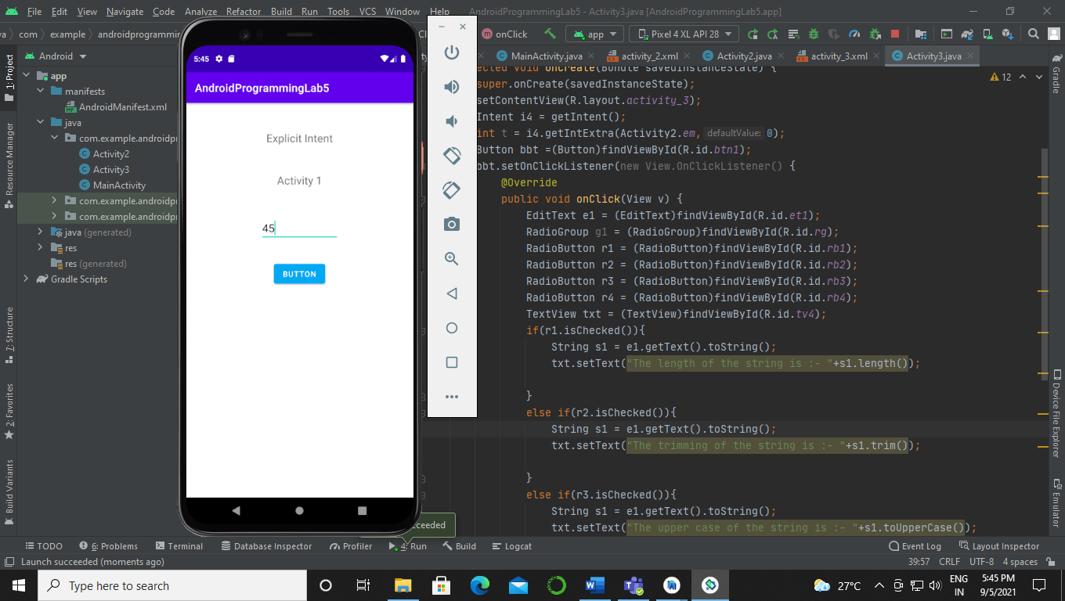

1. Second activity:-

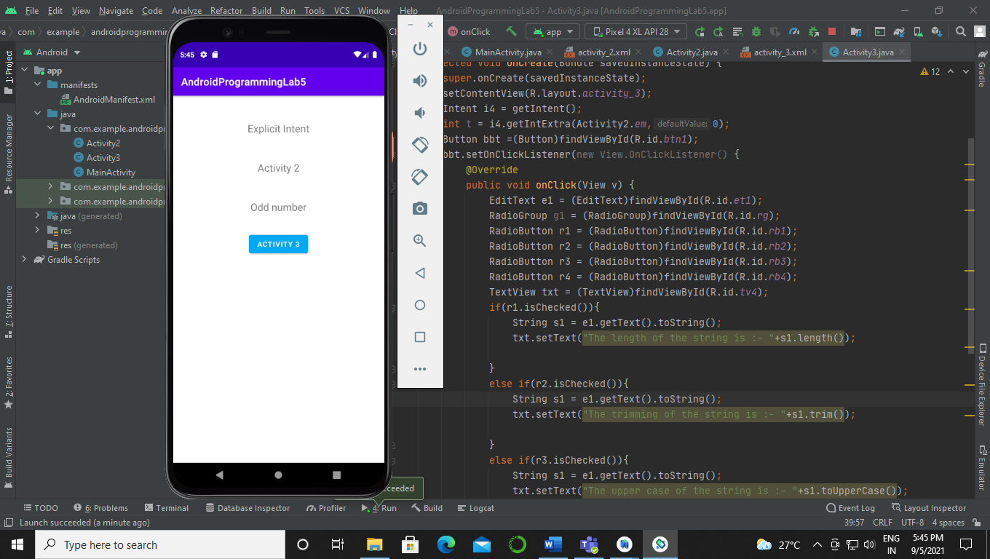

1. Third activity:-

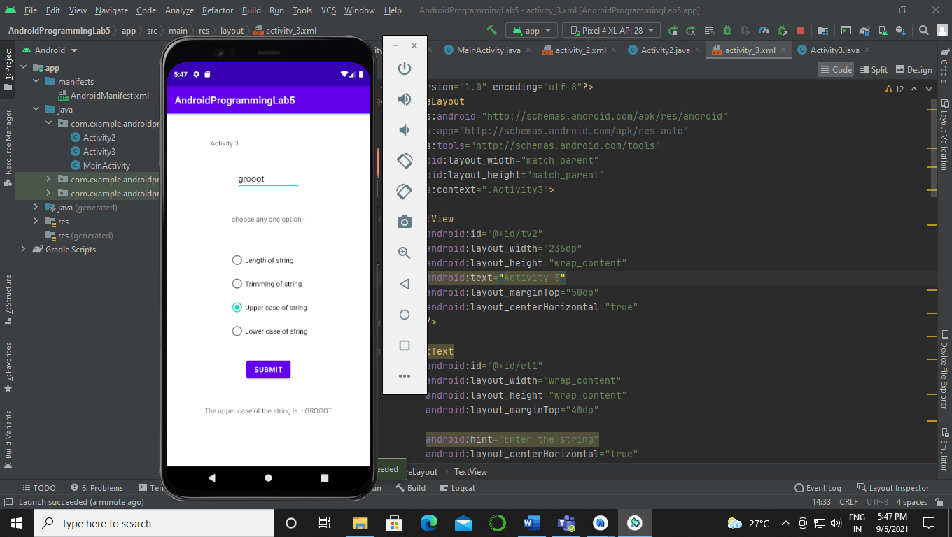

1. Develop an android application to understand passing data through Intent.

Sol:-

activity_main.xml:-

<?xml version=”1.0” encoding=”utf-8”?>  
<RelativeLayout  
 xmlns:android=”http://schemas.android.com/apk/res/android”  
 xmlns:app=”http://schemas.android.com/apk/res-auto”  
 xmlns:tools=”http://schemas.android.com/tools”  
 android:layout_width=”match_parent”  
 android:layout_height=”match_parent”  
 tools:context=”.MainActivity”>  
  
 <TextView  
 android:layout_width=”wrap_content”  
 android:layout_height=”wrap_content”  
 android:text=”Activity 1”  
 android:layout_marginTop=”50dp”  
 android:layout_centerHorizontal=”true”  
 android:id=”@+id/tv1”  
 />  
  
 <Button  
 android:layout_width=”wrap_content”  
 android:layout_height=”wrap_content”  
 android:text=”Go to Activity 2”  
 android:id=”@+id/btn1”  
 android:layout_marginTop=”50dp”  
 android:layout_centerHorizontal=”true”  
 android:layout_below=”@id/tv1”/>  
  
  
</RelativeLayout>

Activity2.xml:-

<?xml version=”1.0” encoding=”utf-8”?>  
<RelativeLayout  
 xmlns:android=”http://schemas.android.com/apk/res/android”  
 xmlns:app=”http://schemas.android.com/apk/res-auto”  
 xmlns:tools=”http://schemas.android.com/tools”  
 android:layout_width=”match_parent”  
 android:layout_height=”match_parent”  
 tools:context=”.Activity2”>  
  
 <TextView  
 android:layout_width=”wrap_content”  
 android:layout_height=”wrap_content”  
 android:text=”Activity 1”  
 android:layout_marginTop=”50dp”  
 android:layout_centerHorizontal=”true”  
 android:id=”@+id/tvt1”  
 />  
 <EditText  
 android:layout_width=”wrap_content”  
 android:layout_height=”wrap_content”  
 android:layout_marginTop=”50dp”  
 android:layout_centerHorizontal=”true”  
 android:layout_below=”@id/tvt1”  
 android:id=”@+id/et1”/>  
  
  
 <Button  
 android:layout_width=”wrap_content”  
 android:layout_height=”wrap_content”  
 android:text=”Return to activity 1”  
 android:id=”@+id/butn1”  
 android:layout_marginTop=”50dp”  
 android:layout_centerHorizontal=”true”  
 android:layout_below=”@id/et1”/>  
  
</RelativeLayout>

MainActivity.java:-

package com.example.androidlablec;  
  
import oolean.appcompat.app.AppCompatActivity;  
  
import android.content.Intent;  
import android.os.Bundle;  
import android.view.View;  
import android.widget.Button;  
import android.widget.Toast;  
  
public class MainActivity extends AppCompatActivity {  
 private static final int *REQUEST_CODE_1*= 1;  
 int requestValue = 1;  
 @Override  
 protected void onCreate(Bundle savedInstanceState) {  
 super.onCreate(savedInstanceState);  
 setContentView(R.layout.*activity_main*);  
 Button bb1 = (Button)findViewById(R.id.*btn1*);  
 bb1.setOnClickListener(new View.OnClickListener() {  
 @Override  
 public void onClick(View view) {  
 Intent i = new Intent(MainActivity.this,Activity2.class);  
 startActivityForResult(i,*REQUEST_CODE_1*);  
   
  
 }  
 });  
  
 }  
 @Override  
 protected void onActivityResult(int requestCode, int resultCode, Intent data )  
 {  
 super.onActivityResult(requestCode,resultCode,data);  
 if(requestCode == requestValue){  
 if(resultCode == *RESULT_OK*){  
 Toast.*makeText*(this,data.getData().toString(), Toast.*LENGTH_SHORT*).show();  
 }  
 }  
 }  
  
}

Activity2.java:-

package com.example.androidlablec;  
  
import oolean.appcompat.app.AppCompatActivity;  
  
import android.content.Intent;  
import android.net.Uri;  
import android.os.Bundle;  
import android.view.View;  
import android.widget.Button;  
import android.widget.EditText;  
import android.widget.Toast;  
  
public class Activity2 extends AppCompatActivity {  
  
 @Override  
 protected void onCreate(Bundle savedInstanceState) {  
 super.onCreate(savedInstanceState);  
 setContentView(R.layout.*activity_2*);  
 Button bb2 = (Button)findViewById(R.id.*butn1*);  
 bb2.setOnClickListener(new View.OnClickListener() {  
 @Override  
 public void onClick(View view) {  
 Intent data = new Intent();  
 EditText etv1 = (EditText)findViewById(R.id.*et1*);  
 data.setData(Uri.*parse*(etv1.getText().toString()));  
 setResult(*RESULT_OK*, data);  
 finish();  
 }  
 });  
  
 }  
}

Output:-

1. First activity:-

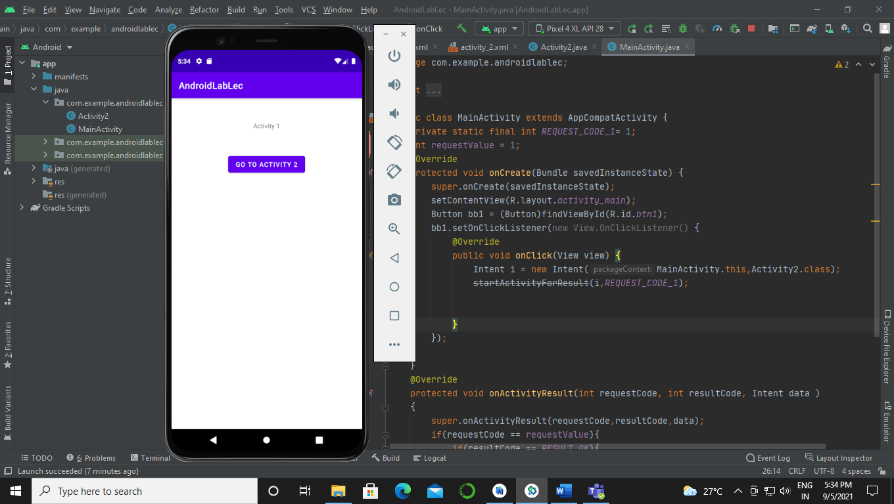

1. Second activity:-

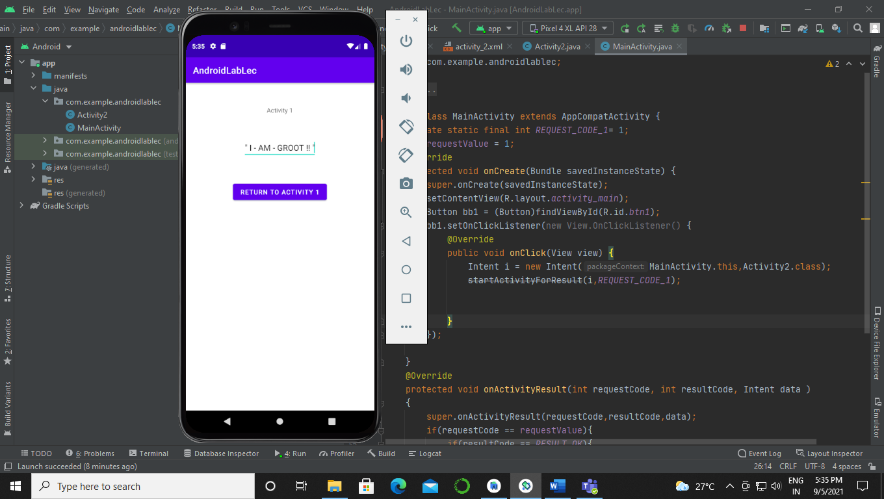

* Returning data to first activity:-

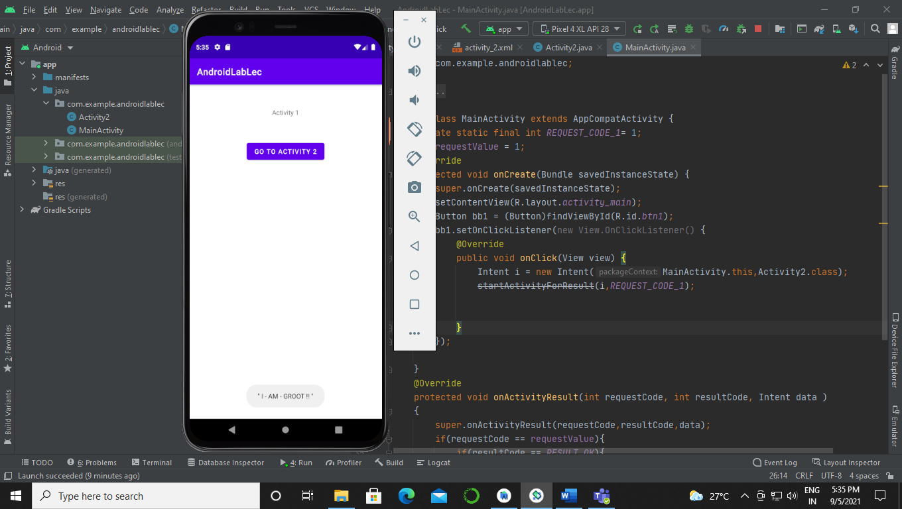

**Experiment 5:-**

1. Develop an android application to invoke built in application like browser, google map and call dialer.

Sol:-

Activity_main.xml:-

<?xml version=”1.0” encoding=”utf-8”?>  
<RelativeLayout  
 xmlns:android=”http://schemas.android.com/apk/res/android”  
 xmlns:app=”http://schemas.android.com/apk/res-auto”  
 xmlns:tools=”http://schemas.android.com/tools”  
 android:layout_width=”match_parent”  
 android:layout_height=”match_parent”  
 tools:context=”.MainActivity”>  
  
 <TextView  
 android:id=”@+id/txt1”  
 android:layout_width=”wrap_content”  
 android:layout_height=”wrap_content”  
 android:layout_centerHorizontal=”true”  
 android:layout_marginTop=”30dp”  
 android:fontFamily=”monospace”  
 android:text=”GGS” />  
  
 <Button  
 android:id=”@+id/btn1”  
 android:layout_width=”wrap_content”  
 android:layout_height=”wrap_content”  
 android:layout_below=”@+id/txt1”  
 android:layout_centerHorizontal=”true”  
 android:layout_marginTop=”20dp”  
 android:fontFamily=”monospace”  
 android:text=”Call”  
 android:textColor=”@color/black”  
 app:backgroundTint=”#009688” />  
  
 <Button  
 android:id=”@+id/btn2”  
 android:layout_width=”wrap_content”  
 android:layout_height=”wrap_content”  
 android:layout_below=”@+id/btn1”  
 android:layout_centerHorizontal=”true”  
 android:layout_marginTop=”10dp”  
 android:fontFamily=”monospace”  
 android:text=”Web Browser”  
 android:textColor=”@color/black”  
 app:backgroundTint=”#4CAF50” />  
  
 <Button  
 android:id=”@+id/btn3”  
 android:layout_width=”wrap_content”  
 android:layout_height=”wrap_content”  
 android:layout_below=”@+id/btn2”  
 android:layout_centerHorizontal=”true”  
 android:layout_marginTop=”10dp”  
 android:fontFamily=”monospace”  
 android:text=”Location Specific”  
 android:textColor=”@color/black”  
 app:backgroundTint=”#FF9800” />  
  
</RelativeLayout>

MainActivity.java:-

package com.example.androidprograminglab6;  
  
import oolean.appcompat.app.AppCompatActivity;  
  
import android.content.Intent;  
import android.net.Uri;  
import android.os.Bundle;  
import android.view.View;  
import android.widget.Button;  
  
public class MainActivity extends AppCompatActivity {  
  
 @Override  
 protected void onCreate(Bundle savedInstanceState) {  
 super.onCreate(savedInstanceState);  
 setContentView(R.layout.*activity_main*);  
 Button bbn1 = (Button)findViewById(R.id.*btn1*);  
 Button bbn2 = (Button)findViewById(R.id.*btn2*);  
 Button bbn3 = (Button)findViewById(R.id.*btn3*);  
 bbn1.setOnClickListener(new View.OnClickListener() {  
 @Override  
 public void onClick(View v) {  
 Intent i = new Intent(Intent.*ACTION_DIAL*, Uri.*parse*(“tel: +917208155391”));  
 startActivity(i);  
 }  
 });  
  
 bbn2.setOnClickListener(new View.OnClickListener() {  
 @Override  
 public void onClick(View v) {  
 Intent i = new Intent(Intent.*ACTION_VIEW*, Uri.*parse*(“https://www.youtube.com/”));  
 startActivity(i);  
 }  
 });  
 bbn3.setOnClickListener(new View.OnClickListener() {  
 @Override  
 public void onClick(View v) {  
 Intent i = new Intent(Intent.*ACTION_VIEW*, Uri.*parse*(“geo:32.23543.-143.5468”));  
 startActivity(i);  
 }  
 });  
 }  
}

Output:-

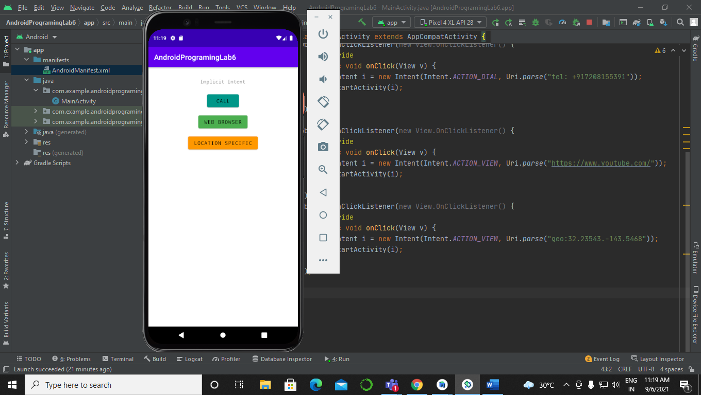

1. Call Dialer:-

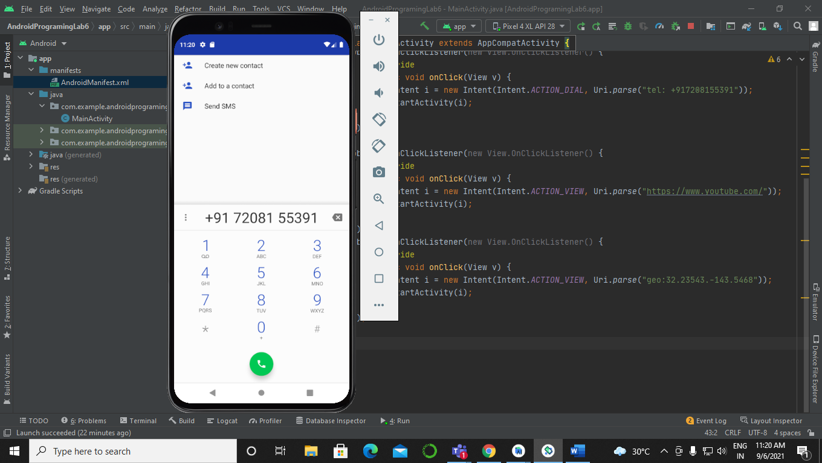

1. Web Browser:-

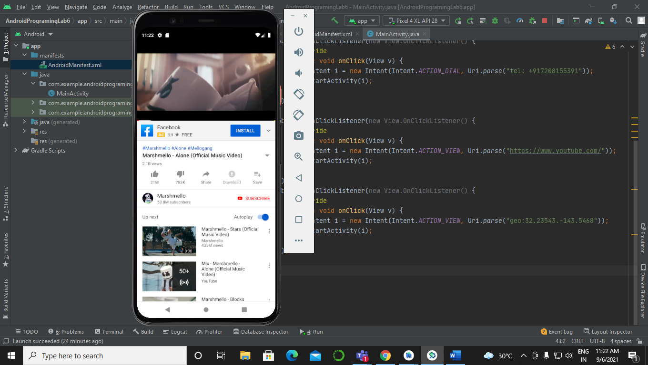

1. Location Specifier:-

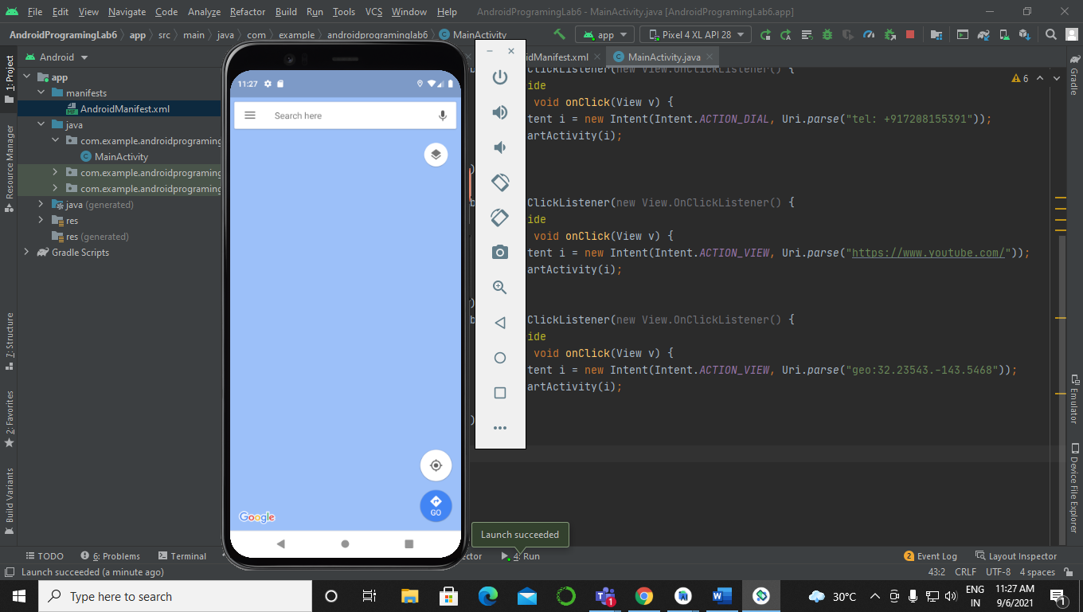

1. Development of an android application for integrating a website inside the application using WebView

activity_main.xml:-

<?xml version=”1.0” encoding=”utf-8”?>  
<RelativeLayout  
 xmlns:android=”http://schemas.android.com/apk/res/android”  
 xmlns:app=”http://schemas.android.com/apk/res-auto”  
 xmlns:tools=”http://schemas.android.com/tools”  
 android:layout_width=”match_parent”  
 android:layout_height=”match_parent”  
 tools:context=”.MainActivity”>  
  
 <TextView  
 android:layout_width=”wrap_content”  
 android:layout_height=”wrap_content”  
 android:text=”Hello World!”  
 android:id=”@+id/tv1”  
 android:layout_marginTop=”20dp”  
 android:layout_centerHorizontal=”true”/>  
  
 <Button  
 android:id=”@+id/btn1”  
 android:layout_width=”wrap_content”  
 android:layout_height=”wrap_content”  
 android:layout_below=”@id/tv1”  
 android:layout_centerHorizontal=”true”  
 android:layout_marginTop=”10dp”  
 android:text=”First webpage”  
 android:textColor=”@color/black”  
 android:textStyle=”bold”  
 app:backgroundTint=”#03A9F4” />  
 <Button  
 android:id=”@+id/btn2”  
 android:layout_width=”wrap_content”  
 android:layout_height=”wrap_content”  
 android:layout_below=”@id/btn1”  
 android:layout_centerHorizontal=”true”  
 android:layout_marginTop=”10dp”  
 android:text=”Second Webpage”  
 android:textColor=”@color/black”  
 android:textStyle=”bold”  
 app:backgroundTint=”#03A9F4” />  
  
 <WebView  
 android:layout_width=”wrap_content”  
 android:layout_height=”wrap_content”  
 android:id=”@+id/wv1”  
 android:layout_below=”@id/btn1”  
 android:layout_marginTop=”40dp”  
 android:layout_centerHorizontal=”true”  
 />  
  
</RelativeLayout>

MainActivity.java:-

package com.example.androidprograminglab6webview;  
  
import oolean.appcompat.app.AppCompatActivity;  
  
import android.os.Bundle;  
import android.view.View;  
import android.webkit.WebView;  
import android.widget.Button;  
  
public class MainActivity extends AppCompatActivity {  
  
 @Override  
 protected void onCreate(Bundle savedInstanceState) {  
 super.onCreate(savedInstanceState);  
 setContentView(R.layout.*activity_main*);  
 Button bn1 = (Button)findViewById(R.id.*btn1*);  
 Button bn2 = (Button)findViewById(R.id.*btn2*);  
 WebView mywv = (WebView)findViewById(R.id.*wv1*);  
 bn1.setOnClickListener(new View.OnClickListener() {  
 @Override  
 public void onClick(View v) {  
 mywv.loadUrl(“https://s.amizone.net/”);  
 }  
 });  
 bn2.setOnClickListener(new View.OnClickListener() {  
 @Override  
 public void onClick(View v) {  
 mywv.loadUrl(“https://www.google.com/”);  
 }  
 });  
  
 }  
}

Output:-

First webpage:-

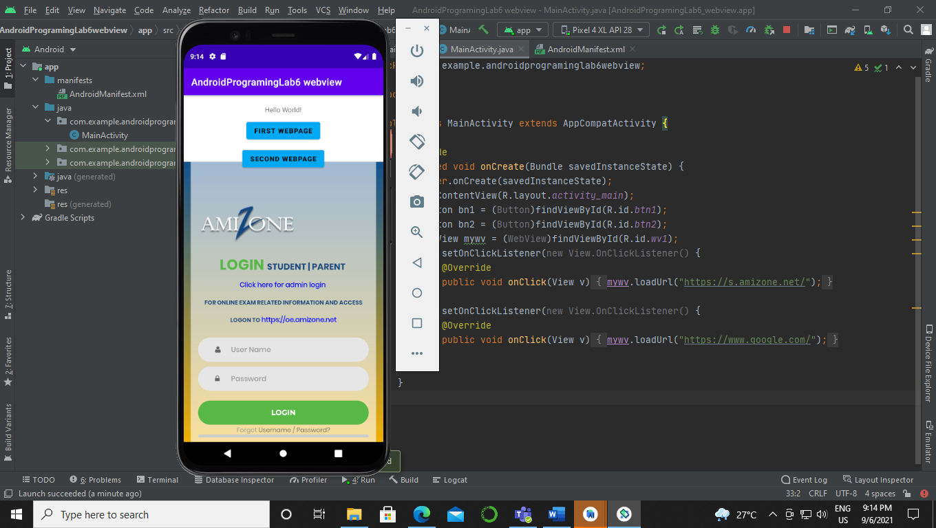

Second webpage:-

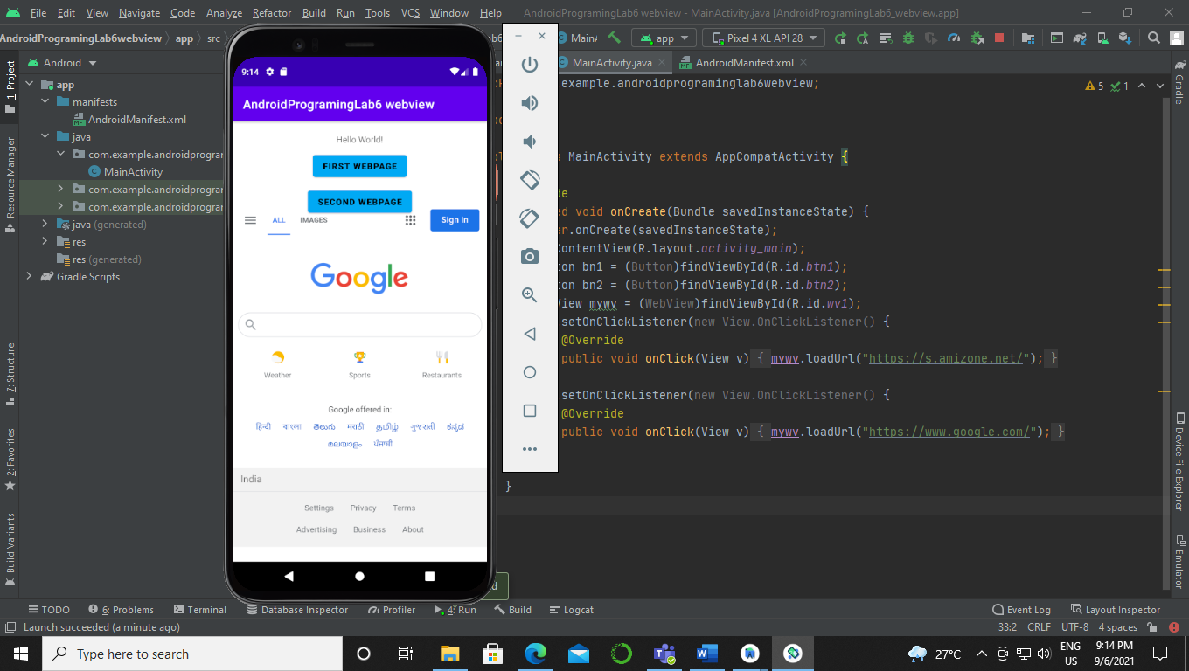

**Experiment 6:-**

Creation of List View

1. Develop an android application for creating a simple list view using Array Adapters

Code:-

Activity_main.xml:-

<?xml version=”1.0” encoding=”utf-8”?>  
<RelativeLayout  
 xmlns:android=”http://schemas.android.com/apk/res/android”  
 xmlns:app=”http://schemas.android.com/apk/res-auto”  
 xmlns:tools=”http://schemas.android.com/tools”  
 android:layout_width=”match_parent”  
 android:layout_height=”match_parent”  
 tools:context=”.MainActivity”>  
  
 <ListView  
 android:layout_width=”wrap_content”  
 android:layout_height=”wrap_content”  
 android:id=”@+id/lv1”  
 />  
  
 <Button  
 android:id=”@+id/btn1”  
 android:layout_width=”wrap_content”  
 android:layout_height=”wrap_content”  
 android:layout_below=”@+id/lv1”  
 android:layout_centerHorizontal=”true”  
 android:layout_marginTop=”20dp”  
 android:text=”View webpage”  
 android:fontFamily=”monospace”  
 android:textColor=”@color/black”  
 app:backgroundTint=”#FF5722” />  
 <WebView  
 android:layout_width=”wrap_content”  
 android:layout_height=”wrap_content”  
 android:id=”@+id/wv1”  
 android:layout_marginTop=”10dp”  
 android:layout_below=”@id/btn1”  
 />  
  
</RelativeLayout>

MainActivity.java:-

package com.example.androidlab7;  
  
import oolean.appcompat.app.AppCompatActivity;  
  
import android.os.Bundle;  
import android.view.View;  
import android.webkit.WebView;  
import android.widget.ArrayAdapter;  
import android.widget.Button;  
import android.widget.ListView;  
  
public class MainActivity extends AppCompatActivity {  
 String namesoflanguages [] = {“Python”,”DBMS”,”C”,”C++”,”Java”,”ASP.NET”,”BlockChain”,”UI/UX”,”Unix”};  
 @Override  
 protected void onCreate(Bundle savedInstanceState) {  
 super.onCreate(savedInstanceState);  
 setContentView(R.layout.*activity_main*);  
 ListView lv = (ListView)findViewById(R.id.*lv1*);  
 ArrayAdapter<String> adp =new ArrayAdapter<String >(this,R.layout.*activity_main2*,R.id.*tva1*,namesoflanguages);  
 lv.setAdapter(adp);  
 Button btn = (Button)findViewById(R.id.*btn1*);  
 btn.setOnClickListener(new View.OnClickListener() {  
 @Override  
 public void onClick(View v) {  
 WebView wv1 = (WebView)findViewById(R.id.*wv1*);  
 wv1.loadUrl(“https://www.google.com/”);  
 }  
 });  
 }  
}

Activity_main2.xml:-

<?xml version=”1.0” encoding=”utf-8”?>  
<RelativeLayout  
 xmlns:android=”http://schemas.android.com/apk/res/android”  
 xmlns:app=”http://schemas.android.com/apk/res-auto”  
 xmlns:tools=”http://schemas.android.com/tools”  
 android:layout_width=”match_parent”  
 android:layout_height=”match_parent”  
 tools:context=”.MainActivity2”>  
 <TextView  
 android:layout_width=”wrap_content”  
 android:layout_height=”wrap_content”  
 android:id=”@+id/tva1”  
 android:layout_centerHorizontal=”true”  
 android:layout_marginTop=”10dp”  
  
  
 />  
  
</RelativeLayout>

MainActivity2.java:-

package com.example.androidlab7;  
  
import oolean.appcompat.app.AppCompatActivity;  
  
import android.os.Bundle;  
  
public class MainActivity2 extends AppCompatActivity {  
  
 @Override  
 protected void onCreate(Bundle savedInstanceState) {  
 super.onCreate(savedInstanceState);  
 setContentView(R.layout.*activity_main2*);  
 }  
}

AndroidManifest.xml:-

<?xml version=”1.0” encoding=”utf-8”?>  
<manifest xmlns:android=”http://schemas.android.com/apk/res/android”  
 package=”com.example.androidlab7”>  
<uses-permission android:name=”android.permission.INTERNET”></uses-permission>  
 <application  
 android:allowBackup=”true”  
 android:icon=”@mipmap/ic_launcher”  
 android:label=”@string/app_name”  
 android:roundIcon=”@mipmap/ic_launcher_round”  
 android:supportsRtl=”true”  
 android:theme=”@style/Theme.AndroidLab7”>  
 <activity android:name=”.MainActivity2”></activity>  
 <activity android:name=”.MainActivity”>  
 <intent-filter>  
 <action android:name=”android.intent.action.MAIN” />  
  
 <category android:name=”android.intent.category.LAUNCHER” />  
 </intent-filter>  
 </activity>  
 </application>  
  
</manifest>

Output:-

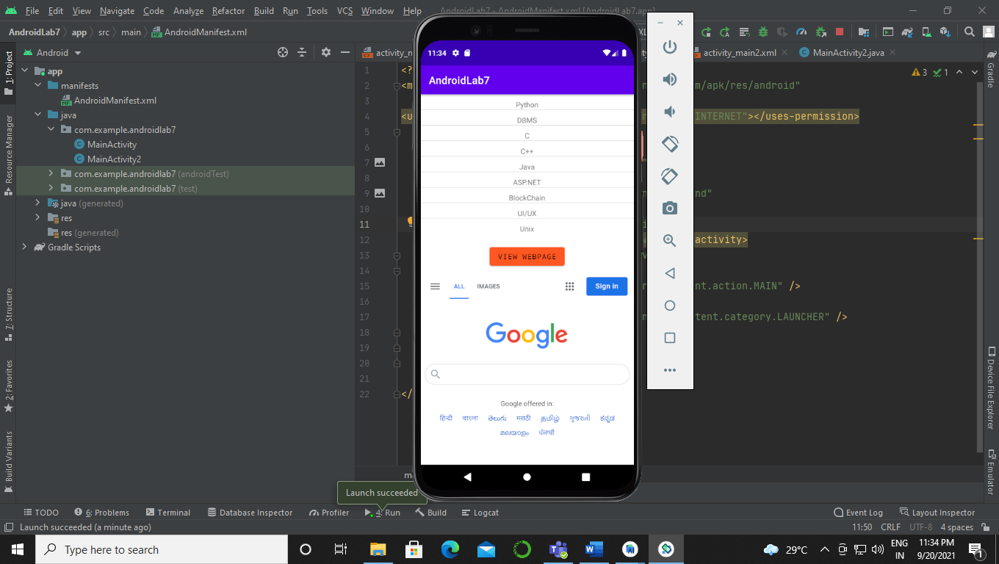

1. Develop an android application for creating a listview with a text and its corresponding Image using Simple Adapters

Code:-

Activity_main.xml:-

<?xml version=”1.0” encoding=”utf-8”?>  
<RelativeLayout  
 xmlns:android=”http://schemas.android.com/apk/res/android”  
 xmlns:app=”http://schemas.android.com/apk/res-auto”  
 xmlns:tools=”http://schemas.android.com/tools”  
 android:layout_width=”match_parent”  
 android:layout_height=”match_parent”  
 tools:context=”.MainActivity”>  
  
 <TextView  
 android:layout_width=”wrap_content”  
 android:layout_height=”wrap_content”  
 android:id=”@+id/tv1”  
 />  
  
 <ListView  
 android:layout_width=”wrap_content”  
 android:layout_height=”wrap_content”  
 android:id=”@+id/lv1”  
/>  
</RelativeLayout>

Trial.xml:-

<?xml version=”1.0” encoding=”utf-8”?>  
<RelativeLayout  
 xmlns:android=”http://schemas.android.com/apk/res/android”  
 android:layout_width=”match_parent”  
 android:layout_height=”match_parent”>  
  
 <ImageView  
 android:layout_width=”150dp”  
 android:layout_height=”150dp”  
 android:id=”@+id/iv”  
 />  
 <TextView  
 android:layout_width=”wrap_content”  
 android:layout_height=”wrap_content”  
 android:id=”@+id/tv2”  
 android:layout_toRightOf=”@id/iv”  
 />  
  
</RelativeLayout>

MainActivity.java:-

package com.example.androidlab13sept;  
  
import oolean.appcompat.app.AppCompatActivity;  
  
import android.os.Bundle;  
import android.widget.ListView;  
import android.widget.SimpleAdapter;  
  
import java.util.ArrayList;  
import java.util.HashMap;  
import java.util.List;  
  
public class MainActivity extends AppCompatActivity {  
String [] pic = {“Pandaa”,”Lightning”,”BGMI”};  
int [] picimg = {R.drawable.*pandaa*,R.drawable.*lightning*,R.drawable.*bgmi*};  
 @Override  
 protected void onCreate(Bundle savedInstanceState) {  
 super.onCreate(savedInstanceState);  
 setContentView(R.layout.*activity_main*);  
 ListView lv = (ListView)findViewById(R.id.*lv1*);  
 List<HashMap<String,String>>li = new ArrayList<>();  
  
 for(int i=0; i<pic.length; i++)  
 {  
 HashMap<String,String> hm = new HashMap<>();  
 hm.put(“name”,pic[i]+””);  
 hm.put(“pictures”,picimg[i]+””);  
 li.add(hm);  
 }  
 String[] from = {“name”,”pictures”};  
 int[] to ={R.id.*tv2*,R.id.*iv*};  
  
 SimpleAdapter sa = new SimpleAdapter(this,li,R.layout.*trial*,from,to);  
 lv.setAdapter(sa);  
  
  
 }  
}

Output:-

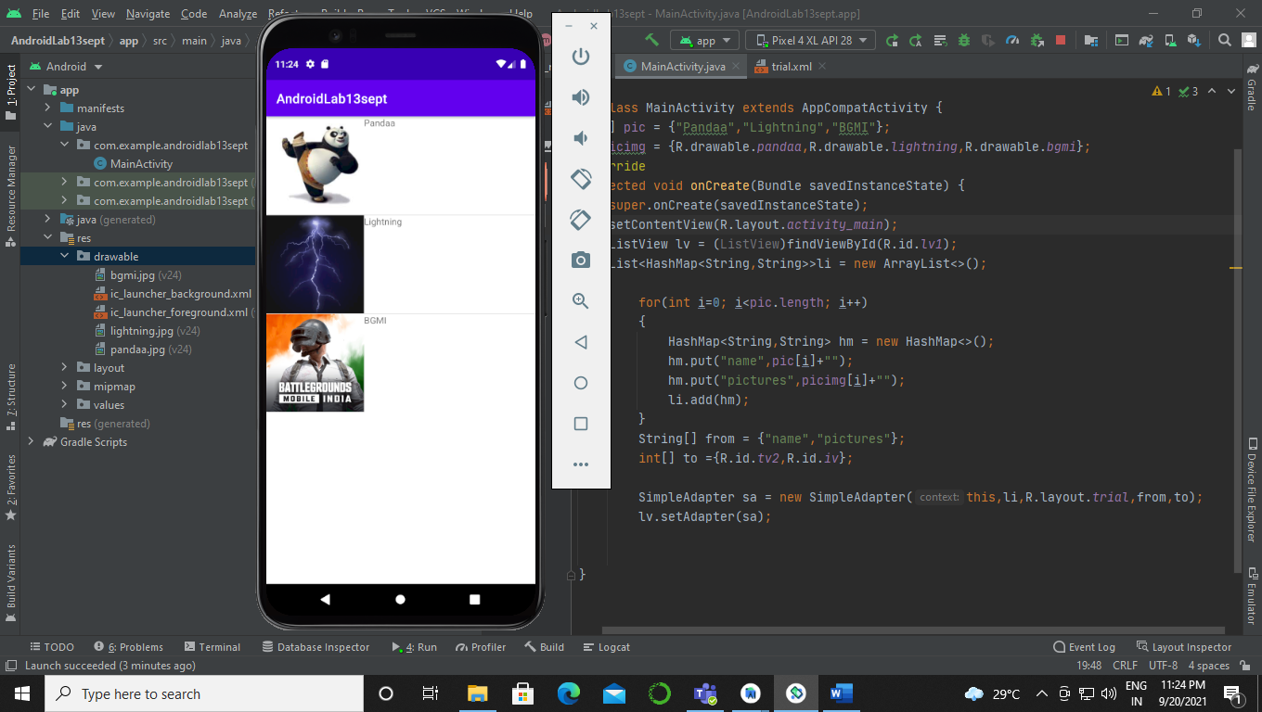

**Experiment 7**

1. Development of an android application to store the details of an employee and further display the details in another activity using shared preference objects.

Code:-

.xml:-

<?xml version=”1.0” encoding=”utf-8”?>  
<RelativeLayout  
 xmlns:android=”http://schemas.android.com/apk/res/android”  
 xmlns:app=”http://schemas.android.com/apk/res-auto”  
 xmlns:tools=”http://schemas.android.com/tools”  
 android:layout_width=”match_parent”  
 android:layout_height=”match_parent”  
 tools:context=”.MainActivity”>  
  
 <TextView  
 android:id=”@+id/tv1”  
 android:layout_width=”wrap_content”  
 android:layout_height=”wrap_content”  
 android:layout_centerHorizontal=”true”  
 android:layout_marginTop=”30dp”  
 android:fontFamily=”@font/aclonica”  
 android:text=”Android application storage”  
 android:textStyle=”bold|italic” />  
  
 <EditText  
 android:id=”@+id/et1”  
 android:layout_width=”wrap_content”  
 android:layout_height=”wrap_content”  
 android:layout_below=”@id/tv1”  
 android:layout_centerHorizontal=”true”  
 android:layout_marginTop=”20dp”  
 android:fontFamily=”monospace”  
 android:hint=”Enter the data in the file”  
 android:textStyle=”bold” />  
  
 <Button  
 android:id=”@+id/btn1”  
 android:layout_width=”wrap_content”  
 android:layout_height=”wrap_content”  
 android:layout_below=”@id/et1”  
 android:layout_centerHorizontal=”true”  
 android:layout_marginTop=”40dp”  
 android:fontFamily=”monospace”  
 android:text=”Writing data to file”  
 android:textColor=”@color/black”  
 android:textStyle=”bold”  
 app:backgroundTint=”#CDDC39”  
 app:cornerRadius=”5px”  
 app:strokeColor=”@color/black”  
 app:strokeWidth=”2px” />  
  
 <Button  
 android:id=”@+id/btn2”  
 android:layout_width=”wrap_content”  
 android:layout_height=”wrap_content”  
 android:layout_below=”@id/btn1”  
 android:layout_centerHorizontal=”true”  
 android:layout_marginTop=”40dp”  
 android:fontFamily=”monospace”  
 android:text=”Reading data from file”  
 android:textColor=”@color/black”  
 android:textStyle=”bold”  
 app:backgroundTint=”#CDDC39”  
 app:cornerRadius=”5px”  
 app:strokeColor=”@color/black”  
 app:strokeWidth=”2px” />  
  
 <TextView  
 android:id=”@+id/tv2”  
 android:layout_width=”wrap_content”  
 android:layout_height=”wrap_content”  
 android:layout_below=”@id/btn2”  
 android:layout_centerHorizontal=”true”  
 android:layout_marginTop=”20dp”  
 android:fontFamily=”monospace”  
 android:textStyle=”bold” />  
  
</RelativeLayout>

.java:-

package com.example.androidprograminglab27sept;  
  
import oolean.appcompat.app.AppCompatActivity;  
  
import android.content.Context;  
import android.os.Bundle;  
import android.view.View;  
import android.widget.Button;  
import android.widget.EditText;  
import android.widget.TextView;  
import android.widget.Toast;  
  
import java.io.FileInputStream;  
import java.io.FileOutputStream;  
import java.io.IOException;  
  
public class MainActivity extends AppCompatActivity {  
private String filename = “c.txt”;  
 @Override  
 protected void onCreate(Bundle savedInstanceState) {  
 super.onCreate(savedInstanceState);  
 setContentView(R.layout.*activity_main*);  
 TextView tvt = (TextView)findViewById(R.id.*tv2*);  
 EditText etxt = (EditText)findViewById(R.id.*et1*);  
 Button button1 = (Button)findViewById(R.id.*btn1*);  
 Button button2 = (Button)findViewById(R.id.*btn2*);  
 button1.setOnClickListener(new View.OnClickListener() {  
 @Override  
 public void onClick(View view) {  
 String data = etxt.getText().toString();  
 if(data.length()==0){  
 etxt.requestFocus();  
 etxt.setError(“This field cannot be empty”);  
 }  
 else if (!data.matches(“[a**-**zA**-**Z]+”)){  
 etxt.requestFocus();  
 etxt.setError(“Only character a-z or A-Z should used”);  
 }  
 try {  
 FileOutputStream fos = openFileOutput(filename, Context.*MODE_PRIVATE*);  
 fos.write(data.getBytes());  
 fos.flush();  
 fos.close();  
 Toast.*makeText*(MainActivity.this,”Data has been oolean in the file successfully”, Toast.*LENGTH_LONG*).show();  
 }  
 catch(IOException e){  
 e.printStackTrace();  
 }  
 }  
 });  
 button2.setOnClickListener(new View.OnClickListener() {  
 @Override  
 public void onClick(View view) {  
 try {  
 FileInputStream fin = openFileInput(filename);  
 int i;  
 StringBuilder strb = new StringBuilder();  
 while ((i= fin.read()) != -1){  
 strb.append((char) i);  
 }  
 tvt.setText(strb.toString());  
 fin.close();  
  
 } catch (IOException e){  
 e.printStackTrace();  
  
 }  
  
 }  
 });  
  
 }  
  
  
}

Output:-

User screen:-

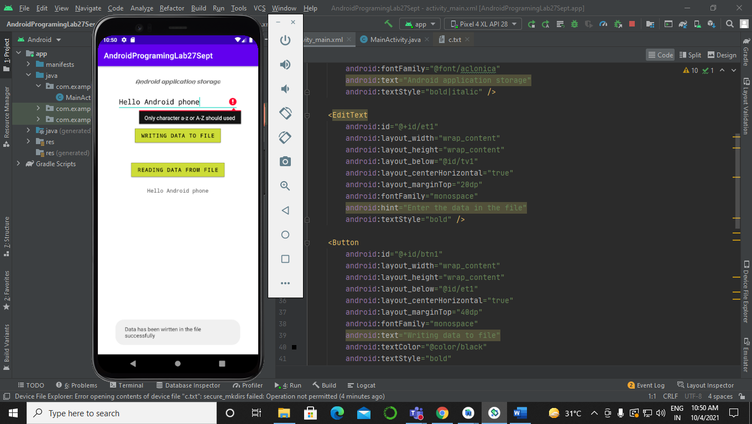

C.txt :-

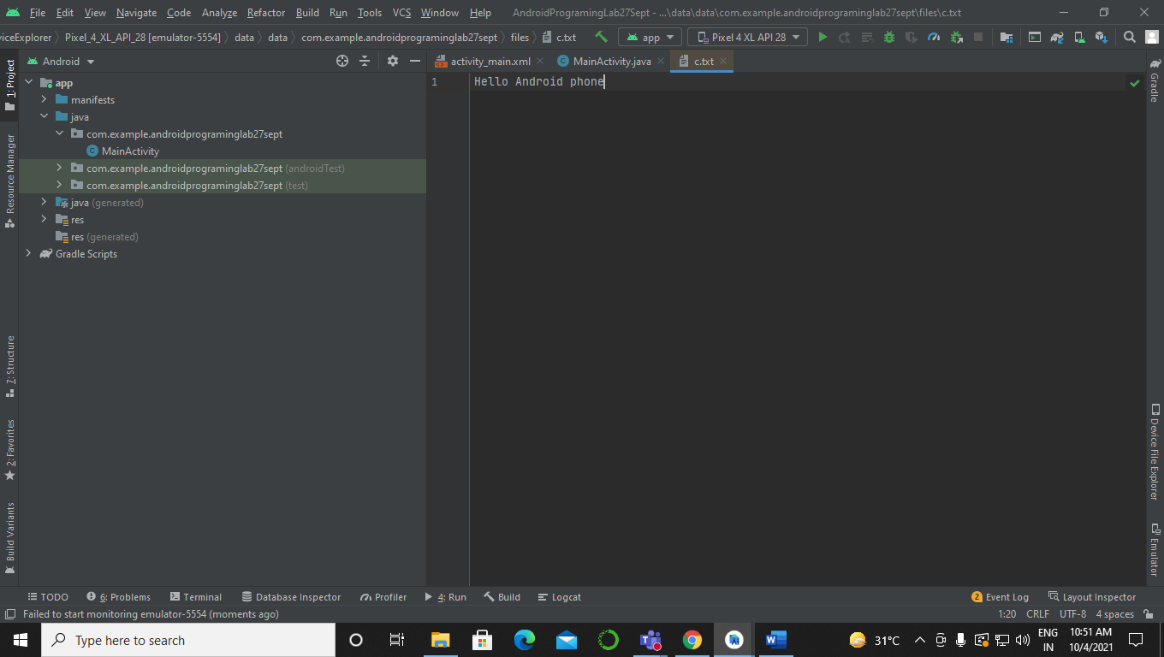

1. Development of an android application to save data in a text file.

Code:-

.xml:-

<?xml version=”1.0” encoding=”utf-8”?>  
<RelativeLayout  
 xmlns:android=”http://schemas.android.com/apk/res/android”  
 xmlns:app=”http://schemas.android.com/apk/res-auto”  
 xmlns:tools=”http://schemas.android.com/tools”  
 android:layout_width=”match_parent”  
 android:layout_height=”match_parent”  
 tools:context=”.MainActivity”>  
  
 <TextView  
 android:layout_width=”wrap_content”  
 android:layout_height=”wrap_content”  
 android:text=”Shared Preferences”  
 android:textSize=”15dp”  
 android:id=”@+id/tv1”  
 android:layout_marginTop=”30dp”  
 android:layout_centerHorizontal=”true”  
 />  
  
 <EditText  
 android:id=”@+id/et1”  
 android:layout_width=”wrap_content”  
 android:layout_height=”wrap_content”  
 android:layout_below=”@+id/tv1”  
 android:layout_centerHorizontal=”true”  
 android:layout_marginTop=”20dp”  
 android:fontFamily=”monospace”  
 android:hint=”Enter name of employee”  
 android:textStyle=”bold” />  
  
 <EditText  
 android:id=”@+id/et2”  
 android:layout_width=”wrap_content”  
 android:layout_height=”wrap_content”  
 android:layout_below=”@+id/et1”  
 android:layout_centerHorizontal=”true”  
 android:layout_marginTop=”20dp”  
 android:fontFamily=”monospace”  
 android:hint=”Enter Salary of the employee”  
 android:textStyle=”bold” />  
  
 <EditText  
 android:id=”@+id/et3”  
 android:layout_width=”wrap_content”  
 android:layout_height=”wrap_content”  
 android:layout_below=”@+id/et2”  
 android:layout_centerHorizontal=”true”  
 android:layout_marginTop=”20dp”  
 android:fontFamily=”monospace”  
 android:hint=”Enter Department of employee”  
 android:textStyle=”bold” />  
  
 <Button  
 android:id=”@+id/btn1”  
 android:layout_width=”wrap_content”  
 android:layout_height=”wrap_content”  
 android:layout_below=”@id/et3”  
 android:layout_centerHorizontal=”true”  
 android:layout_marginTop=”25dp”  
 android:fontFamily=”monospace”  
  
 android:text=”Save data”  
 android:textColor=”@color/black”  
 android:textStyle=”bold”  
 app:backgroundTint=”#009688”  
 app:cornerRadius=”5px”  
 app:strokeColor=”@color/black”  
 app:strokeWidth=”2px” />  
  
</RelativeLayout>

.java:-

package com.example.androidprograminglec28sept;  
  
import oolean.appcompat.app.AppCompatActivity;  
  
import android.content.Context;  
import android.content.SharedPreferences;  
import android.os.Bundle;  
import android.view.View;  
import android.widget.Button;  
import android.widget.EditText;  
import android.widget.Toast;  
  
public class MainActivity extends AppCompatActivity {  
 public static final String *MyPreferences* =”Pref”;  
 public static final String *n* =”namekey”;  
 public static final String *s* =”salarykey”;  
 public static final String *d* =”deptkey”;  
  
  
 @Override  
 protected void onCreate(Bundle savedInstanceState) {  
 super.onCreate(savedInstanceState);  
 setContentView(R.layout.*activity_main*);  
 EditText etxt1 = (EditText)findViewById(R.id.*et1*);  
 EditText etxt2 = (EditText)findViewById(R.id.*et2*);  
 EditText etxt3 = (EditText)findViewById(R.id.*et3*);  
 Button btn = (Button)findViewById(R.id.*btn1*);  
 SharedPreferences sharedPreferences = getSharedPreferences(*MyPreferences*, Context.*MODE_PRIVATE*);  
 btn.setOnClickListener(new View.OnClickListener() {  
 @Override  
 public void onClick(View v) {  
 String name =etxt1.getText().toString();  
 String salary = etxt2.getText().toString();  
 String dept = etxt3.getText().toString();  
  
 SharedPreferences.Editor editor = sharedPreferences.edit();  
 editor.putString(*n*,name);  
 editor.putString(*s*,salary);  
 editor.putString(*d*,dept);  
 editor.commit();  
 Toast.*makeText*(MainActivity.this,”Data is saved”,Toast.*LENGTH_LONG*).show();  
  
 }  
 });  
 }  
}

Output:-

User screen:-

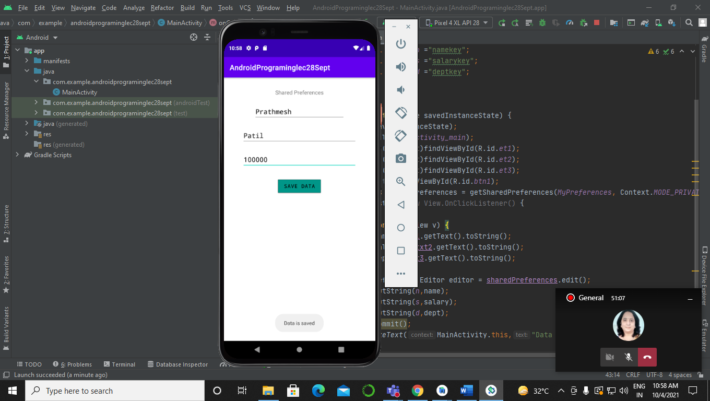

Data saved in saved preference:-

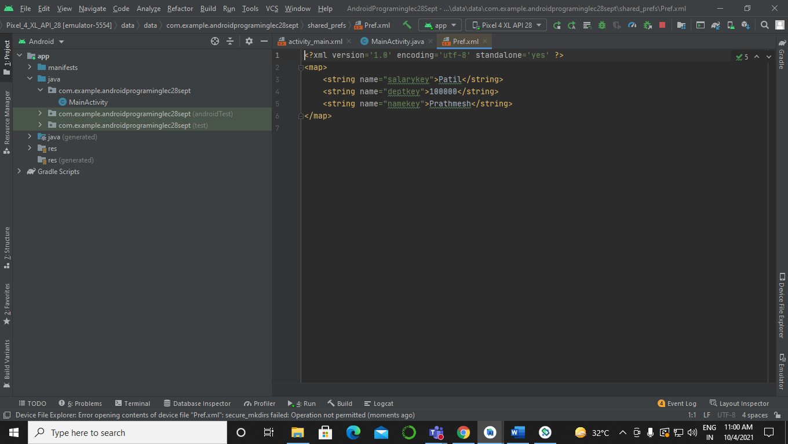

**EXPERIMENT 8:-**

Develop an android application to store data in the SQLite database.

Sol:-

MainActivity.java:-

package com.example.databaseform;  
  
import oolean.appcompat.app.AppCompatActivity;  
  
import android.content.ContentValues;  
import android.database.Cursor;  
import android.database.sqlite.SQLiteDatabase;  
import android.os.Bundle;  
import android.view.View;  
import android.widget.Button;  
import android.widget.EditText;  
import android.widget.TextView;  
import android.widget.Toast;  
  
public class MainActivity extends AppCompatActivity {  
 EditText e1,e2,e3;  
 TextView r1,r2,r3;  
 SQLiteDatabase db1;  
 @Override  
 protected void onCreate(Bundle savedInstanceState) {  
 super.onCreate(savedInstanceState);  
 db objdb = new db(this);  
 db1 = objdb.getWritableDatabase();  
  
 setContentView(R.layout.*activity_main*);  
 e1 =(EditText)findViewById(R.id.*edt1*) ;  
 e2 =(EditText)findViewById(R.id.*edt2*) ;  
 e3 =(EditText)findViewById(R.id.*edt3*) ;  
 r1 =(TextView)findViewById(R.id.*rs1*) ;  
 r2 =(TextView)findViewById(R.id.*rs2*) ;  
 r3 =(TextView)findViewById(R.id.*rs3*) ;  
 Button b1 = (Button)findViewById(R.id.*butn1*);  
 Button b2 = (Button)findViewById(R.id.*butn2*);  
 Button b3 = (Button)findViewById(R.id.*butn3*);  
 b1.setOnClickListener(new View.OnClickListener() {  
 @Override  
 public void onClick(View view) {  
  
 recordUser();  
 }  
 });  
 b2.setOnClickListener(new View.OnClickListener() {  
 @Override  
 public void onClick(View view) {  
 SQLiteDatabase db = openOrCreateDatabase (“Table”,*MODE_PRIVATE*,null);  
 String sq =”SELECT * from empdetails”;  
 Cursor cr = db.rawQuery(sq,null);  
 if(cr !=null){  
 cr.moveToFirst();  
// startManagingCursor(cr);  
 while(!cr.isAfterLast()){  
 String no = cr.getString(1);  
 String n = cr.getString(2);  
 String de = cr.getString(3);  
 String s1 = “Employee id”+no;  
 String s2 = “Employee name”+n;  
 String s3 = “Employee dept”+de;  
  
 r1.setText(no);  
 r2.setText(n);  
 r3.setText(de);  
  
 Toast.*makeText*(MainActivity.this,”Data Displayed”,Toast.*LENGTH_LONG*).show();  
 cr.moveToNext();  
  
 }  
 }  
  
 }  
 });  
  
 b3.setOnClickListener(new View.OnClickListener() {  
 @Override  
 public void onClick(View v) {  
 deleteUser();  
 }  
 });  
  
  
  
 }  
 public void recordUser(){  
 String empid,empname,empdept;  
 empid=e1.getText().toString();  
 empname=e2.getText().toString();  
 empdept=e3.getText().toString();  
 ContentValues values = new ContentValues();  
 values.put(“empid”,empid);  
 values.put(“empname”,empname);  
 values.put(“empdept”,empdept);  
 long ID = db1.insert(“empdetails”,null,values);  
 Toast.*makeText*(MainActivity.this,”No of records “+ID,Toast.*LENGTH_LONG*).show();  
 }  
 public void deleteUser(){  
 SQLiteDatabase db1;  
 db objdb = new db(this);  
 db1 = objdb.getWritableDatabase();  
  
 int ID=1;  
 long delID = db1.delete(“empdetails”,”empid=”+ID,null);  
 objdb.close();  
 Toast.*makeText*(MainActivity.this,”Deleted record is “+ID,Toast.*LENGTH_LONG*).show();  
 }  
}

Db.java:-

package com.example.databaseform;  
  
  
import android.content.Context;  
import android.database.sqlite.SQLiteDatabase;  
import android.database.sqlite.SQLiteOpenHelper;  
public class db extends SQLiteOpenHelper{  
 private static final int *DATABASE_VERSION*=1;  
 private static final String *DATABASE_NAME*=”Table”;  
 public db(Context context){  
 super(context,*DATABASE_NAME*,null,*DATABASE_VERSION*);  
 }  
 public void onCreate (SQLiteDatabase db){  
 String CREATE_USER_TABLE =”CREATE TABLE empdetails( ID INTEGER PRIMARY KEY AUTOINCREMENT, empid TEXT NOT NULL,empname TEXT NOT NULL,empdept TEXT NOT NULL) “;  
 db.execSQL(CREATE_USER_TABLE);  
  
 }  
 public void onUpgrade(SQLiteDatabase db,int oldVersion, int newVersion){  
 String DELETE_USER_TABLE =”DELETE from empdetails WHERE ID=1”;  
 db.execSQL(DELETE_USER_TABLE);  
 }  
}

Activity_main.xml:-

<?xml version=”1.0” encoding=”utf-8”?>  
<LinearLayout xmlns:android=”http://schemas.android.com/apk/res/android”  
 xmlns:app=”http://schemas.android.com/apk/res-auto”  
 xmlns:tools=”http://schemas.android.com/tools”  
 android:layout_width=”match_parent”  
 android:layout_height=”match_parent”  
 android:orientation=”vertical”  
 tools:context=”.MainActivity”>  
  
 <TextView  
 android:id=”@+id/txt1”  
 android:layout_width=”wrap_content”  
 android:layout_height=”wrap_content”  
 android:layout_gravity=”center_horizontal”  
 android:background=”#AEEA00”  
 android:fontFamily=”@font/oolean”  
 android:text=”Employee details:-“  
 android:textColor=”@color/black”  
 />  
  
 <TextView  
 android:id=”@+id/txt2”  
 android:layout_width=”wrap_content”  
 android:layout_height=”wrap_content”  
 android:fontFamily=”@font/oolean”  
 android:text=”Enter employee id:-“  
 android:layout_marginTop=”30dp”  
 android:textColor=”@color/black” />  
  
 <EditText  
 android:id=”@+id/edt1”  
 android:layout_width=”400dp”  
 android:layout_height=”wrap_content”  
 android:layout_gravity=”center_horizontal”  
 android:layout_marginTop=”10dp”  
 android:fontFamily=”monospace”  
 android:hint=”Enter employee id”  
 android:textColor=”#00BFA5”  
 android:textColorHint=”#3F4040”  
 android:textStyle=”bold” />  
  
 <TextView  
 android:id=”@+id/txt3”  
 android:layout_width=”wrap_content”  
 android:layout_height=”wrap_content”  
 android:fontFamily=”@font/oolean”  
 android:text=”Enter employee name:-“  
 android:layout_marginTop=”20dp”  
 android:textColor=”@color/black” />  
  
 <EditText  
 android:id=”@+id/edt2”  
 android:layout_width=”400dp”  
 android:layout_height=”wrap_content”  
 android:layout_gravity=”center_horizontal”  
 android:layout_marginTop=”10dp”  
 android:fontFamily=”monospace”  
 android:hint=”Enter employee name “  
 android:textColor=”#00BFA5”  
 android:textColorHint=”#3F4040”  
 android:textStyle=”bold” />  
  
 <TextView  
 android:id=”@+id/txt4”  
 android:layout_width=”wrap_content”  
 android:layout_height=”wrap_content”  
 android:fontFamily=”@font/oolean”  
 android:text=”Enter employee department:-“  
 android:layout_marginTop=”20dp”  
 android:textColor=”@color/black” />  
  
 <EditText  
 android:id=”@+id/edt3”  
 android:layout_width=”400dp”  
 android:layout_height=”wrap_content”  
 android:layout_gravity=”center_horizontal”  
 android:layout_marginTop=”10dp”  
 android:fontFamily=”monospace”  
 android:hint=”Enter employee department “  
 android:textColor=”#00BFA5”  
 android:textColorHint=”#3F4040”  
 android:textStyle=”bold” />  
  
 <Button  
 android:id=”@+id/butn1”  
 android:layout_width=”wrap_content”  
 android:layout_height=”wrap_content”  
 android:layout_gravity=”center_horizontal”  
 android:layout_marginTop=”15dp”  
 android:fontFamily=”monospace”  
 android:text=”Add record”  
 android:textColor=”@color/black”  
 android:textStyle=”bold”  
 app:backgroundTint=”#FF6D00”  
 app:strokeColor=”@color/black”  
 app:strokeWidth=”5px” />  
  
 <Button  
 android:id=”@+id/butn2”  
 android:layout_width=”wrap_content”  
 android:layout_height=”wrap_content”  
 android:layout_gravity=”center_horizontal”  
 android:layout_marginTop=”15dp”  
 android:fontFamily=”monospace”  
 android:text=”View added record”  
 android:textColor=”@color/black”  
 android:textStyle=”bold”  
 app:backgroundTint=”#304FFE”  
 app:strokeColor=”@color/black”  
 app:strokeWidth=”5px” />  
  
 <Button  
 android:id=”@+id/butn3”  
 android:layout_width=”wrap_content”  
 android:layout_height=”wrap_content”  
 android:layout_gravity=”center_horizontal”  
 android:layout_marginTop=”15dp”  
 android:fontFamily=”monospace”  
 android:text=”Delete the record”  
 android:textColor=”@color/black”  
 android:textStyle=”bold”  
 app:backgroundTint=”#DD2C00”  
 app:strokeColor=”@color/black”  
 app:strokeWidth=”5px” />  
  
 <TextView  
 android:id=”@+id/rs1”  
 android:layout_width=”wrap_content”  
 android:layout_height=”wrap_content”  
 android:layout_marginTop=”30dp”  
 android:fontFamily=”@font/biryani_bold”  
 android:hint=”Employee id”  
 android:textColor=”#DD2C00”  
 android:textStyle=”bold” />  
  
 <TextView  
 android:id=”@+id/rs2”  
 android:layout_width=”wrap_content”  
 android:layout_height=”wrap_content”  
 android:layout_marginTop=”30dp”  
 android:fontFamily=”@font/biryani_bold”  
 android:hint=”Employee name”  
 android:textColor=”#FF6D00”  
 android:textStyle=”bold” />  
  
 <TextView  
 android:id=”@+id/rs3”  
 android:layout_width=”wrap_content”  
 android:layout_height=”wrap_content”  
 android:layout_marginTop=”30dp”  
 android:fontFamily=”@font/biryani_bold”  
 android:hint=”Employee department”  
 android:textColor=”#304FFE”  
 android:textStyle=”bold” />  
  
  
</LinearLayout>

Output:-

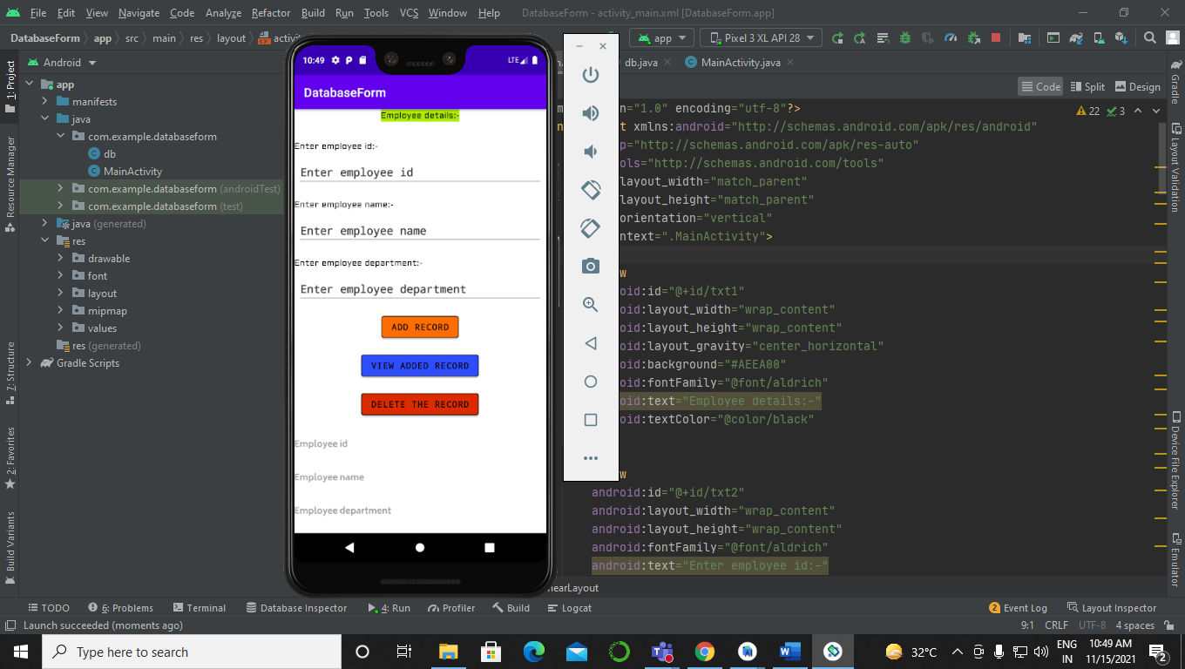

Filling details:-

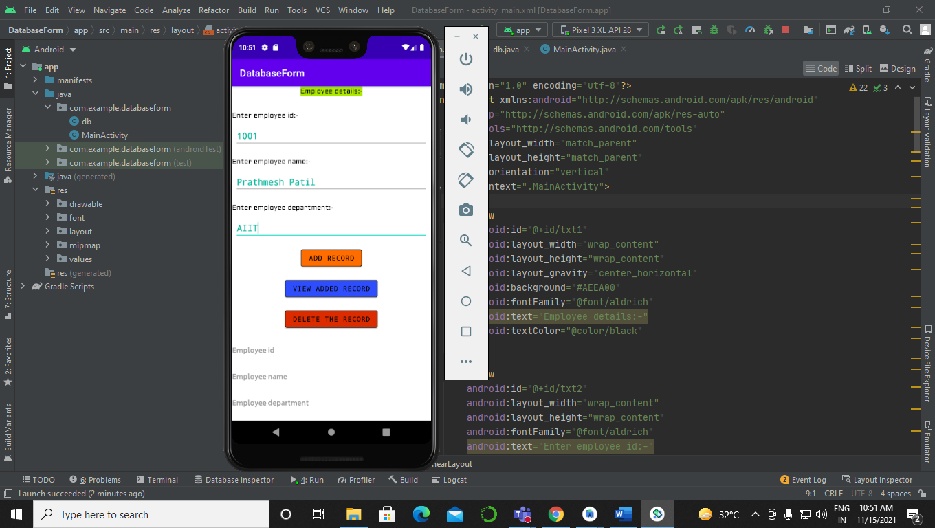

Adding record:-

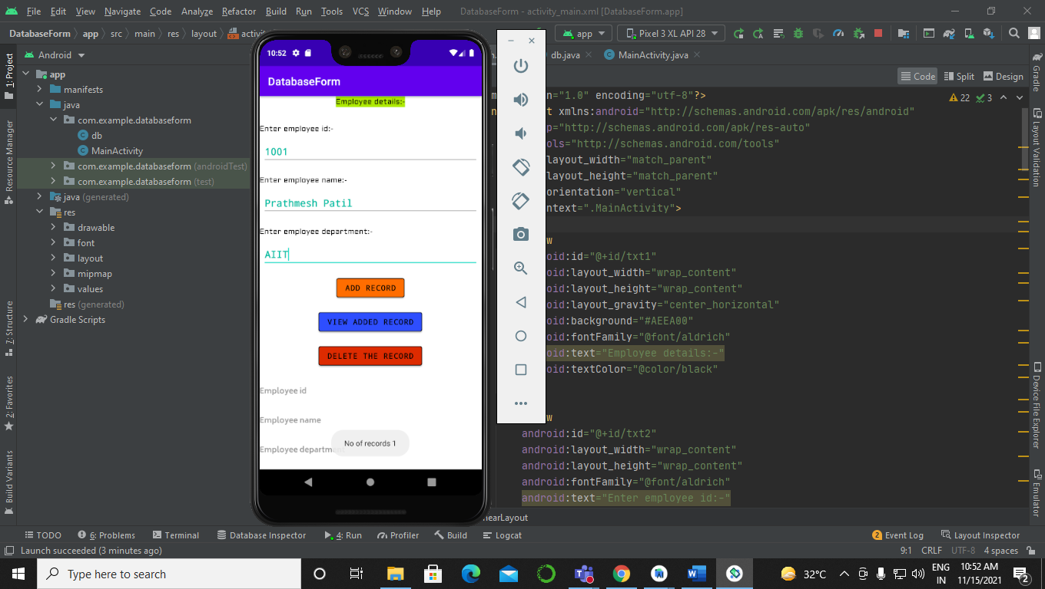

Viewing record:-

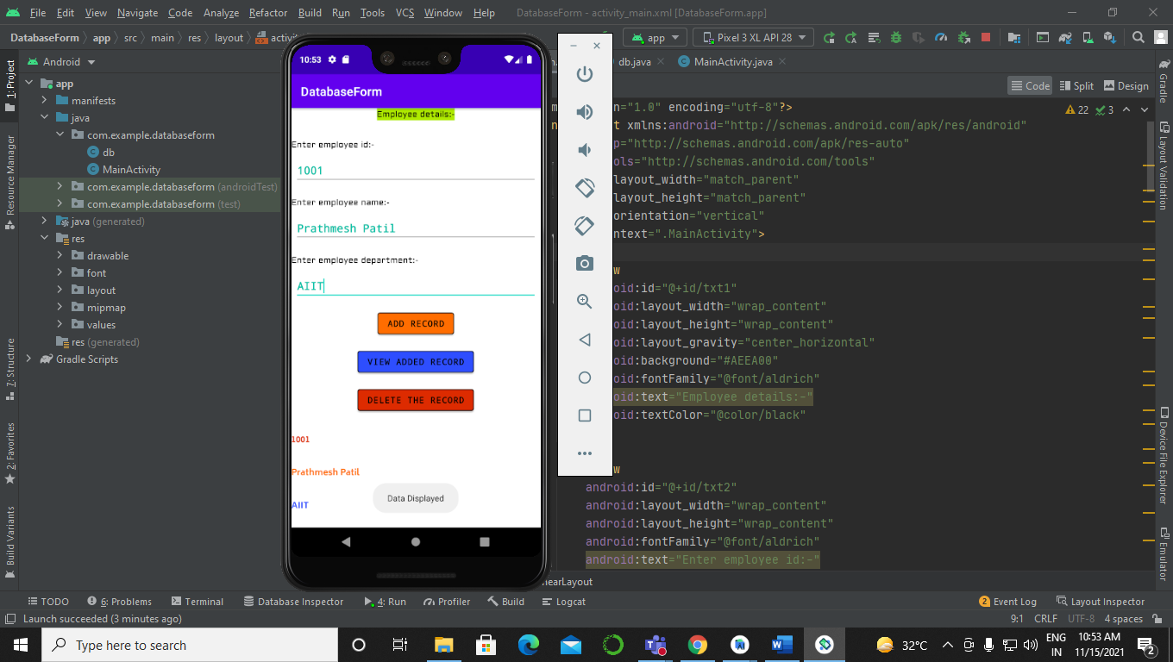

**EXPERIMENT 9:-**

Applications using Android SDK framework –  
i) Development of an android application that runs audio file in the application. Development of an android application that runs video file in the application.

Sol:-

MainActivity.java:-

package com.example.androidprograminglec13nov;  
  
import oolean.appcompat.app.AppCompatActivity;  
  
import android.media.MediaPlayer;  
import android.net.Uri;  
import android.os.Bundle;  
import android.view.View;  
import android.widget.Button;  
import android.widget.VideoView;  
  
public class MainActivity extends AppCompatActivity {  
 MediaPlayer mp;  
  
 @Override  
 protected void onCreate(Bundle savedInstanceState) {  
 super.onCreate(savedInstanceState);  
 setContentView(R.layout.activity_main);  
 Button b1 = (Button)findViewById(R.id.btn3);  
 VideoView v1 = (VideoView)findViewById(R.id.vv1);  
 mp = MediaPlayer.create(MainActivity.this, R.raw.music);  
 b1.setOnClickListener(new View.OnClickListener() {  
 @Override  
 public void onClick(View view) {  
 String path =”android.resource://”+getPackageName()+”/”+R.raw.fireworks;  
 v1.setVideoURI(Uri.parse(path));  
 v1.start();  
  
   
  
 }  
 });  
  
 }  
 public void start(View view) {  
 mp.start();  
  
  
 }  
 public void stop(View view) {  
 mp.stop();  
  
  
 }  
}

activity_main.xml.xml:-

<?xml version=”1.0” encoding=”utf-8”?>  
<RelativeLayout xmlns:android=”http://schemas.android.com/apk/res/android”  
 xmlns:app=”http://schemas.android.com/apk/res-auto”  
 xmlns:tools=”http://schemas.android.com/tools”  
 android:layout_width=”match_parent”  
 android:layout_height=”match_parent”  
 android:background=”#FF6D00”  
 tools:context=”.MainActivity”>  
  
 <TextView  
 android:id=”@+id/tv1”  
 android:layout_width=”wrap_content”  
 android:layout_height=”wrap_content”  
 android:layout_centerHorizontal=”true”  
 android:layout_marginTop=”30dp”  
 android:text=”Audio/Video player “  
 android:textColor=”@color/black” />  
  
 <Button  
 android:id=”@+id/btn1”  
 android:layout_width=”wrap_content”  
 android:layout_height=”wrap_content”  
 android:layout_below=”@id/tv1”  
 android:layout_centerHorizontal=”true”  
 android:layout_marginTop=”30dp”  
 android:onClick=”start”  
 android:text=”Start playing audio file” />  
  
 <Button  
 android:id=”@+id/btn2”  
 android:layout_width=”wrap_content”  
 android:layout_height=”wrap_content”  
 android:layout_below=”@id/btn1”  
 android:layout_centerHorizontal=”true”  
 android:layout_marginTop=”30dp”  
 android:onClick=”stop”  
 android:text=”Stop playing audio file” />  
  
 <Button  
 android:id=”@+id/btn3”  
 android:layout_width=”wrap_content”  
 android:layout_height=”wrap_content”  
 android:layout_below=”@id/btn2”  
 android:layout_centerHorizontal=”true”  
 android:layout_marginTop=”30dp”  
 android:text=”Start playing Video file” />  
  
 <VideoView  
 android:id=”@+id/vv1”  
 android:layout_width=”320dp”  
 android:layout_height=”320dp”  
 android:layout_below=”@id/btn3”  
 android:layout_centerHorizontal=”true”  
 android:layout_marginTop=”30dp” />  
  
  
</RelativeLayout>

Output:-

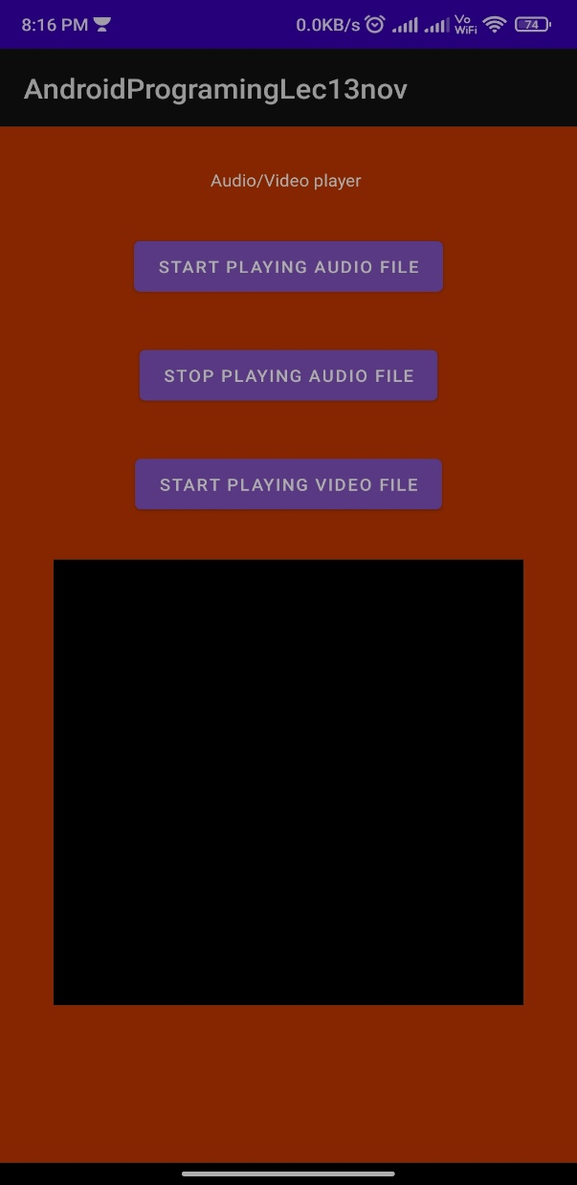

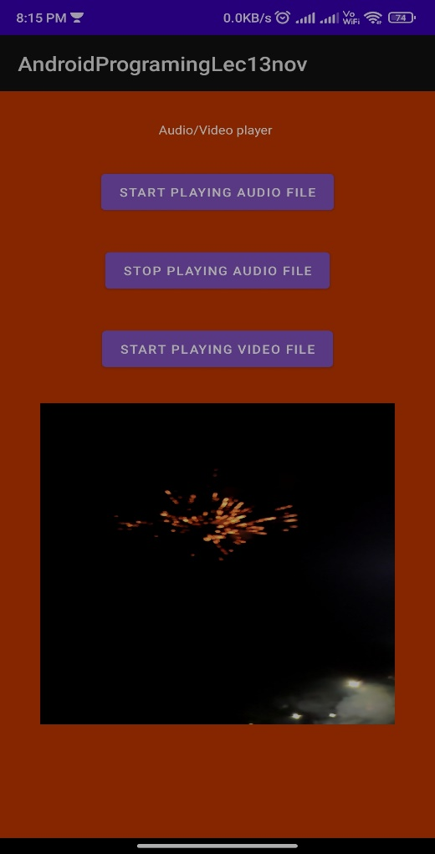

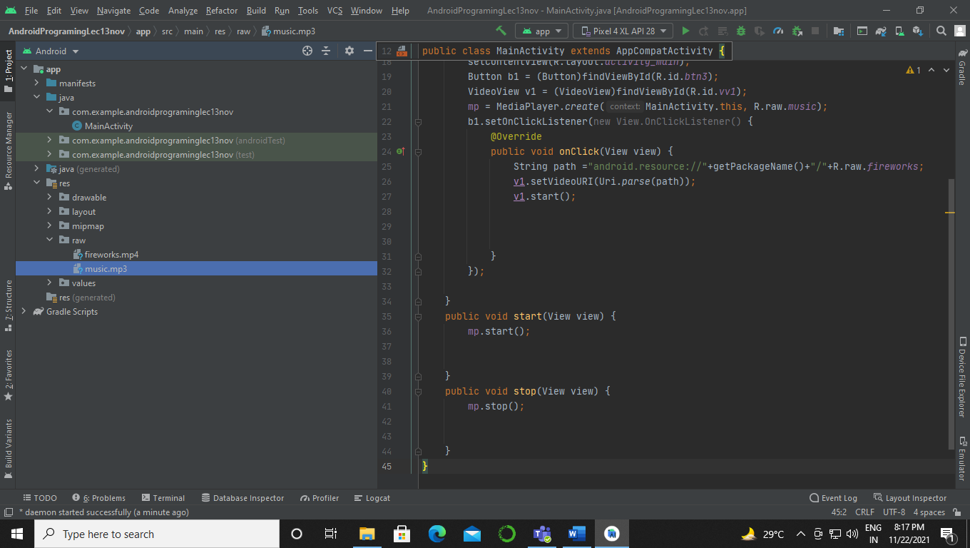

**Experiment 10**

Mobile networking applications –

1. Development of an android application to enable and disable Bluetooth in the device, also get information about the paired devices.

Sol:-

MainActivity.java:-

package com.example.androidprograminglec26oct;  
  
import oolean.appcompat.app.AppCompatActivity;  
  
import android.bluetooth.BluetoothAdapter;  
import android.bluetooth.BluetoothDevice;  
import android.content.Intent;  
import android.os.Bundle;  
import android.view.View;  
import android.widget.Button;  
import android.widget.TextView;  
import android.widget.Toast;  
  
import java.util.Set;  
  
public class MainActivity extends AppCompatActivity {  
  
 @Override  
 protected void onCreate(Bundle savedInstanceState) {  
 super.onCreate(savedInstanceState);  
 setContentView(R.layout.*activity_main*);  
 Button b1 = (Button)findViewById(R.id.*btn1*);  
 Button b2 = (Button)findViewById(R.id.*btn2*);  
 Button b3 = (Button)findViewById(R.id.*btn3*);  
 TextView t1 = (TextView)findViewById(R.id.*tv2*);  
  
 BluetoothAdapter ba = BluetoothAdapter.*getDefaultAdapter*();  
 b1.setOnClickListener(new View.OnClickListener() {  
 @Override  
 public void onClick(View v) {  
 if(ba == null){  
 Toast.*makeText*(MainActivity.this, “Bluetooth is not supported”,Toast.*LENGTH_LONG*).show();  
  
 }  
 else{  
 if(!ba.isEnabled()){  
 Intent ib = new Intent(BluetoothAdapter.*ACTION_REQUEST_ENABLE*);  
 startActivity(ib);  
  
 }  
 }  
 }  
 });  
 b2.setOnClickListener(new View.OnClickListener() {  
 @Override  
 public void onClick(View v) {  
 ba.disable();  
 }  
 });  
 b3.setOnClickListener(new View.OnClickListener() {  
 @Override  
 public void onClick(View v) {  
 if(ba == null){  
 Toast.*makeText*(MainActivity.this, “Bluetooth is not supported”,Toast.*LENGTH_LONG*).show();  
  
 }  
 else{  
 final Set<BluetoothDevice> pD = ba.getBondedDevices();  
 if(pD.size()>0){  
 for(BluetoothDevice device : pD )  
 {  
 String dname = device.getName();  
 String daddress = device.getAddress();  
 t1.setText(“Name of the paired device “+dname+” “+”Address of paired device “+daddress);  
  
  
 }  
 }  
 }  
 }  
 });  
  
 }  
}

Activity_main.xml:-

<?xml version=”1.0” encoding=”utf-8”?>  
<RelativeLayout  
 xmlns:android=”http://schemas.android.com/apk/res/android”  
 xmlns:app=”http://schemas.android.com/apk/res-auto”  
 xmlns:tools=”http://schemas.android.com/tools”  
 android:layout_width=”match_parent”  
 android:layout_height=”match_parent”  
 tools:context=”.MainActivity”>  
  
 <TextView  
 android:layout_width=”wrap_content”  
 android:layout_height=”wrap_content”  
 android:text=”Bluetooth Adapter”  
 android:id=”@+id/tv1”  
 android:layout_centerHorizontal=”true”  
 android:layout_marginTop=”30dp”  
 />  
  
 <Button  
 android:id=”@+id/btn1”  
 android:layout_width=”wrap_content”  
 android:layout_height=”wrap_content”  
 android:layout_below=”@id/tv1”  
 android:layout_centerHorizontal=”true”  
 android:layout_marginTop=”30dp”  
 android:fontFamily=”monospace”  
 android:text=”Switch on ooleanh”  
 android:textColor=”@color/black”  
 android:textStyle=”bold”  
 app:backgroundTint=”#0091EA”  
 app:strokeColor=”@color/black”  
 app:strokeWidth=”2px” />  
  
 <Button  
 android:id=”@+id/btn2”  
 android:layout_width=”wrap_content”  
 android:layout_height=”wrap_content”  
 android:layout_below=”@id/btn1”  
 android:layout_centerHorizontal=”true”  
 android:layout_marginTop=”30dp”  
 android:fontFamily=”monospace”  
 android:text=”Switch off ooleanh”  
 android:textColor=”@color/black”  
 android:textStyle=”bold”  
 app:backgroundTint=”#0091EA”  
 app:strokeColor=”@color/black”  
 app:strokeWidth=”2px” />  
  
 <Button  
 android:id=”@+id/btn3”  
 android:layout_width=”wrap_content”  
 android:layout_height=”wrap_content”  
 android:layout_below=”@id/btn2”  
 android:layout_centerHorizontal=”true”  
 android:layout_marginTop=”30dp”  
 android:fontFamily=”monospace”  
 android:text=”Pair devices”  
 android:textColor=”@color/black”  
 android:textStyle=”bold”  
 app:backgroundTint=”#0091EA”  
 app:strokeColor=”@color/black”  
 app:strokeWidth=”2px” />  
  
 <TextView  
 android:layout_width=”wrap_content”  
 android:layout_height=”wrap_content”  
 android:id=”@+id/tv2”  
 android:hint=”List of paired device”  
 android:layout_below=”@id/btn3”  
 android:layout_centerHorizontal=”true”  
 android:layout_marginTop=”40dp”  
 />  
  
  
  
</RelativeLayout>

AndroidManifest.xml:-

<?xml version=”1.0” encoding=”utf-8”?>  
<manifest xmlns:android=”http://schemas.android.com/apk/res/android”  
 package=”com.example.androidprograminglec26oct”>  
 <uses-permission android:name=”android.permission.BLUETOOTH”/>  
 <uses-permission android:name=”android.permission.BLUETOOTH_ADMIN”/>  
 <uses-permission android:name=”android.permission.ACCESS_COARSE_LOCATION”/>  
  
  
 <application  
 android:allowBackup=”true”  
 android:icon=”@mipmap/ic_launcher”  
 android:label=”@string/app_name”  
 android:roundIcon=”@mipmap/ic_launcher_round”  
 android:supportsRtl=”true”  
 android:theme=”@style/Theme.AndroidProgramingLec26Oct”>  
 <activity android:name=”.MainActivity”>  
 <intent-filter>  
 <action android:name=”android.intent.action.MAIN” />  
  
 <category android:name=”android.intent.category.LAUNCHER” />  
 </intent-filter>  
 </activity>  
 </application>  
  
</manifest>

Output:-

Application:-

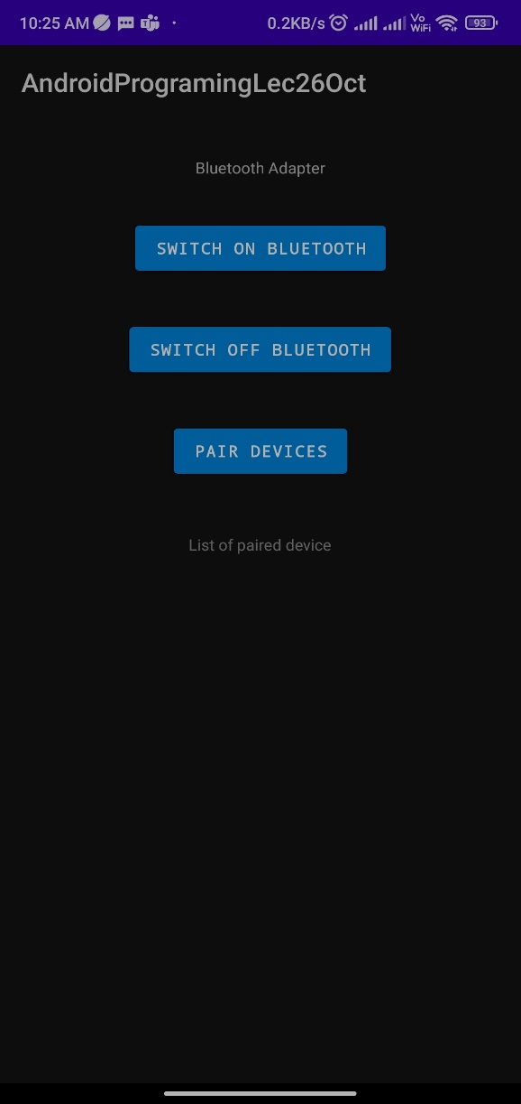

Before switching on Bluetooth:-

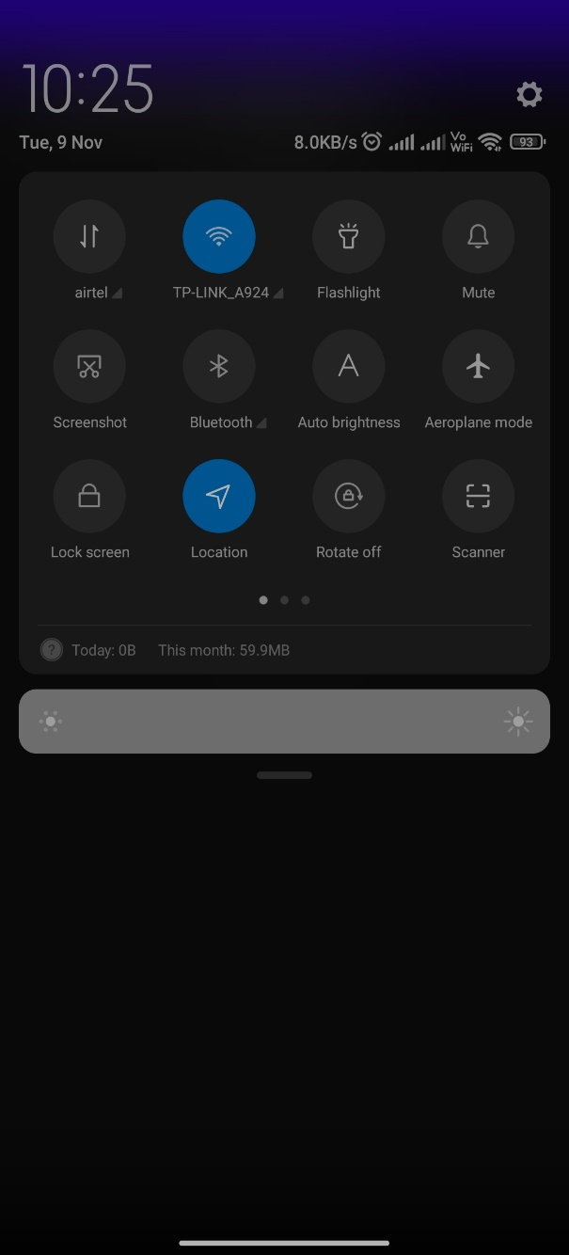

After switching on Bluetooth:-

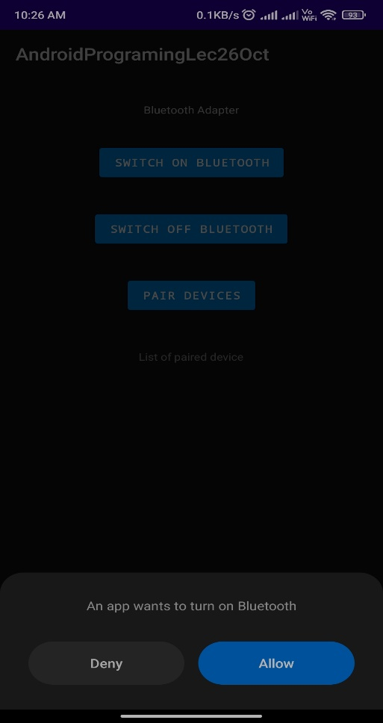

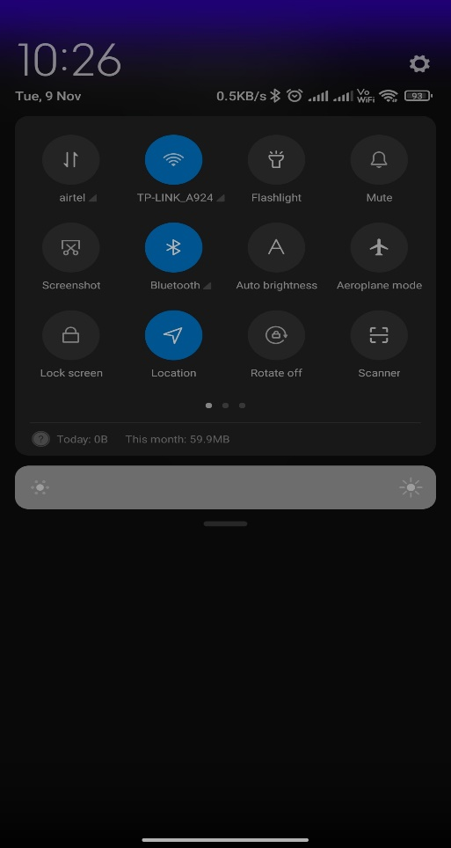

List of paired devices:-

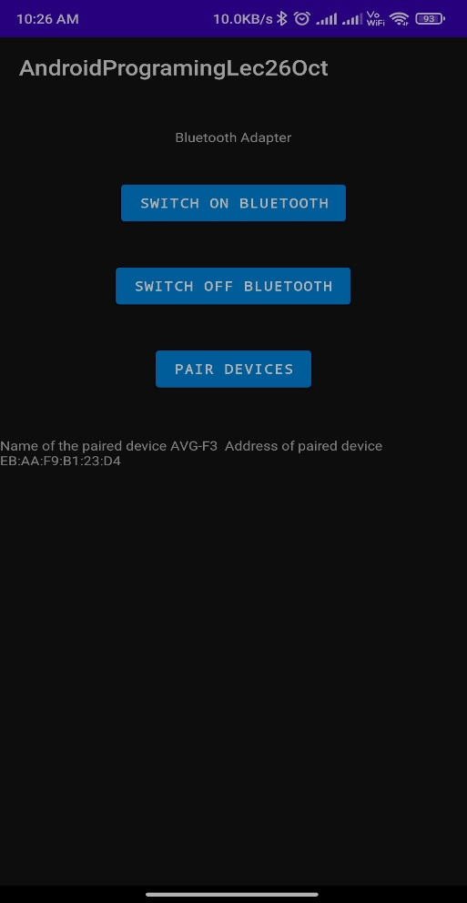

1. Development of an android application using Android TelephonyManager for acquiring the details of the android device and network.

MainActivity.java:-

package com.example.androidprograminglabnov11;  
  
import oolean.appcompat.app.AppCompatActivity;  
  
import android.os.Bundle;  
import android.telephony.TelephonyManager;  
import android.widget.Switch;  
import android.widget.TextView;  
  
public class MainActivity extends AppCompatActivity {  
  
 @Override  
 protected void onCreate(Bundle savedInstanceState) {  
 super.onCreate(savedInstanceState);  
 setContentView(R.layout.activity_main);  
 TextView t1 = (TextView)findViewById(R.id.tv1);  
 TelephonyManager tm = (TelephonyManager) getSystemService(TELEPHONY_SERVICE);  
 String ntwcc =tm.getNetworkCountryIso();  
 String ntwcs = tm.getSimCountryIso();  
 Boolean roaming = tm.isNetworkRoaming();  
 String pt=””;  
 int phtp = tm.getPhoneType();  
 switch(phtp)  
 {  
 case (TelephonyManager.PHONE_TYPE_CDMA):  
 pt = “CDMA”;  
 break;  
 case (TelephonyManager.PHONE_TYPE_GSM):  
 pt = “GSM”;  
 break;  
  
  
 }  
  
 String info = “Phone Details\n”;  
 info += “Network Country ISO: “+ntwcc;  
 info += “\nSim Country ISO: “+ntwcs;  
 info += “\nIs Roaming? : “+roaming;  
 info += “\nPhone Type : “+pt;  
 t1.setText(info);  
  
  
  
  
  
 }  
}

Activity_main.xml:-

<?xml version=”1.0” encoding=”utf-8”?>  
<RelativeLayout  
 xmlns:android=”http://schemas.android.com/apk/res/android”  
 xmlns:app=”http://schemas.android.com/apk/res-auto”  
 xmlns:tools=”http://schemas.android.com/tools”  
 android:layout_width=”match_parent”  
 android:layout_height=”match_parent”  
 tools:context=”.MainActivity”>  
  
 <TextView  
 android:layout_width=”wrap_content”  
 android:layout_height=”wrap_content”  
 android:text=”Android Telephony”  
 android:id=”@+id/tv1”  
 android:layout_centerHorizontal=”true”  
 android:layout_marginTop=”30dp”  
 />  
</RelativeLayout>

Output:-

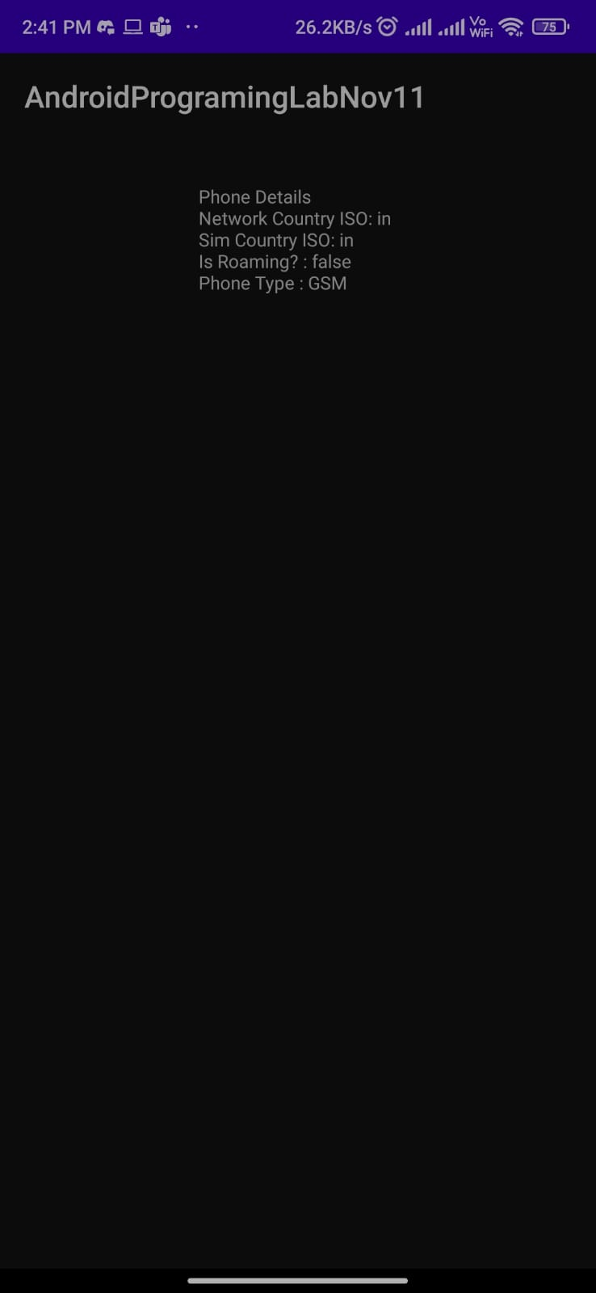

**EXPERIMENT 11:-**

Working with Sensors

1. Development of an android application to create a list of all the sensors present on the android enabled device.

Sol:-

MainActivity.java:-

package com.example.sensors16nov;  
  
import oolean.appcompat.app.AppCompatActivity;  
  
import android.hardware.Sensor;  
import android.hardware.SensorManager;  
import android.os.Bundle;  
import android.widget.TextView;  
import android.widget.Toast;  
  
import java.util.List;  
  
public class MainActivity extends AppCompatActivity {  
 SensorManager smgr;  
  
 @Override  
 protected void onCreate(Bundle savedInstanceState) {  
 super.onCreate(savedInstanceState);  
 setContentView(R.layout.*activity_main*);  
 TextView t1 = (TextView)findViewById(R.id.*tv2*);  
 smgr = (SensorManager)this.getSystemService(*SENSOR_SERVICE*);  
 List<Sensor> list= smgr.getSensorList(Sensor.*TYPE_ALL*);  
 for (int i =1; i< list.size();i++)  
 {  
 t1.append(list.get(i).getName()+”\n”+list.get(i).getVendor()+”\n”+list.get(i).getVersion());  
 Toast.*makeText*(MainActivity.this,”List of sensor is displayed”,Toast.*LENGTH_LONG*).show();  
  
 }  
   
 }  
}

Activity_main.xml:-

<?xml version=”1.0” encoding=”utf-8”?>  
<RelativeLayout xmlns:android=”http://schemas.android.com/apk/res/android”  
 xmlns:app=”http://schemas.android.com/apk/res-auto”  
 xmlns:tools=”http://schemas.android.com/tools”  
 android:layout_width=”match_parent”  
 android:layout_height=”match_parent”  
 android:background=”#FF6D00”  
 tools:context=”.MainActivity”>  
  
 <TextView  
 android:id=”@+id/tv1”  
 android:layout_width=”wrap_content”  
 android:layout_height=”wrap_content”  
 android:layout_centerHorizontal=”true”  
 android:layout_marginTop=”30dp”  
 android:text=”List of available of sensors”  
  
 android:textColor=”@color/black” />  
  
 <TextView  
 android:id=”@+id/tv2”  
 android:layout_width=”wrap_content”  
 android:layout_height=”wrap_content”  
 android:layout_below=”@id/tv1”  
 android:layout_centerHorizontal=”true”  
 android:layout_marginTop=”30dp”  
 android:text=”Devices”  
 android:textColor=”@color/black”  
 android:textColorHighlight=”#00BFA5”  
 android:textStyle=”bold” />  
  
  
</RelativeLayout>

Output:-

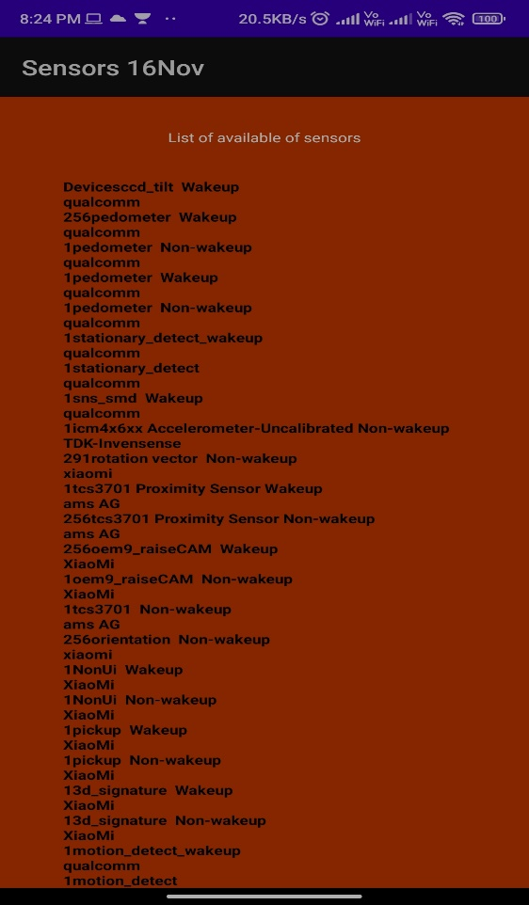

1. Development of an android application making use of sensors like accelerometer.

Sol:-

MainActivity.java:-

package com.example.androidprograminglec23nov;  
  
import android.graphics.Color;  
import android.hardware.Sensor;  
import android.hardware.SensorEvent;  
import android.hardware.SensorEventListener;  
import android.hardware.SensorManager;  
import android.os.Bundle;  
import android.view.Window;  
import android.view.WindowManager;  
import android.widget.TextView;  
import android.widget.Toast;  
  
import oolean.appcompat.app.AppCompatActivity;  
  
public class MainActivity extends AppCompatActivity implements SensorEventListener {  
 private SensorManager sensorManager;  
 private oolean color = false;  
 private TextView view;  
 private long lastUpdate;  
  
 @Override  
 public void onCreate(Bundle savedInstanceState) {  
 requestWindowFeature(Window.*FEATURE_NO_TITLE*);  
 getWindow().setFlags(WindowManager.LayoutParams.*FLAG_FULLSCREEN*,  
 WindowManager.LayoutParams.*FLAG_FULLSCREEN*);  
  
 super.onCreate(savedInstanceState);  
 setContentView(R.layout.*activity_main*);  
 view = findViewById(R.id.*tv1*);  
 view.setBackgroundColor(Color.*GREEN*);  
  
 sensorManager = (SensorManager) getSystemService(*SENSOR_SERVICE*);  
 lastUpdate = System.*currentTimeMillis*();  
 }  
  
 @Override  
 public void onSensorChanged(SensorEvent sensorEvent) {  
 if(sensorEvent.sensor.getType() == Sensor.*TYPE_ACCELEROMETER*)  
 {  
 getAccelerometer(sensorEvent);  
 }  
 }  
  
 private void getAccelerometer(SensorEvent sensorEvent) {  
 float [] values = sensorEvent.values;  
 float x = values[0];  
 float y = values[1];  
 float z = values[2];  
 float accelerationSquareRoot = (x*x+y*y+z*z) / (SensorManager.*GRAVITY_EARTH* * SensorManager.*GRAVITY_EARTH*);  
 long actualTime = sensorEvent.timestamp;  
 if(accelerationSquareRoot >= 2)  
 {  
 if(actualTime – lastUpdate < 200)  
 {  
 return;  
 }  
 lastUpdate = actualTime;  
 Toast.*makeText*(MainActivity.this, “Device Moved”, Toast.*LENGTH_SHORT*).show();  
 if(color)  
 {  
 view.setBackgroundColor(Color.*GREEN*);  
 }  
 else  
 {  
 view.setBackgroundColor(Color.*CYAN*);  
 }  
 color = !color;  
 }  
 }  
 @Override  
 public void onAccuracyChanged(Sensor sensor, int accuracy) {  
  
 }  
  
 @Override  
 protected void onResume() {  
 super.onResume();  
 // register this class as a listener for the orientation and  
 // accelerometer sensors  
 sensorManager.registerListener(this,  
 sensorManager.getDefaultSensor(Sensor.*TYPE_ACCELEROMETER*),  
 SensorManager.*SENSOR_DELAY_NORMAL*);  
 }  
  
 @Override  
 protected void onPause() {  
 // unregister listener  
 super.onPause();  
 sensorManager.unregisterListener(this);  
 }  
}

Activity_main.xml:-

<?xml version=”1.0” encoding=”utf-8”?>  
<RelativeLayout xmlns:android=”http://schemas.android.com/apk/res/android”  
 xmlns:app=”http://schemas.android.com/apk/res-auto”  
 xmlns:tools=”http://schemas.android.com/tools”  
 android:layout_width=”match_parent”  
 android:layout_height=”match_parent”  
 android:background=”#FBF9F9”  
 tools:context=”.MainActivity”>  
  
 <TextView  
 android:id=”@+id/tv1”  
 android:layout_width=”wrap_content”  
 android:layout_height=”wrap_content”  
 android:layout_centerHorizontal=”true”  
 android:layout_marginTop=”30dp”  
 android:background=”@color/white”  
  
 android:text=”Play with colors” />  
  
  
</RelativeLayout>

Colors.xml:-

<?xml version=”1.0” encoding=”utf-8”?>  
<resources>  
 <color name=”purple_200”>#FFBB86FC</color>  
 <color name=”purple_500”>#FF6200EE</color>  
 <color name=”purple_700”>#FF3700B3</color>  
 <color name=”teal_200”>#FF03DAC5</color>  
 <color name=”teal_700”>#FF018786</color>  
 <color name=”black”>#FF000000</color>  
 <color name=”white”>#FFFFFFFF</color>  
 <color name=”RED”>#FFD50000</color>  
 <color name=”GREEN”>#64DD17</color>  
 <color name=”YELLOW”>#FFD600</color>  
  
  
</resources>

Output:-

When device is stable

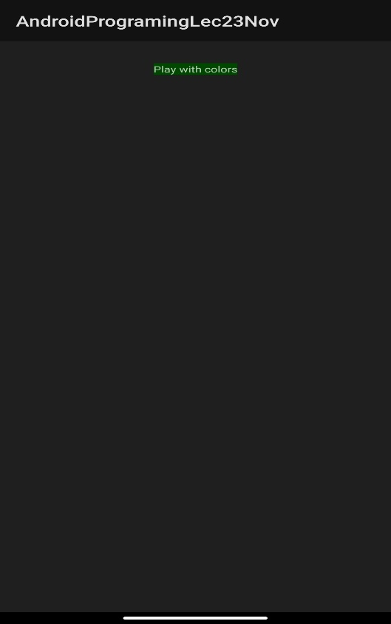

When device is moved

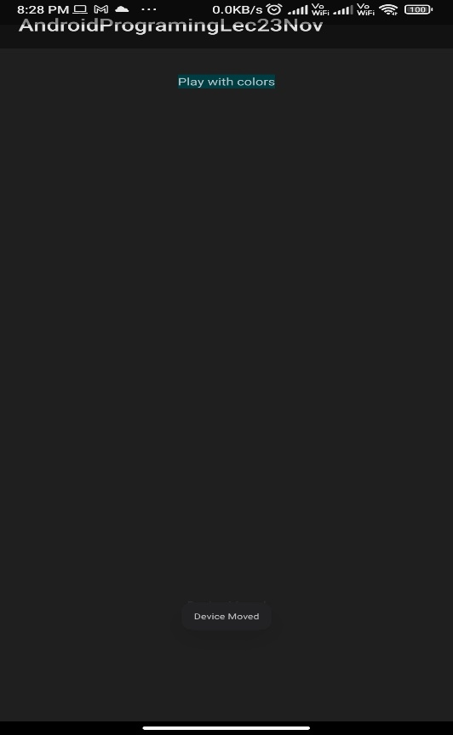

**EXPERIMENT 12:-**

1. Installing an application on a mobile device

Sol:-

Before installing any application on a mobile device you have to follow the below checklist.

Regression Testing:-

Before you publish your application, you need to make sure that its

meeting the basic quality expectations for all Android apps, on all

of the devices that you are targeting. So perform all the required

testing on different devices including phone and tablets.

Application Rating:-

When you will publish your application at Google Play, you will

have to specify a content rating for your app, which in forms Google

Play users of its maturity level. Currently available ratings are

(a)Everyone (b)Low maturity (c)Medium maturity (d)High maturity.

Targeted Regions:-

Google Play lets you control what countries and territories where

your application will be sold. Accordingly you must take care of

setting up timezone, localization or any other specific requirement

as per the targeted region.

Application Size:-

Currently, the maximum size for an APK published on Google Play is

50 MB. If your app exceeds that size, or if you want to offer a

secondary download, you can use APK Expansion Files, which

Google Play will host for free on its server infrastructure and

automatically handle the download to devices.

SDK and Screen Compatibility:-

It is important to make sure that your app is designed to run

properly on the Android platform versions and device screen sizes

that you want to target.

Application Pricing :-

Deciding whether your app will be free or paid is important.If you

want to sell your application then you will have tospecify its price

in different currencies.

Promotional Content:-

It is a good marketing practice to supply a variety of high-quality

graphic assets to show case your app or brand. After you publish,

these appear on your product details page,in store listings and

search results,and else where.

Build and Upload release-ready APK:-

The release-ready APK is what you will upload to the Developer

Console and distribute to users.

Now for installing the application on a mobile device below following way you have to follow.

1. APK: Android Application Package:-

• An APK file is the file format used to install the applications on android operating system.

• A program in android is first compiled, and then all of its parts are packaged into one single file to make it an APK file.

• APK files can be saved in compressed zip format, with any decompression or unzip tool it can be opened.

• When you are downloading and installing an android application then actually you are installing an APK file.

• NOTE - You can install an APK file directly from a desktop, or from within a file manager app without downloading. By default, ability to install from desktop, or file manager app is disabled for security reasons. TO enable it, you have to change the setting of 'Unknown sources' from settings.

1. Export Android Application Process

• Before exporting the apps, you must have some of the tools:

• Dx tools(Dalvik executable tools ): It converts .class file to .dex file. It is useful for memory optimization and reduces the boot-up speed time

• AAPT(Android assistance packaging tool):it is useful to convert .Dex file to .Apk

• APK(Android packaging kit): The final stage of deployment process is called as .apk.

1. Exporting an application

• Step 1 - Open that application project in Android studio.

• Step 2 - Select Build → Generate Signed Bundle or APK from your Android studio

• Step 3 – On selecting Generate Signed Bundle or APK option ,the following wizard opens, select APK and click Next

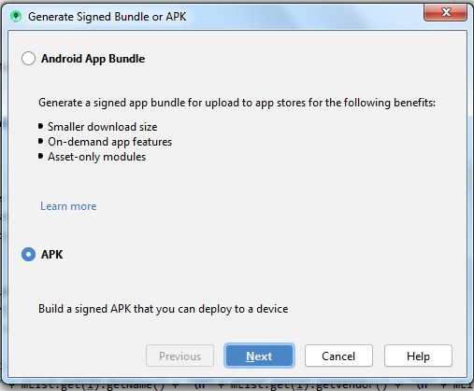

• Step 4 – Fill up the entries in the next wizard.

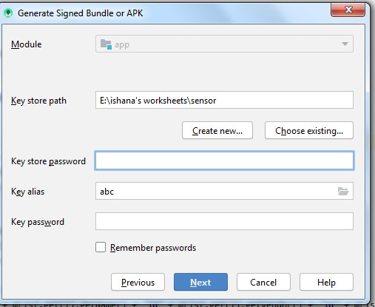

• Step 5 – Select release in the next wizard and click Finish

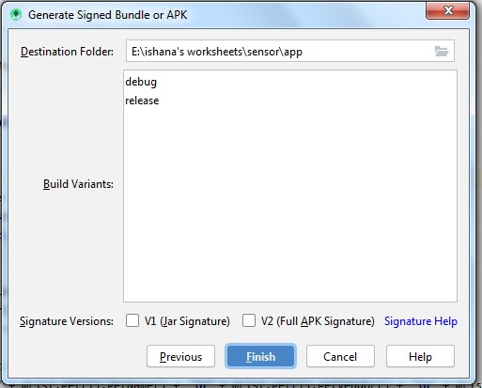

Once you filled up all the information, like app destination, build variant click finish button While creating an application it will show as below Finally, it will generate your Android Application as APK format File which will be uploaded at Google Play marketplace.

1. Google Play Registration

• An important step is to register with Google Play using Google Play Marketplace (https://play.google.com/console/signup)

• You can use your existing google ID. You will have screen where you will have to accept terms and conditions.

• A registration fee will be charged to complete the registration.

• Once you are a registered user at Google Play, you can upload release-ready APK for your application and finally you will complete application detail using application detail page. Google Play gives you a variety of ways to promote your app and engage with users on your product details page, from colourful graphics, screen shots, and videos to localized descriptions, release details, and links to your other apps. So you can decorate your application page and provide as much as clear crisp detail you can provide.

1. Creation of a developer account

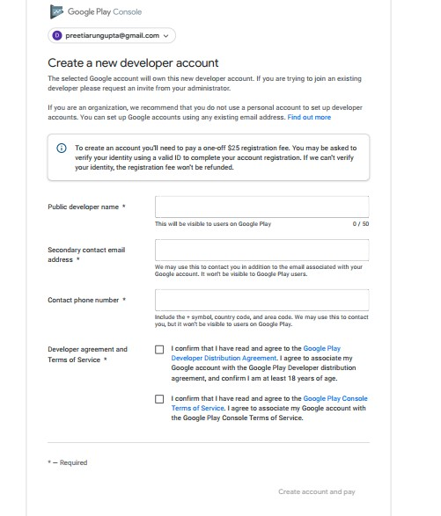

1. Distributing your apps by email

• A quick and easy way to release your apps is to send them to users by email.

• To do this, you prepare the app for release, attach it to an email, and send it to a user.

• When the user opens your email on their Android-powered device, the Android system recognizes the APK and displays an Install Now button in the email message.

• Users can install your app by touching the button. Users need to opt in for installing unknown apps if they haven't already to proceed with the installation.

• Distributing apps through email is convenient if you’re sending them to a few trusted users, as it provides few protections from piracy and unauthorized distribution; that is, anyone you send your apps to can simply forward them to others.

1. Steps for Distribution

• Go to "build" from the navigation bar in Android Studio.

• Go to "build bundle(s)/APK(s)" from the drop down that appears.

• Click on "build APK(s)". You will get a notification box at the bottom right of your screen.

• Click on "locate". Two files will appear. One is a ".json" file and one is an ".apk" file.

• Send these files to the other end and tell them to download the JSON file and install the APK file.

• Now your application will run at the other end.